European Headquarters
Alloy Industrial Estate | Pontardawe Swansea Wales UK SA8 4HL
Tel +44 (0) 1792 862287 | Fax +44 (0) 1792 860687 | Web www.wallcolmonoy.co.uk | Email sales@wallcolmonoy.co.uk

For Immediate Release
November 2019
Wall Colmonoy Announces
Rob Davies, Managing Director, European Headquarters
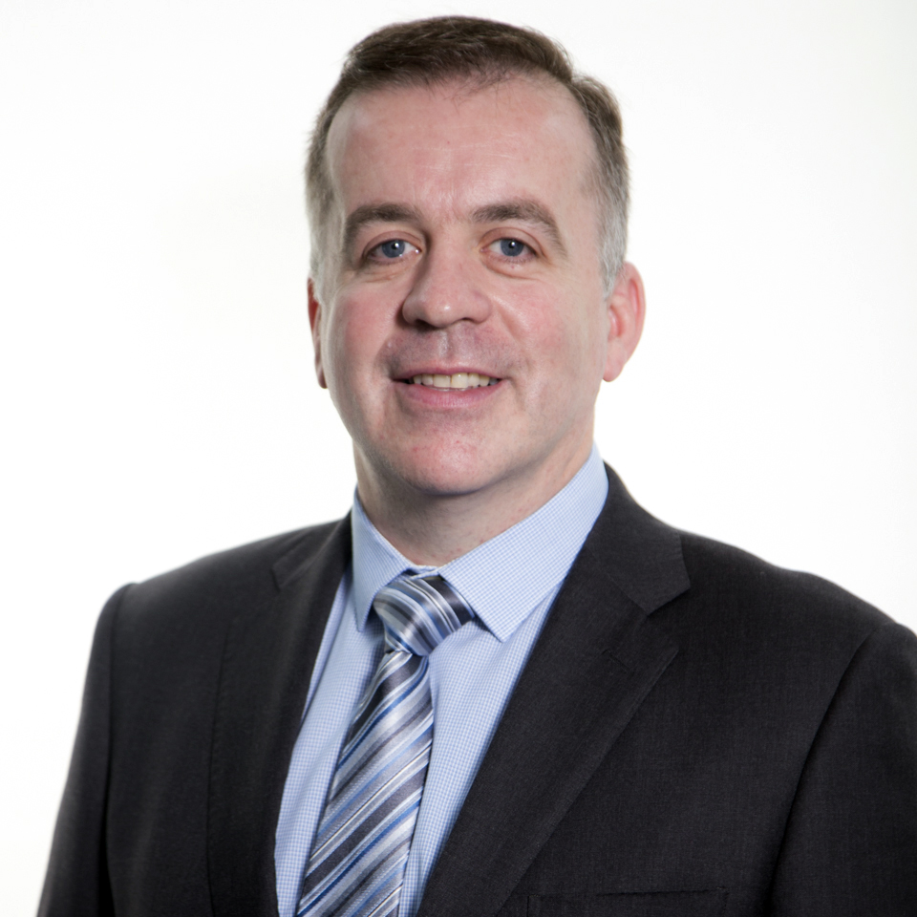
Wall Colmonoy announces the appointment of Rob Davies as Managing Director for its’ European Headquarters.
Robert Davies joined Wall Colmonoy Limited in March 2015, bringing with him 14 years of experience in strategic, operational and engineering management. He has worked predominantly in the automotive industry with over 5 years P&L responsibility as Plant Manager. His experience covers assembly, precision machining and extrusion processes for safety critical steering systems, engine and seating components.

Rob’s strategy for the European Business is focused on growing both organically and reaching into new markets through innovative product solutions and business acquisitions. Rob is driving the business forward, by leveraging a well-established and very experienced workforce, whilst coupling strategic recruitment to focus on new opportunities and growth. He will continue to drive the organisation to provide excellent customer experience, customised engineered solutions, high product quality and a safe working culture.

Robert states, “I am highly motivated to extend my responsibilities within Wall Colmonoy and the opportunity to take the business to new levels of growth and technical advancement. The landscape of manufacturing is changing daily and our team is ready, we have the drive, the knowledge and the backing to thrive – we certainly will make our metals work harder”.

Commencing his career as a toolmaking apprentice, Robert graduated with a BSc in Mechanical & Manufacturing Engineering from the University of Glamorgan. Robert is a certified Six Sigma Black Belt, a change agent with a proven track record of implementing Lean manufacturing practices across all departments and all levels within manufacturing businesses.
About Wall Colmonoy
Wall Colmonoy is a global materials engineering group of companies engaged in the manufacturing of Colmonoy®, Wallex® surfacing and Nicrobraz® brazing products, castings, and engineered components across aerospace, automotive, oil & gas, mining, energy and other industrial sectors.
Known for our unique proven way of creating superior performing alloys that enhance engineered components, we pride ourselves on long-term strategic customer collaboration that produces value-added ideas and creative solutions.
Combining over 80 years of engineering technology with a progressive, visionary outlook, Wall Colmonoy offers customers trusted, customized expertise that results in smart innovation and shared growth.
More information about Wall Colmonoy is available at: wallcolmonoy.co.uk

Wall Colmonoy. Making Metals Work Harder Since 1938

## Contact: Jordan Brace, Marketing Coordinator | jordanbrace@wallcolmonoy.co.uk | +44 (0)1792 860622

