DEHN protects wind turbines
Wind energy is a clean and renewable form of energy, which is also drought-resistant and almost emission-free. However, as South Africa’s renewable energy industry continues to explore wind energy as a potential resource, considerations around possible lightning strikes need to be factored in. Across the globe, whether on- or offshore, DEHN protects wind turbines against disturbances resulting from lightning currents and surges, and provides components and solutions relating to safety equipment.

The cost of constructing and operating wind power plants must be amortised within the timeframe of an average 20 years of operation. Constant monitoring and foresighted maintenance are essential. DEHNdetect, available from lightning and surge protection expert, DEHN Africa, is designed to measure lightning currents and detects not only impulse currents but also the dangerous long stroke currents (ICC only events - Initial Continuous Current).

Damage resulting from a lightning strike does not necessarily lead to the immediate failure of the turbine, and so lightning events often remain undetected. Especially in the case of upward flashes, the initial long stroke current flowing is only a few hundred amps, and this can be the main cause of melting, for example on the receptors of rotor blades. The resulting subsequent damage can be severe.

DEHNdetect allows the operator to assess the situation and ask the following important questions: “Was the lightning strike harmless or does the turbine need to be switched off and inspected in order to rule out damage to the rotor blades or other components?” As well as the total current in the system, DEHNdetect registers individual partial currents in the rotor blades.

The provision and management of data is simple and convenient via web applications (cloud). DEHNdetect allows for the monitoring of several plants or even entire wind parks.

DEHNdetect can be installed directly by the wind turbine manufacturer or retro-fitted in existing plants. Installation is quick and easy and can be adjusted to the specifications of the individual turbine.

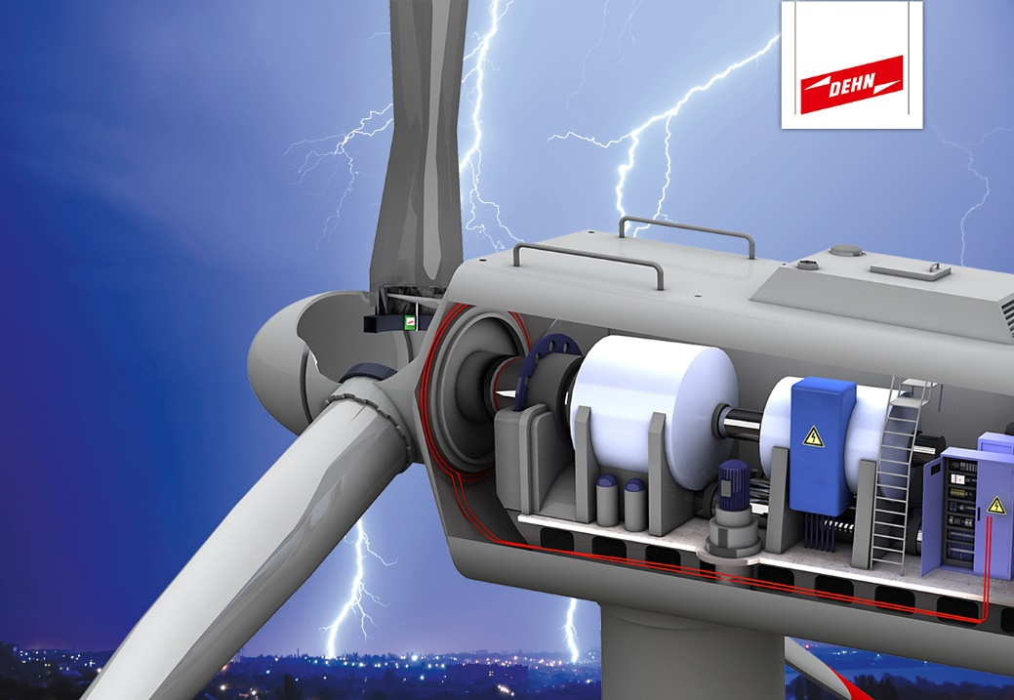
DEHN at HUSUM WIND 2017
Market leader DEHN, a globally active family-owned electrotechnical company with more than 1700 employees worldwide, offers innovative products and solutions as well as comprehensive services in the field of surge protection, lightning protection and safety equipment. DEHN focuses on the protection of system and building technology, the transportation, telecommunication and process sector, photovoltaic systems, wind turbines, etc. The company's continuous growth is based on more than 100 years of tradition and experience as well as highest quality standards and consistent customer and market orientation throughout the world.

