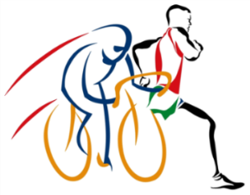

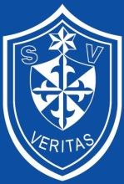

3RD ELB EXTREME ROAD CHALLENGE – WHAT A RACE IT WAS!
Runners vs Cyclists over a distance of 353km

ELB is yet again proud to announce that the ELB Extreme Road Challenge was a great success with teams completing the epic journey across border in record time. ELB employees and friends from general industry got together for the third ELB Extreme Road Challenge, where runners challenged cyclists over a distance of 353km, which included the Lesotho mountains, to raise much needed funds for St Vincent School for the Deaf in Johannesburg.
Numerous legends, including David Gatebe, Gift Kelehe, Gordon Lesetedi, Latidu (Surprise) Makofane, Andrew Kelehe, Terence Parkin and Thomas Ngidi to name a few were part of the running and cycling teams and the pressure to perform was heavy on these athletes. We thank these great athletes and look forward to having them on-board in 2018.
The cyclists, broken into teams of 5 took on the distance in three stages, with overnight stops at Golden Gate, Ficksburg and Afriski, Lesotho. They not only competed against each other, but also against the running teams of 5 runners each. We congratulate Terence Parkin for the King of the Mountain award, Jaco Engelbrecht for the yellow jersey award and John Tucker for the green jersey award.
Our cyclists had a challenge on their hands on day 1, (104km – Bergville-KZN to Golden Gate Elevation: 1875m gain/1249m loss) with strong cross and head winds and reaching temperatures of 34 degrees. Day two (123km - Golden Gate to Ficksburg Elevation: 2015m gain/2140m loss) was a much smoother ride, but they had to contend with poor road conditions and big trucks, but managed to make up a lot of time. Day three, brought on the monstrous mountains of Lesotho! What a climb it was (Ficksburg to Afriski, 126km Elevation: 3667m gain/2338m loss), but they managed well and we welcomed our first cyclist at Afriski in a time of 18h4min.
In order for athletes to arrive at the finish at more-or-less the same time a formula is used to calculate expected times, which enable us to predict the average finishing time for runners and cyclists. The runners completed the distance in a non-stop relay format with one runner per team on the road at all times. Each runner was expected to run at least 60 kilometres.
On Friday morning, 20th October 40 runners and their support teams took off from Bergville. Some of them Comrades winners and Washie 100 miler medal holders, discussing different strategies for the 353km that lay ahead – apprehension was in the air! Ready to take on the cyclists and the Lesotho mountains, knowing that sleeping, eating and drinking will be done in the team’s minibus until they reached the finish at Afriski.
Conditions were perfect and the runners proved to be the fastest over the distance of 353km, our winners, Team Eye of the Tiger (Christopher Ferguson, David Gatebe, Gordon Lesetedi, Thomas Ngidi and Jaco de Jager) who ran 26h45 won with an average of 4:33/km. Congratulations Team Eye of the Tiger, your strategy worked well! Team Scud, our second team ran 27h30 and averaged 4:40/km, while Team We Are One came in third in 27h50 with an average of 4:43/km. Followed by Team Diverse Connections, Team Shaw Control, Team 4 Chicks and a Dude, Team Zikonde and our all ladies team, Team HotFit!
Dedication, determination, passion and “vasbyt” through those gruelling Lesotho mountains shown by the runners and cyclists were inspirational. There are no words to describe the pain, guts and glory these amazing athletes experienced and endured. The Challenge is without a doubt a life changing experience, not only for the participants, but for the support teams as well.
Lots of planning and organisation went into successfully arranging this event and we are extremely grateful that everyone returned safe and sound. Keeping our cyclists and runners safe on the roads was our first priority and we thank everyone for their cooperation in this regard.
So many people and organisations contributed to the success of our third ELB Extreme Road Challenge. We would like to take this opportunity to thank all of them, participants, support, medics, sponsors, Lesotho Ministry of Police, Lesotho Ministry of Tourism and Traffic Departments in the different regions. We also thank the various hotels and establishments for your kindness in accommodating our participants and support teams.
This year’s ELB Extreme Road Challenge was without a doubt the most testing to date, however it created more memories and comradery than most other extreme events on the race calendar. The success of the 3 days was only due to the hard work, dedicated training and the will to never give up. Every step of the way helped a child at St Vincent’s and ELB look forward to continuing this initiative for the school into the future and to hosting an even bigger and better ELB Extreme Road Challenge next year.
"The more difficult the victory, the greater the happiness in winning." - Pele.
For more information, contact Cornel Charlton on 011 772 1509 or cornelc@elb.co.za
www.facebook.com/ELBextremechallenge

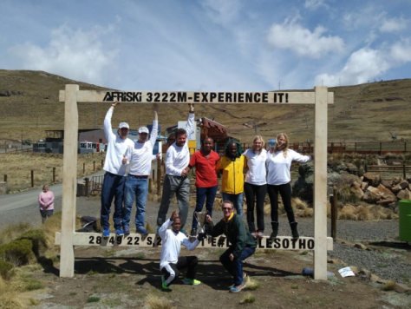
Our winners celebrating at Afriski in Lesotho: Team Eye of the Tiger – Christopher Ferguson, David Gatebe, Gordon Lesetedi, Thomas Ngidi and Jaco de Jager with their amazing support team – Teresa Hutchinson, Elmarie van Niekerk, Kegan Malan and Derek Ferguson

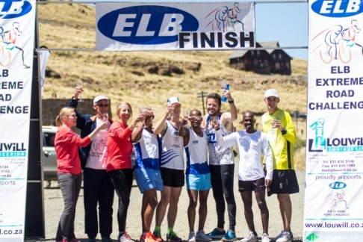
Eye of the Tiger enjoying a well-deserved glass of champagne at the finish

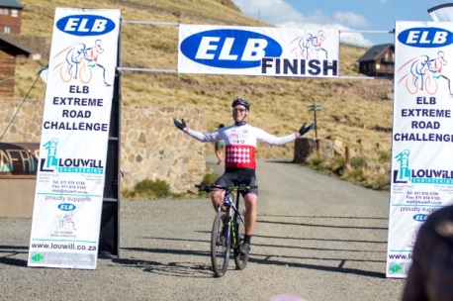
Terence Parkin at the finish at Afriski, he also took the King of the Mountain award

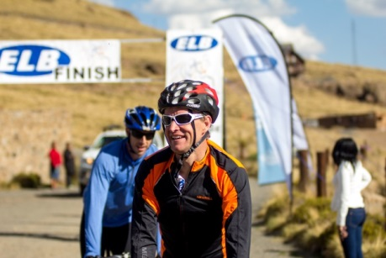
John Tucker and Luca Altini at the finish at Afriski
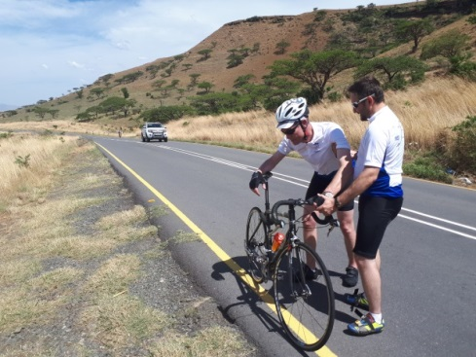
Double trouble

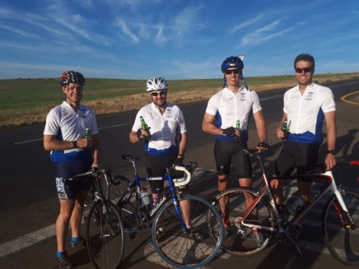
Our cyclists enjoying a cold beer at the end of day 1

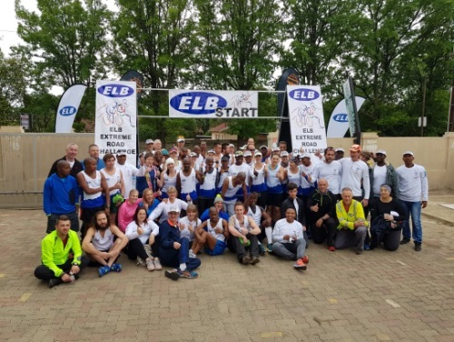
Runners at the start in Bergville

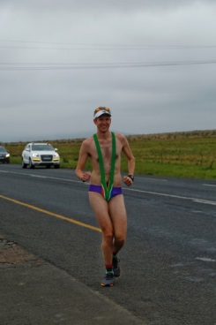
4 Chicks and a Dude’s James Barker, running his third ELB Challenge and still having fun!

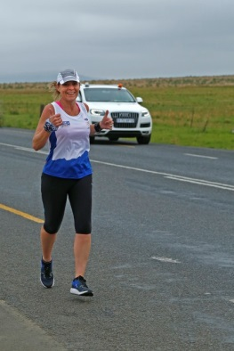
A thumbs up from Pat Hamlett from the all ladies team, Team Hotfit

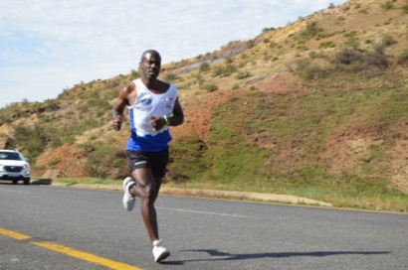
David Gatebe, Comrades winner 2016 and part of Team Eye of the Tiger, at his best

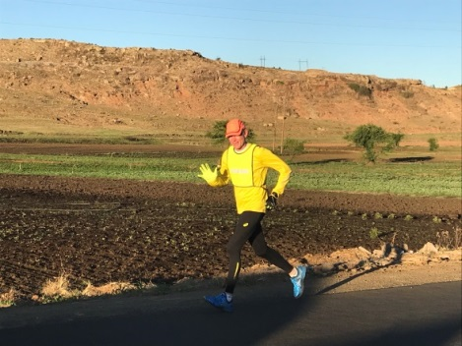
ELB CE Dr Stephen Meijers giving us a wave in the Lesotho mountains

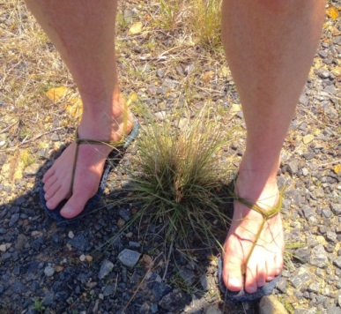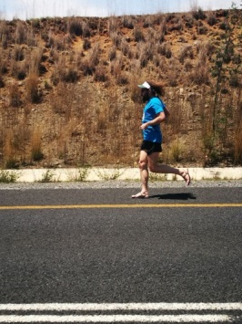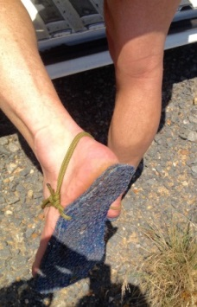
Team Diverse Connections’ Willie Senekal with his interesting “home-made carpet and rope soles” Willie ran parts of the ELB Challenge in his home-made specials and some of it in his running shoes, unbelievable!

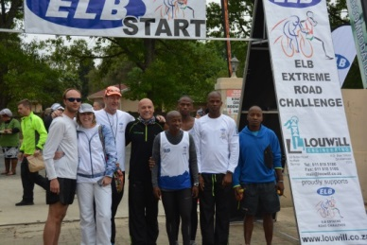
Team Scud at the start – Rainier Joubert, Stephen Meijers, Coach John Hamlett, Gift Kelehe, Edwin Khonkhobe, Surprise Makofane, and support Taryn Honeyman

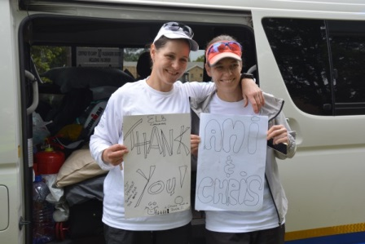
Team 4 Chicks and a Dude thanking their sponsors

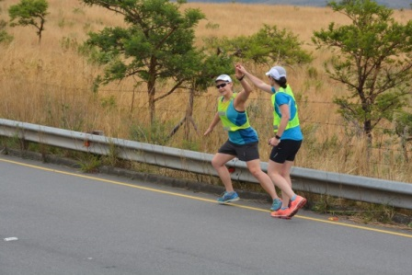
Team 4 Chicks and a Dude on the road passing the “baton”

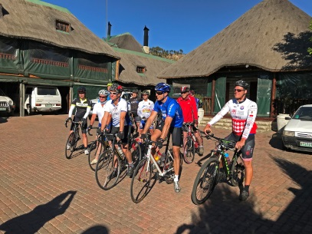
Cyclists at the start of the last day – ready for the Lesotho mountains

