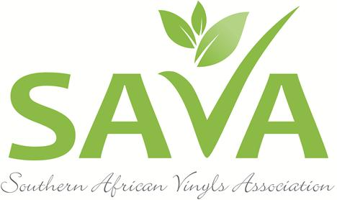
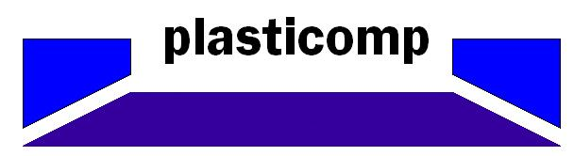
Press announcement for immediate release
SAVA WELCOMES PLASTICOMP AS LATEST SMME MEMBER TO JOIN THE ASSOCIATION
Johannesburg, September 27, 2017. Plasticomp cc has become the latest SMME to join the Southern African Vinyls Association (SAVA). According to SAVA Chief Executive Officer, Delanie Bezuidenhout, Plasticomp has successfully satisfied the criteria for membership and has been accredited as a member and signatory to the association’s Product Stewardship Commitment (PSC).
“We are thrilled to welcome them to the SAVA family. As a recycler of rigid PVC (PVC-U), Plasticomp has successfully demonstrated that they support our commitment to increase the recycling rates of PVC in South Africa and adherence to the principle of extended producer responsiblity regarding end-of-life material”, Delanie says.

Boksburg-based Plasticomp started its operations in September 2006 providing toll pulverizing services to the PVC-U pipe and conduit customers for their own start-up scrap. Since then, the company has grown significantly and now provide toll services to the LLDPE (roto moulding market), pigments and masterbatch manufacturers in both virgin and recycled materials. They also provide recycled PVC-U powder that they export into Africa as well as supply to local pipe, borehole and profile manufacturers.
Above: Anton Tjabring, Managing Member of Plasticomp cc
“We read about SAVA and the amazing work the association does in trade publications. We identified that there is great potential for working with SAVA members and decided that joining their ranks would signal a clear message about our company’s own commitment to sustainable and ethical practices, whilst at the same time unlocking new sources of PVC-U scap thereby broadening our customer base,” said Anton Tjabring, the Managing Member of Plasticomp.
For more information about Plasticomp, visit their website on www.plasticomp.co.za or contact Anton Tjabring directly via email at atjabring@plasticomp.co.za or telephone (011) 918-3412 / (074) 366-8636.
For more information about SAVA, visit www.savinylsassociation.co.za
ENDS

Issued on behalf of SAVA by Aim Marketing & Communications Consultants. Tel: (021) 531-0313 / (071)083-5219
Email: Monique@aimmarketing.co.za

