Johannesburg, South Africa–September 28, 2017

Yokogawa to Conduct PoC Test of Remote Pump Monitoring Service Using Its IIoT Architecture
−Creating new value by working with partner companies−

Yokogawa Electric Corporation (TOKYO: 6841) announces that it has begun working with Iwaki Co., Ltd. on a proof-of-concept (PoC) test for a remote pump monitoring service. This service will use an Industrial IoT (IIoT) architecture that is currently under development by Yokogawa. The PoC test will examine the market potential for such a service and investigate means by which it may be offered.

Yokogawa will exhibit and demonstrate a prototype version of this service at the IoT Solutions World Congress 2017, which will be held in Barcelona, Spain starting October 3, and IoT Korea Exhibition 2017, which will be held in Seoul, South Korea starting October 11.

About This Service
Yokogawa and Iwaki will jointly conduct a PoC test of a service for remotely monitoring the operating status of Iwaki magnetic drive pumps^{*1}, which are widely used in chemical, pharmaceutical, and food plants for the transport of various types of fluids. With this service, operating data such as the current being drawn by a pump, pump discharge pressure and flow rate, temperature of the conveyed liquid, and tank empty/not empty status will be collected via an Iwaki pump protector DRN and transferred to the cloud using the IIoT infrastructure that Yokogawa currently has under development, and will be available for remote access from any location by a facility manager. With the ability to remotely monitor the operating status of the pumps at a facility, the facility manager will be able to detect problems early on and consult with staff at the head office to decide on comprehensive and appropriate countermeasures. Pump manufacturers will be able to use this service to ensure the timely maintenance of their customers’ products in the field. With this service, it will be possible to remotely monitor the operating status of multiple pumps, and a warning message can be emailed to the facility or maintenance manager to ensure a timely response whenever a set threshold is exceeded.

Iwaki is Japan’s leading manufacturer of chemical and pharmaceutical pumps. By partnering with this company, Yokogawa will gain access to its abundant know-how and expertise and thus be able to rapidly evaluate the market potential for such a service.

With the IIoT architecture that Yokogawa is developing, an IoT gateway device will receive sensor data via a low power wide area network (LPWAN) or some other wireless link, or via an analog/digital communications interface. Once in the cloud, this data can then be accessed using a cellular or fixed line network. Yokogawa aims to create a system that simplifies the process of connecting to sensors and other instruments and transferring that data to the cloud. With plug-and-play^{*2} functionality, device detection and configuration will be done automatically, and other functions will ease the tasks of data transfer, remote control, and alarm notification. This service is expected to be compatible with pumps from manufacturers other than Iwaki, providing they use the DRN pump protector.

Through the PoC test, we will evaluate the market potential for this service and look into the feasibility of speeding up its commercialization by offering it based on a subscription model^{*3}. By working together with Iwaki, a leader in the pump industry, Yokogawa will be able to present solutions that generate new value for its customers.

*1 A centrifugal pump in which the rotational force of a motor is transmitted to an impeller using magnetic force, eliminating the need for a seal to prevent the leakage of fluid. The wetted part is coated with either Teflon or silicon carbide and is chemical resistant.
*2 The automatic detection and configuration of a sensor or some other device when it is connected to a network. Devices thus configured are then immediately available for use.
*3 A system in which fees are paid depending on the usage period
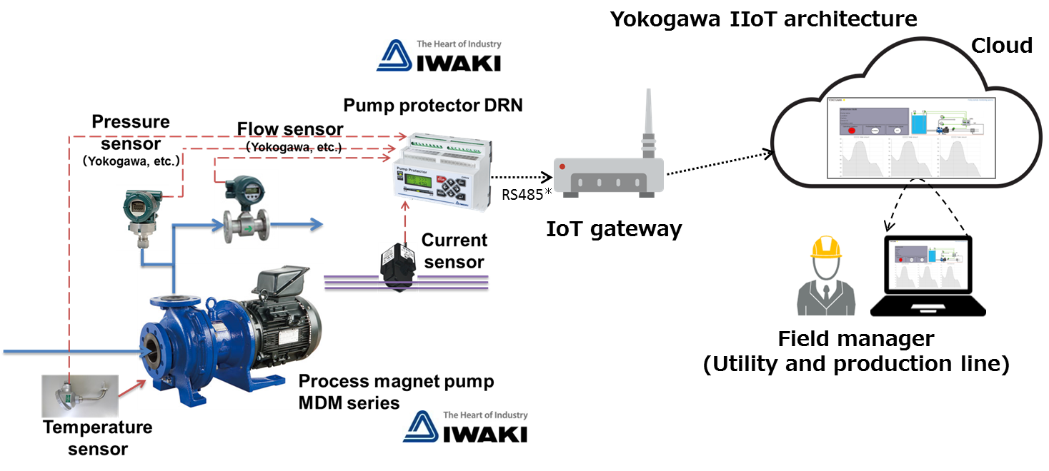* A serial communications standard jointly published by the Telecommunications Industry Association and the Electronic Industries Alliance (TIA/EIA)
System image of remote pump monitoring service

About Iwaki Co., Ltd.
Since its foundation in 1956, the company has provided a variety of fluid control products, mainly pumps, to producers of pharmaceuticals, chemicals, and other products.
http://www.iwakipumps.jp/en/corporate/profile
About Yokogawa
Yokogawa's global network of 113 companies spans 60 countries. Founded in 1915, the US$3.5 billion company engages in cutting-edge research and innovation. Yokogawa is active in the industrial automation and control (IA), test and measurement, and aviation and other businesses segments. The IA segment plays a vital role in a wide range of industries including oil, chemicals, natural gas, power, iron and steel, pulp and paper, pharmaceuticals, and food. Targeting this segment, Yokogawa helps companies maximize their profits by offering a wide range of highly reliable products and working with the subsidiary KBC Advanced Technologies to provide premium solutions and services. For more information about Yokogawa, please visit www.yokogawa.com/za

The names of corporations, organizations, and products herein are either trademarks or registered trademarks of their respective holders.

