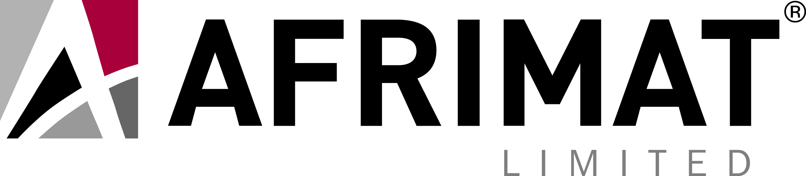

Afrimat Construction Index takes a dip in the second quarter of 2017, but prospects seem poised to improve

Johannesburg, 21 September 2017 – Afrimat, a leading open pit mining company providing industrial minerals and construction materials, has released the findings of the third Afrimat Construction Index (“ACI”) for the second quarter of 2017.

The ACI is a composite index of the level of activity within the building and construction sectors, compiled by renowned economist Dr Roelof Botha on behalf of Afrimat.

According to Dr Botha, the index was impacted by low levels of business and consumer confidence during the second quarter of the year, mainly influenced by a series of political shocks, including major changes to the executive leadership at National Treasury and the fiscal threat imposed by significant losses at a number of state-owned enterprises.

Botha points out that policy uncertainty exists, which is acting as a constraint to the expansion of productive capacity in the economy, whilst durable consumption expenditure by households also continues to decline, in real terms.

Despite these and other well-publicised obstacles to construction activity and the economy in general, the ACI only declined marginally in the 2nd quarter of 2017. After reaching an eight-quarter high of 127 in the fourth quarter of last year, the ACI has now declined for two successive quarters to reach a level of 117 in the second quarter of 2017.

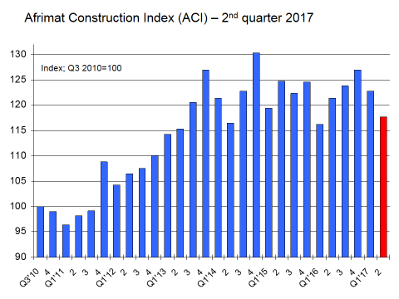

The construction sector nevertheless remains on a stronger footing than seven years ago, with the ACI having expanded by 17.7% since the third quarter of 2010 (the base period), almost 50% higher than the rate of growth of the economy as a whole over this period (in real terms).

Botha says the composite index provides a balanced and realistic view of the level of activity in the construction sector as it evens out the contradictory trends of conditions in the construction sector that are often portrayed by the individual components that comprise the index.

The ACI is calculated from nine different constituent indicators, including the FNB/BER building confidence index.

The expansion in construction activity since the third quarter of 2010, as indicated by the ACI, has been driven mainly by strong increases in the following four key indicators:
- Retail sales values for hardware, glass and paint
- Employment in construction
- The volume of mined building materials
- The value of buildings completed in large municipalities

It remains a point of concern that the value of buildings plans approved by the larger municipalities continues to perform poorly, whilst confidence levels in the construction sector declined dramatically in the second quarter of 2017. Formal employment in the industry also took a knock between April and June 2017.

Botha believes that the tide may be turning for construction activity. “Fortunately, the SA Reserve Bank decided to ease the debt servicing burden of South African households and businesses, with a marginal decline in the repo rate having been announced in July 2017. Due to a sharp retreat of inflationary pressures in the South African economy, further interest rate cuts are widely expected, which is likely to witness a return to a positive ACI trend before the end of the year”.

Dr Botha also points out that the South African economy expanded by more than 1% during the first half of the year, the first time this has occurred since the beginning of 2015. “Construction sector output is traditionally a lagged indicator of overall economic activity. Prospects are likely to improve into the second half of the year, as the country’s GDP starts to build momentum on the back of higher world growth, lower interest rates and the recovery of several key export commodities”.

Andries van Heerden, Afrimat CEO, says the activity in the construction sector has tightened but for players such as Afrimat, being well diversified, nimble and positioned to work on the medium to small projects, the sector remains attractive. “Granted you have to remain on your toes and ever-vigilant to opportunities, van Heerden explained. The results of this study are showing that construction is a sector in which government spend is still taking place and given economic constraints, it is natural for the sector to come off slightly. “However, if companies position themselves correctly on product quality, price and service delivery, they should be able to make a decent return for shareholders,” concluded van Heerden.

Ends

Issued for: Afrimat Limited
Contact: Andries van Heerden, Chief Executive Officer (CEO)
Tel: 021-917-8853
Email: andries@afrimat.co.za
Website: www.afrimat.co.za

Account: Keyter Rech Investor Solutions
Contact: Vanessa Rech
Tel: 083 307 5600

Date: 21 September 2017

