Endress+Hauser wins Digital Champion Award - IIoT in the process industry

Endress+Hauser accompanies customers on the path to digitalisation
The Industrial Internet of Things (IIoT) has huge potential: predictive maintenance, asset information management and device configuration are just some examples of the opportunities digitalisation has in store for companies. Endress+Hauser is driving IIoT forward through innovative products and solutions as well as by working with partners. This dedication has been proven twice – winning the Digital Champion Award and presenting a new digital platform at the German Digital Summit.
The advantages of digitalisation in the process industry can already be seen clearly. Increased networking opens up new opportunities in process optimisation and increases plant efficiency. Endress+Hauser is therefore constantly increasing its offer of products, solutions and services in order to increase customers’ productivity and system availability while expanding competitiveness.
Digital Champion 2017: one step ahead with innovative sensor technology
With Memosens, Endress+Hauser introduced a pioneering sensor technology for liquid analysis in various industries such as chemical, power & energy, food & beverage and water & wastewater over 10 years ago. Memosens sensors measure the pH-value in liquids, for example, and transform it into a digital signal while still in the sensor. The data is then passed on via a contactless system and provides extremely accurate, reproducible and reliable measurement results. Furthermore, the technology combines high process and data security with simple handling: it can withstand corrosion and moisture, can be calibrated in the laboratory and enables predictive maintenance.
Endress+Hauser’s Memosens was presented with the Digital Champion Award in the category Digital Products and Services in June 2017. The award is a joint initiative of the German telecommunications provider Telekom and the business magazine WirtschaftsWoche, which was set up in 2016 with the aim of awarding prizes to significant projects by medium-sized companies.
Endress+Hauser at the Digital Summit
Endress+Hauser also demonstrates its commitment through its work with partners: the company created a platform through which data can be exchanged together with BASF, SAP, Pepperl+Fuchs and SAMSON. This was presented for the first time at the Digital Summit of the German Federal Ministry for Economic Affairs and Technology. The event took place in June 2017 in the metropolitan Rhine-Neckar region and saw over 1000 participants, including the German Chancellor Dr. Angela Merkel.
The platform enables new forms of data-based cooperation. The effectiveness and efficiency in chemical production can be increased significantly, allowing new business models to be created. The ability to gather data on the condition of devices and components and exchanging this data with all those involved with the process helps determine maintenance requirements, plan maintenance work more efficiently and reduce plant shutdowns.
Subsidiary for IIoT activities
Endress+Hauser has combined its activities for IIoT in order to meet the high pressures of digitalisation. Specialists work exclusively on products, solutions and services for digitalised plants. These include customised cloud solutions, for example, which utilises specific data from production processes and increases efficiency, as well as services for the plant’s entire life cycle.

For further information, please visit http://bit.ly/IIoT_Endress_Hauser
From: Endress+Hauser (Pty) Ltd
Submitted by: Su-Anne Willemse
Tel: (011) 262 8080
Email: suanne.willemse@za.endress.com

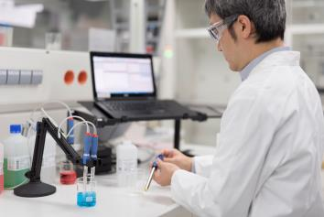
EH_Memosens.jpg
Award-winning technology: Memosens sensors by Endress+Hauser can be calibrated and regenerated in the laboratory. This allows them to be exchanged quickly and easily on site.
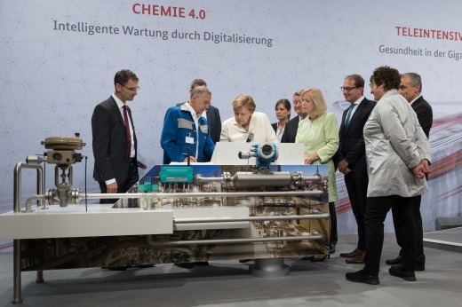
EH_Digital-Gipfel.jpg
A platform for Industry 4.0 in chemistry: together with BASF, SAP, Pepperl+Fuchs and SAMSON, Endress+Hauser presented the opportunities of digitalization to Chancellor Angela Merkel.
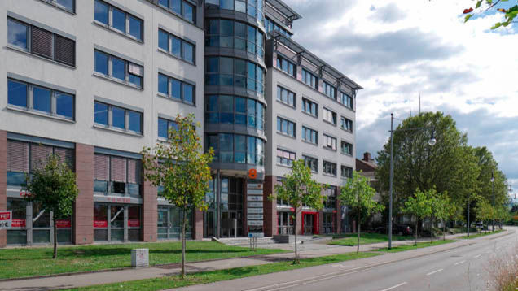
EH_Standort_Freiburg.jpg
Ready for digitalization: Endress+Hauser is combining its IIoT activities at a subsidiary in Freiburg.
The Endress+Hauser Group
Endress+Hauser is a global leader in measurement instrumentation, services and solutions for industrial process engineering. The Group employs 13,000 personnel across the globe, generating net sales of more than 2.1 billion euros in 2016.
Structure
With dedicated sales centers and a strong network of partners, Endress+Hauser guarantees competent worldwide support. Our production centers in 12 countries meet customers’ needs and requirements quickly and effectively. The Group is managed and coordinated by a holding company in Reinach, Switzerland. As a successful family-owned business, Endress+Hauser is set for continued independence and self-reliance.
Products
Endress+Hauser provides sensors, instruments, systems and services for level, flow, pressure and temperature measurement as well as analytics and data acquisition. The company supports customers with automation engineering, logistics and IT services and solutions. Our products set standards in quality and technology.
Industries
We work closely with the chemical, petrochemical, food & beverage, oil & gas, water & wastewater, power & energy, life science, primaries & metal, renewable energies, pulp & paper and shipbuilding industries. Endress+Hauser supports its customers in optimizing their processes in terms of reliability, safety, economic efficiency and environmental impact.
History
Founded in 1953 by Georg H Endress and Ludwig Hauser, Endress+Hauser has been solely owned by the Endress family since 1975. The Group has developed from a specialist in level measurement to a provider of complete solutions for industrial measuring technology and automation, with constant expansion into new territories and markets.
For further information, please visit www.endress.com/media-center or www.endress.com

Contact
Martin Raab Email martin.raab@holding.endress.com
Group Media Spokesperson Phone +41 61 715 7722
Endress+Hauser AG Fax +41 61 715 2888
Kägenstrasse 2
4153 Reinach BL
Switzerland

