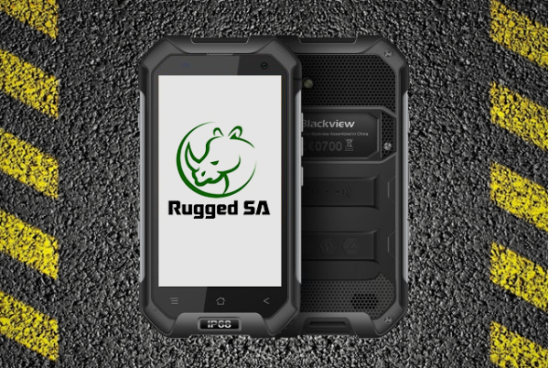
Afraid to take your smartphone anywhere because dropping it means a painful R5,000?
Many screens don’t survive from falls even below 3 feet and some phone screens even have a track record for shattering by being in one’s pocket.
Thankfully, Rugged SA offers many options from smartphones to smartphone covers to suit the toughest of needs.
Rugged SA has been one of the top South African online distributors for rugged smartphones and rugged phone covers over the last 2 years.
The durable smartphones and smartphone covers are especially designed to keep your phone safe from drops, rain, dust, and the rigorous conditions faced by first responders, industrial workers, extreme sports enthusiasts, and even parents.
Rugged SA aim to bring the convenience of smartphone functionality to working environments in which ordinary smartphones don’t survive.
More than IP68, our devices are compatible with MIL STD 810g which also means they are drop proof up to 1.8m and can handle extreme heat and cold.
“Our selection is based not only on the smartest and most rugged but also on reliability and commitment to local support,” says Rugged SA
They currently hold the exclusive importing and distribution rights for the Blackview Rugged Smartphone range, which have become a very popular alternative to highly priced and limited rugged hardware available elsewhere in South Africa.
The Blackview Rugged Smartphones currently available include the BV6000s, BV6000, and BV7000 PRO models starting from R3,899 up to R5,799.
The BV6000 currently holds the title for best seller and is available for R4,799.
If a rugged phone is not what you are looking for, Rugged SA also has you “covered” with a large range of rugged mobile covers available for your favourite smartphone.
Rugged SA sells well-known South African and International brands that include UAG, Body Glove, Lunatik, Optrix, RhinoShield, X-Doria, Spigen and many more available starting at R199.
Rugged Outdoor Speakers are also available from Rugged SA which will survive tough terrains and weather conditions as well as severe hammering when brutally handled.
What’s more is Rugged SA also offers free shipping for online orders over R399, and all products come standard with a 1-year manufacturer warranty.
Products can be purchased from the Rugged SA online store with a Visa or Mastercard, or you can use the Mobicred financing option.
Call Rugged SA on 087 550 9908 or visit their online store and like Rugged SA on Facebook for all products and promotions.

