Johannesburg, South Africa–August 7, 2017

Yokogawa Establishes Sustainability Goals for the Year 2050
- Addressing global issues through co-innovation to create new value -

Yokogawa Electric Corporation (TOKYO: 6841) announces that it has developed sustainability goals for the year 2050 that will guide its efforts to make the world a better place for future generations.

Yokogawa’s efforts to achieve a sustainable society are in keeping with the Paris Agreement, which was adopted in 2015 by the 21st Framework Convention on Climate Change (COP21) to provide a basis for global efforts to tackle issues related to climate change. The agreement calls for the achievement of net-zero greenhouse gas emissions by the second half of this century. Also in 2015, the UN adopted the 2030 Agenda for Sustainable Development centering on the Sustainable Development Goals (SDGs). Through these initiatives, a global consensus is developing on how to address these issues, and the direction that companies should take is becoming clear.

Yokogawa’s efforts to achieve sustainability and build a brighter future for all are based on the company’s corporate philosophy, which states: “As a company, our goal is to contribute to society through broad-ranging activities in the areas of measurement, control, and information. Individually, we aim to combine good citizenship with the courage to innovate.” To ensure a flexible response to environmental and technology changes and guide its long-term efforts to address social issues, Yokogawa is committing itself to the achievement of goals that are based on a vision of where our society should be by the year 2050. Through the selection of products and solutions and the formulation of medium-term business plans and the like that are based on environmental, economic, and societal considerations, Yokogawa will carry out the detailed tasks needed to achieve these goals.

Commenting on this initiative, Takashi Nishijima, Yokogawa President and CEO, says: “Companies have a growing responsibility to respond to issues such as population growth and the rising use of fossil fuels that are addressed in the Paris Agreement and the SDGs. Yokogawa provides solutions that improve the stability, efficiency, and safety of operations at industrial plants and other infrastructure facilities by, for example, speeding up processes, reducing workloads, and saving energy. Yokogawa needs to work harder to broaden its solutions so that it can address other issues that impact our society. Yokogawa will establish key performance indicators (KPIs) to evaluate on a medium-term basis the achievement of its sustainability goals, and will continue to create new value through co-innovation with its customers and partners.

Statement on Yokogawa’s aspiration for sustainability
Yokogawa will work to achieve net-zero emissions, make a transition to a circular economy, and ensure the well-being of all by 2050, thus making the world a better place for future generations.
We will undergo the necessary transformation to achieve these goals by 1. becoming more adaptable and resilient, 2. evolving our businesses to engage in regenerative value creation, and 3. promoting co-innovation with our stakeholders.

Yokogawa’s sustainability goals: “Three goals”
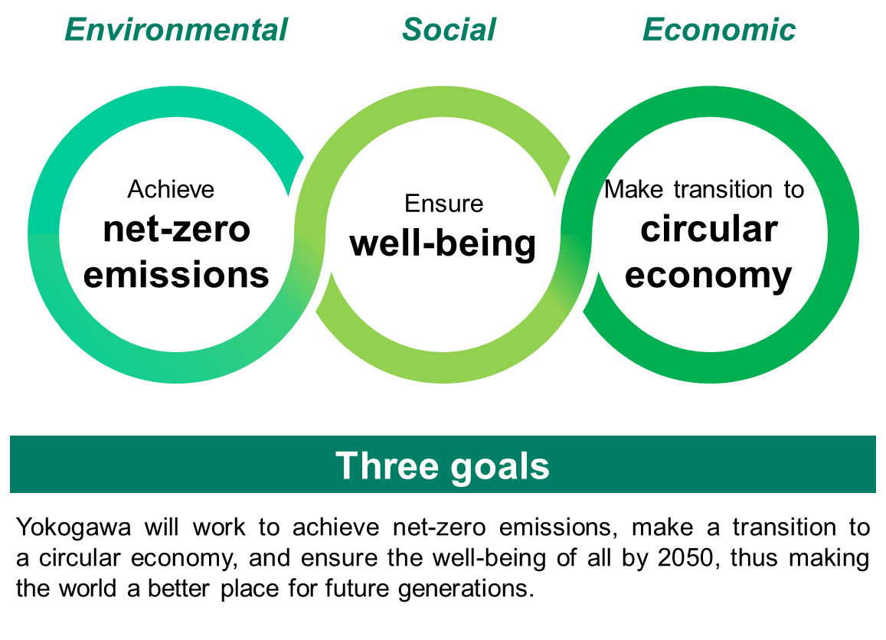
Achieve net-zero emissions; stopping climate change
Climate change is an urgent issue that requires a global response. We aim for net-zero emissions, which means that the greenhouse gas concentrations in the atmosphere do not rise due to the balance of emissions and the absorption of greenhouse gases, which can be accomplished through the introduction of renewable energy and efficient use of energy. We are also working to reduce the impact of natural disasters and respond to biodiversity issues.

Make the transition to a circular economy; circulation of resources and efficiency
The transformation from a one-way economy based on the take, make, and dispose model to an economy where resources are circulated without waste, and the transition to businesses that emphasize services, are under way. We aim to realize a social framework and ecosystem in which various resources are circulated without waste and assets are utilized effectively. We also are contributing to the efficient use of water resources and the supply of safe drinking water.

Ensure well-being; quality life for all
With the aim of achieving the physical, mental, and social well-being described in the 2030 Agenda for Sustainable Development adopted by the United Nations in 2015, we support people's health and prosperity through the achievement of safe and comfortable workplaces and our pursuits in such areas as the life sciences and drug discovery. We promote human resource development and employment creation in local communities, and diversity and inclusion.

Yokogawa sustainability policies: www.yokogawa.com/csr/policy

About Yokogawa
Yokogawa's global network of 113 companies spans 60 countries. Founded in 1915, the US$3.5 billion company engages in cutting-edge research and innovation. Yokogawa is active in the industrial automation and control (IA), test and measurement, and aviation and other businesses segments. The IA segment plays a vital role in a wide range of industries including oil, chemicals, natural gas, power, iron and steel, pulp and paper, pharmaceuticals, and food. Targeting this segment, Yokogawa helps companies maximize their profits by offering a wide range of highly reliable products and working with the subsidiary KBC Advanced Technologies to provide premium solutions and services. For more information about Yokogawa, please visit www.yokogawa.com/za

