PRESS RELEASE
6th July 2017

Tanaka Precious Metals
Tanaka Holdings Co., Ltd.

Tanaka Precious Metals to Exhibit at SEMICON WEST 2017

World’s leading supplier of precious metals’ bonding wire to unveil new ruthenium precursors;
New technology to support the microfabrication of next-generation semiconductors

SAN FRANCISCO, Calif., July 6th, 2017 - Tanaka Precious Metals (Tanaka) is pleased to announce that the company will be exhibiting at SEMICON WEST 2017, the world’s largest semiconductor related exhibition. The event will be held from Tuesday, July 11 through Thursday, July 13 at the Moscone Center in San Francisco, California.

At its booth, Tanaka will be unveiling its precious metal precursors for the first time, which are being effectively used in the microfabrication processing of modern semiconductors.
Semiconductor developments to improve performance are currently advancing with focus on semiconductor miniaturization. This miniaturization of semiconductors is an essential technology for the continued advancement of IoT, IoE and AI. Semiconductor technology nodes, which are currently reaching the 7 to 10 nanometer level (one nano is 10⁻⁹), are expected to advance to the 4 to 5 nanometer level by 2020.
Metal precursors are the compounds which are used as raw materials in the thin metal film formation technologies of chemical vapor deposition (CVD) (*1) and atomic layer deposition (ALD) (*2). These precursors are vaporized as organic metal complexes through MOCVD (*3), and are chemically vapor deposited on wafer surfaces. The electrical characteristics, high melting points, and other physical properties of precious metals are superior compared to other metals, and thus precious metal precursors are useful in the development of semiconductors. Ruthenium, in particular, has low resistance and exhibits a good affinity with the copper used in wiring, and therefore ruthenium precursors are gaining attention as an indispensable material for the miniaturization of next-generation semiconductors.
In addition to its world-leading top-selling bonding wire, Tanaka will also be exhibiting its low temperature baked paste for gold bonding, AuroFUSE™ as well as its ultra-fine wiring printing technology, SuPR-Nap. Other products that will be on exhibit include the company’s medical device component-grade precious metals, as well as its precious metal materials and processing technologies that Tanaka provides to various industrial fields.

Tanaka is a precious metals manufacturer with more than 130 years in the industry. The company has an expansive precious metals procurement network worldwide and is therefore able to provide a stable supply of precious metal precursors. Extremely precise molecular design is required to provide precursors with characteristics that are tailored to customer demands. With its many years of experience in precious metals and its extensive procurement network, Tanaka is able to supply high performance precursors tailored to meet specific purposes and demands by advancing with molecular design, while incorporating feedback from its customers.

As a leading company in precious metals, Tanaka supplies the processed precious metal products necessary in semiconductor manufacturing post-processes, such as high purity vapor deposition and bonding, as well as sealing materials and bonding wires. By supplying precious metal precursors for semiconductor manufacturing pre-processes as well, the company will be able to supply processed precious metal products for all semiconductor manufacturing processes moving forward. The company intends to also expand its business further to facilitate the miniaturization of next-generation semiconductors; essential for a computer-based society that will further enrich people’s lives.

*1 Chemical Vapor Deposition (CVD) Method: a method of sublimating materials to make thin films on wafers. Also known as Chamber Vapor Deposition (CVD).
*2 Atomic Layer Deposition (ALD) film formation method: a method to make thin film on a wafer surface at an atomic level.
*3 MOCVD (Metal Organic Chemical Vapor Deposition): Chemical Vapor Deposition using organometallic compounds as a metal source. The MOCVD method has an advantage that a thin film with a uniform thickness can be formed.

Outline Figure of Ru-MOCVD equipment
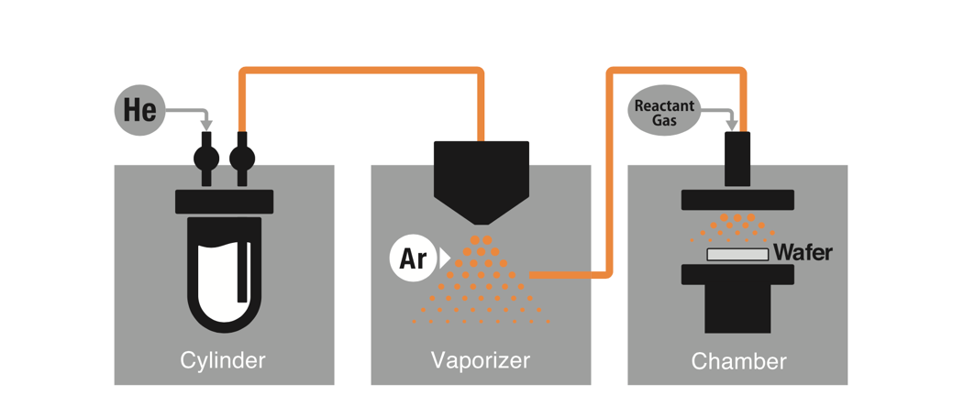

Semiconductor miniaturization and Precursor materials

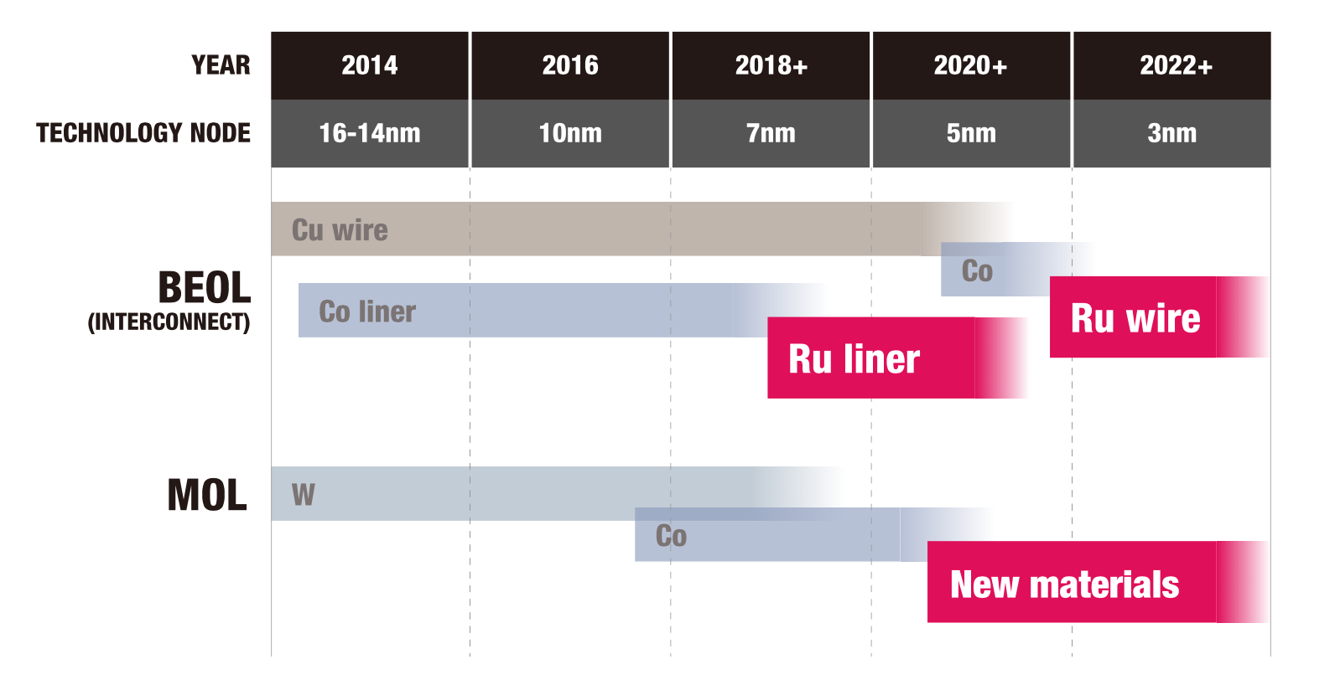

About the Exhibition in SEMICON WEST 2017

- Date and Time: July 11- 13, 2017
- Place: Moscone Centre, San Francisco, CA, USA
- Booth: 6278
- Main Exhibits: Introducing the Technological Power and Products of Tanaka Precious Metals.
＜Featured Products＞

Ruthenium Precursors | Tanaka will be introducing for the first time a precursor using the precious metal ruthenium, which is expected to realize miniaturization processing in next generation semiconductors. A precursor is a compound used as a raw material in a method of depositing a metal thin film, called CVD or ALD.
Low-Temperature Baked Paste for Au-Au Bonding, AuroFUSE™ | Tanaka developed a halogen-free gold paste that can be used for gold-to-gold bonding at 200°C by focusing on the low-temperature sintering properties of sub-micron size gold particles. This paste is made solely from sub-micron sized gold particles with a solvent that has low electrical resistivity (5.4μΩ-cm) and provides high thermal conductivity (150W/mK) metal bonds.
Flexible touch panel sensor using SuPR-NaP printing | Tanaka introduced its new, ultra-fine wiring printing technology for simple and high-speed printing of circuits over a wide area.
Medical Device Components | Tanaka will exhibit its medical device components making use of precious metals for optimum treatments and surgical procedures, such as for guidewires, catheters for intravascular medical treatments, and indwelling medical devices.
Innovative direct patterning plating technology | Introduction of plating technology that enables direct formation of micro-wires on a variety of materials with low resistance, by a low-temperature process at 100° or less, without requiring a vacuum environment or photoresist.

＜Additional products being exhibited＞
Bonding Wire | The world’s leading vendor of bonding wire used for semiconductor wiring for high-performance equipment, from general-purpose machines such as PCs and smartphones, to automotive electronics.
Precious Metals Cladding Materials | Produced using its own unique continuous bonding process, with precious metals clad on strips of copper and iron based alloys, Tanaka offers its multi-layer and multi-strip tapes of variable widths and thicknesses, for use with micromotors such as with sound/video, smartphones, the automotive field etc.  Tanaka is proud to hold a leading share of global production volume of over 40% of the precious metals cladding industry.
Recovery and Refinement Technology | Tanaka is introducing a new total system of recovery and refinement of used scrap materials containing precious metals, based on the criteria of “trust”, “safety” and “technology”.  Out of only five companies worldwide, Tanaka’s recycling technology allows it to be the only Japanese company to be designated as an officially certified inspection company by the LBMA (London Bullion Markets Association).

■Tanaka Holdings Co., Ltd. (Holding company of Tanaka Precious Metals)
Headquarters: 22F, Tokyo Building, 2-7-3 Marunouchi, Chiyoda-ku, Tokyo
Representative: Akira Tanae, Representative Director & CEO
Founded: 1885 Incorporated: 1918 Capital: 500 million yen
Employees in consolidated group: 3,476 (as of March 31, 2016)
Net sales of consolidated group: 1,026.7 billion yen (FY2015)
Main businesses of the group:
Strategic and efficient group management and guidance to group companies as the holding company at the center of Tanaka Precious Metals.
Website: http://www.tanaka.co.jp/english (Tanaka Precious Metals),
http://pro.tanaka.co.jp/en (Industrial products)
http://pro.tanaka.co.jp/en/elements/ (Applied Uses of Precious Metals)
* Tanaka Holdings adopted a holding company structure on April 1, 2010
<About the Tanaka Precious Metals>
Since its foundation in 1885, the Tanaka Precious Metals Group has built a diversified range of business activities focused on precious metals. Tanaka is a leader in Japan in terms of the volumes of precious metals handled. Over the course of many years, Tanaka Precious Metals has not only manufactured and sold precious metal products for industry, but also provided precious metals in such forms as jewelry and resources. As precious metals specialists, all Group companies within and outside Japan work together with unified cooperation between manufacturing, sales, and technological aspects to offer products and services. In addition, in order to make further progress in globalization, Tanaka Kikinzoku Kogyo welcomed Metalor Technologies International SA as a member of the Group in 2016.

As precious metal professionals, Tanaka Precious Metals will continue to contribute to the development of an enriching and prosperous society.

The five core companies in the Tanaka Precious Metals Group are as follows.
・Tanaka Holdings Co., Ltd. (pure holding company)
・Tanaka Kikinzoku Kogyo K.K.
・Tanaka Denshi Kogyo K.K.
・Electroplating Engineers of Japan, Limited
・Tanaka Kikinzoku Jewelry K.K.

Media Contact:
Annie Gudorf
Walker Sands Communications
312-648-6008
annie.gudorf@walkersands.com

