


Complimentary RECP & IEE Training at the NCPC-SA

Women’s complimentary training in Resource Efficient and Cleaner Production (RECP) and Industrial Energy Efficiency (IEE) is offered to women who register during the month of August 2017.

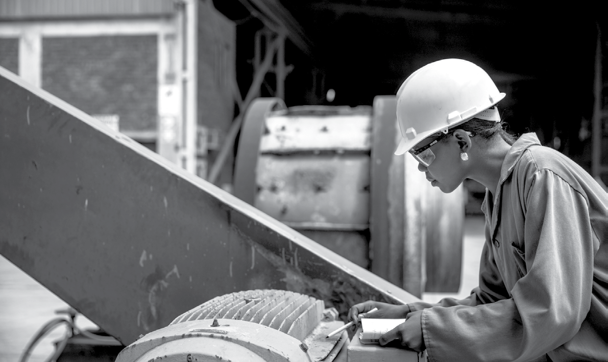
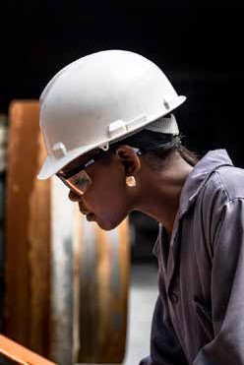
This includes NCPC-SA’s 1 and 2-day training courses held in Pretoria, Cape Town, Durban and Port Elizabeth up to the 31 March 2018. Please note that the following courses are excluded from this offer:

Energy Performance Management Indicators (EnPMI)
- All expert level courses
Our training courses specifically benefit people with academic backgrounds in engineering, natural sciences and environmental sciences.
Please share this opportunity with all your female colleagues. Registration details and dates are available on the NCPC-SA website.

Further information email: ncpcgreenskills@csir.co.za

Terms and Conditions
To qualify for the complimentary seat, the following criteria MUST be met: 1. Register for the course/courses of your choice online at ncpc.co.za during the month of August 2017 OR 2. Send an email to ncpcgreenskills@csir.co.za during the month of August 2017 expressing interest in attending. 3. Please register separately for each course online. Alternatively send an email to ncpcgreenskills@ csir.co.za clearly stating the course title, date and venue/province. Please visit: ncpc.co.za/ training for course dates and information.
4. The NCPC-SA will not accept any early or late registration / notifications even resulting from technical difficulties.





The NCPC-SA is the industrial resource efficiency and cleaner production programme of the dti, hosted by the CSIR.

Pretoria (012) 841 2264
Cape Town (021) 658 2779
Durban (031) 242 2319

Website www.ncpc.co.za
Email ncpc@csir.co.za
Follow us LinkedIn Twitter Facebook

