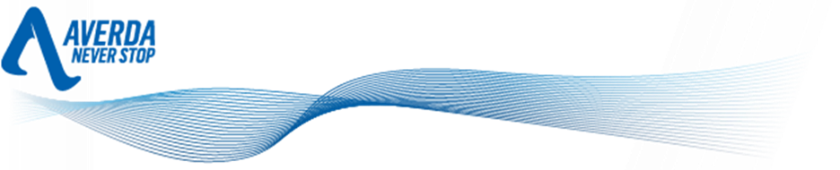

BEGINS

17TH July 2017

Averda announces major new investment in its South African operations

Since its arrival into the South African market in April 2015 with the acquisition of a majority stake in Wasteman Holdings, Averda’s operations in the region have gone from strength to strength. Spurred by a number of major new contract wins, including three year municipal waste collection contracts in the City of Cape Town and on-site waste management service contracts for major industrial players in the Cape and Gauteng regions, Averda’s Group Board have today announced a stronger drive towards investing in new innovative solutions and further diversification of its waste related business.

Building on Averda’s existing integrated waste management offerings, the new funding will substantially expand Averda’s waste-handling capacity and infrastructure, and signals the Board’s commitment and long-term investment in South Africa. Operations will be bolstered by the following:
- The acquisition of two medical waste companies, with the aim of building a world-class end-to-end national healthcare waste solution. Current facilities will be upgraded in partnership with state-of-the-art specialist technology providers, alongside investment into a new medical waste treatment plant.
- Further investment in Vlakfontein hazardous waste landfill to further promote international best practice in environmentally low impact waste storage.
- Introduction of new technologies in on site waste minimization and handling tailored to the needs of the producers in the various industrial sectors

Commenting on these initiatives Malek Sukkar, Averda CEO said,

“This is an unequivocal declaration of Averda’s commitment to doing business in South Africa. This is a market with huge opportunities to develop innovative solutions to one of the most pressing challenges facing the world today: the sustainable treatment and disposal of the myriad forms of waste produced by our societies. While building new low-impact waste storage facilities and pioneering medical waste management solutions, we also aim to bring new jobs to the communities we serve. We are hugely excited for our future here in South Africa, and its vital role to our continued strategic growth.”

ENDS

For more information please contact Ms. Melvi Todd, Marketing Manager, South Africa, on (021) 908 9008 or info.sa@averda.com

Note to Editors: About Averda South Africa
- Averda is headquartered in Dubai, with regional operations centres in Abu Dhabi, Johannesburg and Casablanca. It operates in 14 countries on three continents: Angola, Gabon, Republic of Congo, Morocco, South Africa, Jordan, Lebanon, Oman; Qatar; Saudi Arabia; UAE; Ireland and the United Kingdom.
- In 2016, Averda established its South African operation through a number of acquisitions, including Wasteman, SharpMed and Solid Waste Technologies (SWT) to become Averda South Africa.
- Averda South Africa now offers a complete waste management solution under one banner and draws on global expertise and experience to offer South Africa end-to-end waste management solutions, from the point of generation to suitable diversion (e.g. recycling, composting etc.) or responsible landfill.
- Averda South Africa offers services in the following portfolios - general waste collection, hazardous waste management, onsite waste management, specialised industrial cleaning, pipe inspection and analysis, landfill management and healthcare waste management.

