Merchandise your products with a Do-It® Round Hole Hang Tab

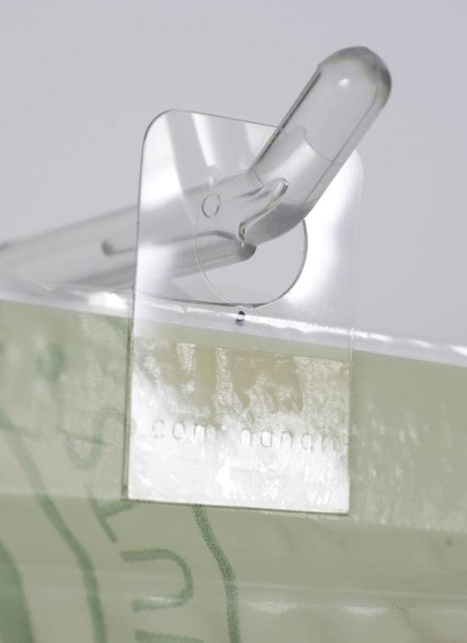
Do-It® Round Hole Hang Tabs are sold exclusively in South Africa by Pyrotec PackMedia. These hang tabs are strong, easy to apply and are distinguished by the round hang hole style which has been designed for hanging smaller, lightweight items on single-wire peg fixtures, such as tissue packets, sachets and sweet packets.
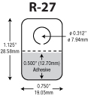
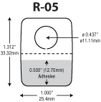
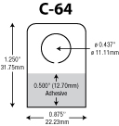
Pyrotec PackMedia stocks four variants of the round hole hang tab. What differentiates them is their recommended product display weight; i.e. how many grams the hang tab can hang. Another great feature of these hang tabs is that they are clear so that they do not interfere with your brand/product message.
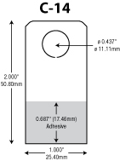

The round hole hang tab allows you to display products vertically, face-forward anywhere in a retail environment, thereby enhancing product visibility, increasing impulse purchases and boosting brand awareness.
For more information on our round hole hang tabs, visit our website on http://www.packmedia.co.za/products/merchandising/ or contact us on 021 787 9600 or do-it@pyrotec.co.za.

