Endress+Hauser launched a new online information and shopping platform
Endress+Hauser has recently launched a NEW online information and shopping platform called the E-direct Shop, to showcase its entry level product portfolio.
Endress+Hauser’s new E-direct shop, offers the following advantages:
- Easy and intuitive handling
- Full entry-level product offering and online ordering possibilities
- Simple product version selection
- Best value for money
- Transparency thanks to a price/quantity display
- Short delivery times

Treat yourself to a short tour and see what is offered!

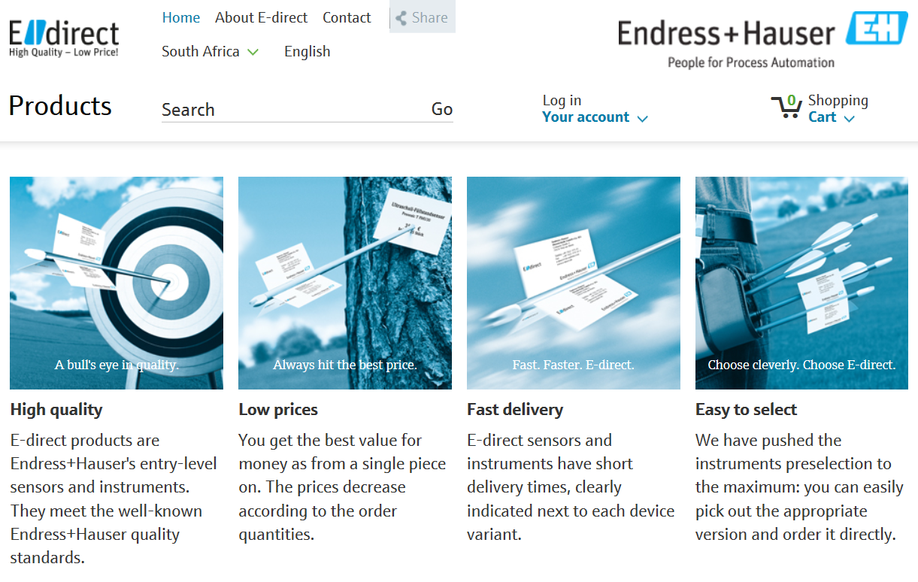
To start your free tour, please click here http://bit.ly/edirect_shop_za

Endress+Hauser’s E-direct Shop

For more information, please contact:
Deshini Govender
E-Business Specialist
deshini.govender@za.endress.com

