New building inaugurated for company anniversary

Endress+Hauser Flowtec AG looks back 40 years – world-leading manufacturer for flow measuring technology
The market for high-quality flowmeters has been growing for decades, with the name Endress+Hauser Flowtec AG in Reinach, Switzerland, closely linked to the last 40 years. “The new facility, finished to coincide with our company anniversary, is a symbol of this growth as well as a commitment to our production and business location in the Basel region,” says Managing Director Dr Bernd-Josef Schäfer.
Endress+Hauser Flowtec’s success story began in the middle of the 1970s. In order to enter the water and wastewater market that was emerging at that time, Endress+Hauser acquired the company ‘Flowtec’ in Bern in 1977. The production of flowmeters in former military barracks in Reinach, Switzerland, started with only three employees. In the meantime, Endress+Hauser Flowtec has become a global company with over 1,700 employees.
Work was done on demand during the company’s founding years. “Whereas today,” points out Bernd-Josef Schäfer, “our production with its state-of-the-art technology and logistics spans six sites across the globe in Switzerland, France, the USA, India, China, and for the last five years in Brazil. This infrastructure has enabled us to produce three million flowmeters to date in accordance with the required quality standards.”
Sustained growth requires new facilities
For decades, demand for high-quality flowmeters in the process industry has shown no signs of slowing down. Liquids and gases that are transported through pipelines in massive quantities every day need to be measured and billed with greater accuracy than ever before – primarily due to increasingly stringent regulations and growing demand for quality across the globe. “In addition, there are process requirements that vary greatly depending on the industry. For this reason, we need to offer our customers a much wider range of flowmeters today than was the case 20 or 30 years ago. This requires further development of our measuring devices as well as the expansion of our production locations,” explains Bernd-Josef Schäfer.

The new facility in Reinach has been built at the cost of 50 million Swiss francs. This recently completed extension offers an additional 25,000 square meters of space for offices and production, which brings the facility to a total of 74,500 square meters. “This enabled us to restructure the individual production lines and make them significantly more effective. This allows for greater efficiency in the use of expensive machinery and equipment now,” says Schäfer. Endress+Hauser Process Solutions AG, the competence center for process automation and digital communication, is also housed in the new facility.

The new facilities are equipped with state-of-the-art building technology, in particular with a comprehensive energy management system and a photovoltaic system with approximately 3,000 square meters of usable space – one of the largest in the Canton of Basel-Landschaft. This means that nearly 500,000 kilowatt hours of electricity can be produced annually under optimal conditions, corresponding to the requirement of 100 single-family homes. Overall, Endress+Hauser Flowtec fulfills 5 percent of its own power requirement with this solar system.

Constant innovation guarantees customer satisfaction
The success of Endress+Hauser Flowtec is based on many factors. “For over 40 years, we have continuously managed to stay one step ahead of the competition,” says Schäfer. “Innovative products and sophisticated production methods enable us to focus continuously on the needs of the future. Digitalization and the Industrial Internet of Things, for example, offer completely new perspectives for comprehensive and reliable process control, which we hope will help us to sustain long-term growth.”

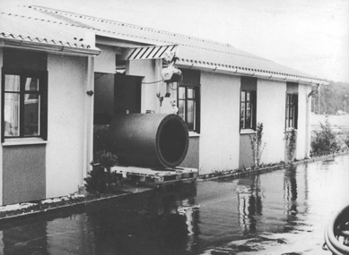
EH_flowtec_1.jpg
Endress+Hauser manufactured its first electromagnetic flowmeters in a military barrack (1977).
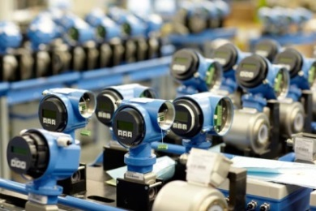
EH_flowtec_2.jpg
Today, Endress+Hauser’s production boasts state-of-the-art flow measuring technology production logistics and spans six sites across the globe in Switzerland, France, the USA, China, India and Brazil.
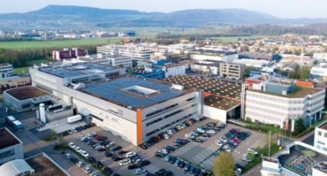
EH_flowtec_3.jpg
The new Endress+Hauser facility completed in 2017 in Reinach, Switzerland, provides an additional 25,000 square meters of usable space for offices and production. The solar system installed on the roof of the building provides up to 500,000 kilowatt hours of electricity per annum.
For further information, please visit www.za.endress.com

From: Endress+Hauser (Pty) Ltd
Submitted by: Su-Anne Willemse
Tel: (011) 262 8080
Email: suanne.willemse@za.endress.com

