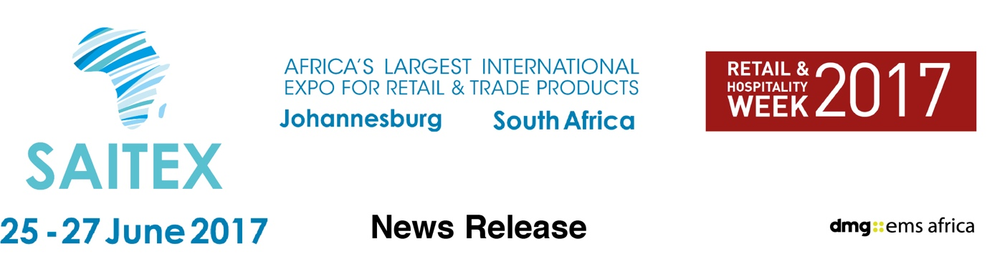

June 20, 2017

Free power: African launch of new batteries you recharge from saltwater

Hydra Light launches fuel cells at Johannesburg show next week that recharge by dipping in seawater, offering hours of free power possibilities without an electrical source

After winning innovation awards around the world, Hydra Light, an Australia company, this week launches its innovative Hydra-Cell technology at the SAITEX show in Johannesburg, June 25 to 27.

Hydra-Cell is a proprietary oxygen fuel cell technology that powers flashlights and lanterns, or charges phones and powers USB devices. Simply dip the Hydra-Cell in regular water mixed with a bit of salt. Seawater works perfectly too. Depending on the drying effects of the surroundings, re-dip the cells every 24 to 72 hours to maintain the energy output.

For its Africa launch, Hydra Light is at SAITEX 2017 – Africa’s biggest retail products sourcing expo - seeking established distributors across sub-Sahara Africa and Asia. Hydra Light management will be demonstrating their entire line of lantern, flashlight and charging products at the expo.

How does hydra light compare?

A single replaceable Hydra-Cell will generate over 300-hours of light, delivering power output greater than 30 AA premium alkaline batteries.

It will change the lives of millions who live off the electrical grid: the light from a single Hydra-Cell can replace over seven litres of fuel used in a kerosene lamp. And, a kerosene lamp won’t charge your phone.

What about solar? Solar is good, there are things we all need to know. A portable solar light requires conscious effort to position in the sun throughout the day. There is a risk of theft of solar lanterns left unattended. Solar performance may be reduced from 10 per cent to 80 per cent on cloudy or raining days, including the extended monsoon season. Hydra Light has none of those risks, it works day or night, rain or shine,

A replacement Hydra-Cell, normally retails at a fraction of the cost of the 30+ premium AA alkaline batteries it replaces.

The background
Did you know, as reported by the EPA, each year Americans throw away more than 3 billion batteries? That’s about 180,000 tons, many of which are single use alkaline batteries – an expensive and environmentally damaging habit. Placed end to end, these dead batteries would circle the world six times! Further, the World Health Organization reports over a billion people live unable to access the electrical power grid, 600 million of those people live in Africa. An estimated 77 billion litres of kerosene are consumed each year for kerosene lighting, releasing millions of tons of CO₂ and particulate matter into homes, and into the atmosphere. Hydra-Light has the potential to make a very significant difference.
Hydra-Light lighting and charging products evolved from their search into portable, safe and ecologically friendly alternatives to devices that use conventional batteries. With their patent pending Hydra-Cell, Hydra-Light lanterns and chargers offer extended usage times and lower operational costs.

Now you can light your way without the need for disposable batteries. A must-have in emergency situations and a great alternative for camping, boating and other off-the-grid adventures, all you need is water and a bit of salt.

SAITEX is co-located with Africa’s Big 7 - the continent’s premier food & beverage expo – and The Hotel Show Africa 2017, one of the world’s most successful hospitality event brands takes its inaugural step into Africa. The three shows together create the largest Retail & Hospitality gathering in Africa.

You may download more press pictures at www.hydralight.net/media-kit/

Press information

SAITEX 2017 runs from June 25-27 at The Gallagher Convention Centre, Midrand, Johannesburg, South Africa. SAITEX is Africa's largest international product sourcing expo. It includes consumer electronics and home appliances, homeware and household, building materials supplies and tools as well as fashion and giftware. It attracts hundreds of manufacturers and suppliers showcasing the most advanced products. more details www.saitexafrica.com

It is part of Retail & Hospitality Week 2017 and co-located with Africa’s Big 7, the continent’s leading food and beverage industry trade expo, and The Hotel Show Africa 2017, which brings one of dmg events’ most successful brands to the continent for the first time.
SAITEX and Africa’s Big 7 were was acquired in 2016 by dmg::events Middle East, Asia & Africa, a wholly owned subsidiary of Daily Mail & General Trust (DMGT), run by dmg::ems Africa.

dmg::events Middle East, Asia & Africa was founded in 1989 and has operated in the Middle East since 1995 and owns some the region’s biggest shows including The Hotel Show and The Big 5. Headquartered in Dubai, UAE and with satellite offices in India, South Africa and the UK, dmg events Middle East, Asia & Africa organises more than 80 events across the Middle East, Africa, Asia, North America and Europe. The events attract more than 250,000 customers every year and provide opportunities for trade professionals to do business, network and learn. For more information visit www.dmgeventsme.com
DMGT manages a balanced multinational portfolio of entrepreneurial companies, with total revenues of almost $3bn, that provide a diverse range of businesses and consumers with compelling information, analysis, insight, news and entertainment. The company employs more than 10,000 people and is listed on the London Stock Exchange. DMGT aims to provide the highest quality information, insight and services to attractive growth markets in innovative ways, building on a track record of earnings and dividend growth. For more information visit www.dmgt.com

For further information, please contact:

Gary Wright,

Head of PR & Comms, dmg-ems Africa

E: garywright@dmgeventsme.com

T: +27 (0) 11 783 7250

W: www.dmgeventsme.com

A: P O Box 650302 BENMORE 2010, South Africa

