HAZLETON PUMPS TAKES TOP HONOURS AT 3rd ANNUAL
SEIFSA AWARDS FOR EXCELLENCE.

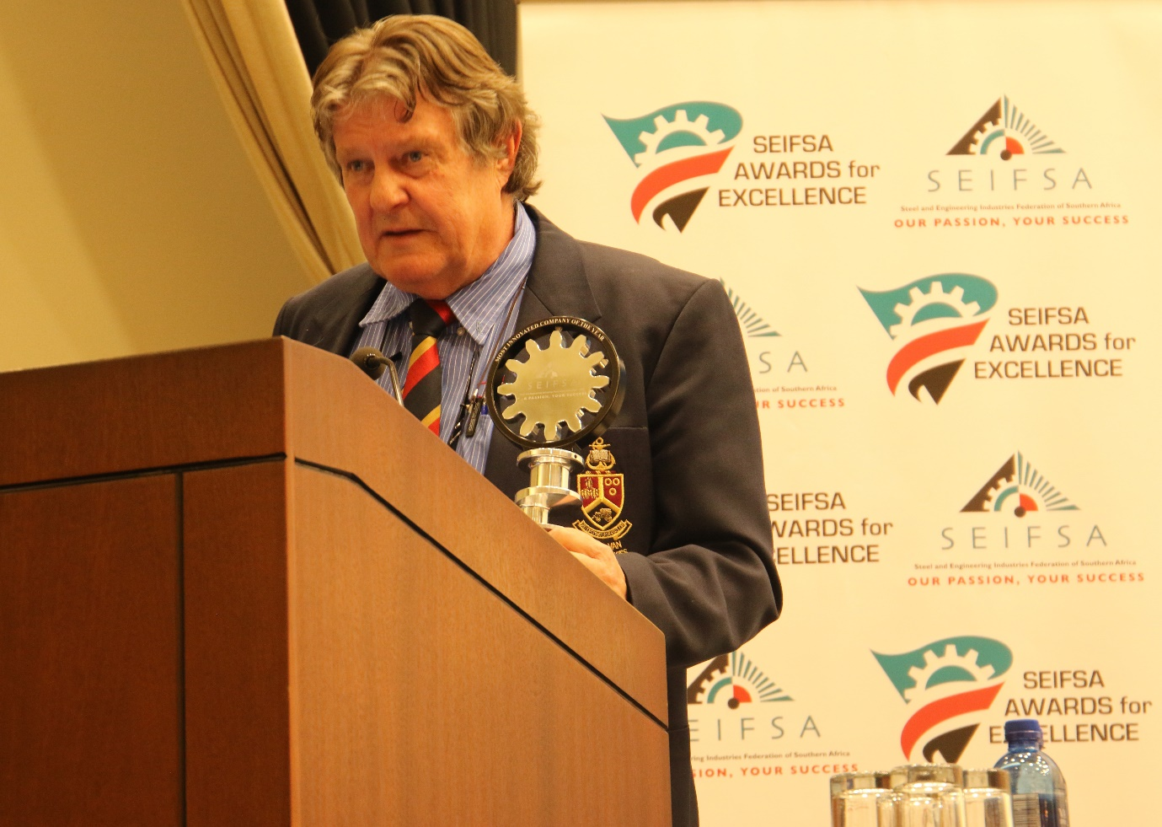
Founder of HAZLETON PUMPS, Thys Wehmeyer, acknowledges receipt of two Awards at the third Annual SEIFSA AWARDS for EXCELLENCE

The third annual SEIFSA Awards for Excellence gala ceremony, honouring companies that have excelled during 2016 in the metals and engineering ceremony was held in Sandton in May 2017.

The ceremony hosted in partnership with Industrial Development Corporation was held on its own for the first time and not as part of the annual Southern African Metals and industry Indaba.

A family owned business situated in Sunderland Ridge, Centurion, HAZLETON PUMPS is exemplary of a company which is at the forefront of not only innovation but also committed to customers.

The company won the two main awards being the “Most Innovative Company” award as well as the “Best Customer Service of the Year” in 2015 and in 2017 this achievement was repeated, and is proof of HAZLETON PUMPS continuous commitment to the solving of customers’ pumping problems with customised pumping solutions and not merely selling pumps.

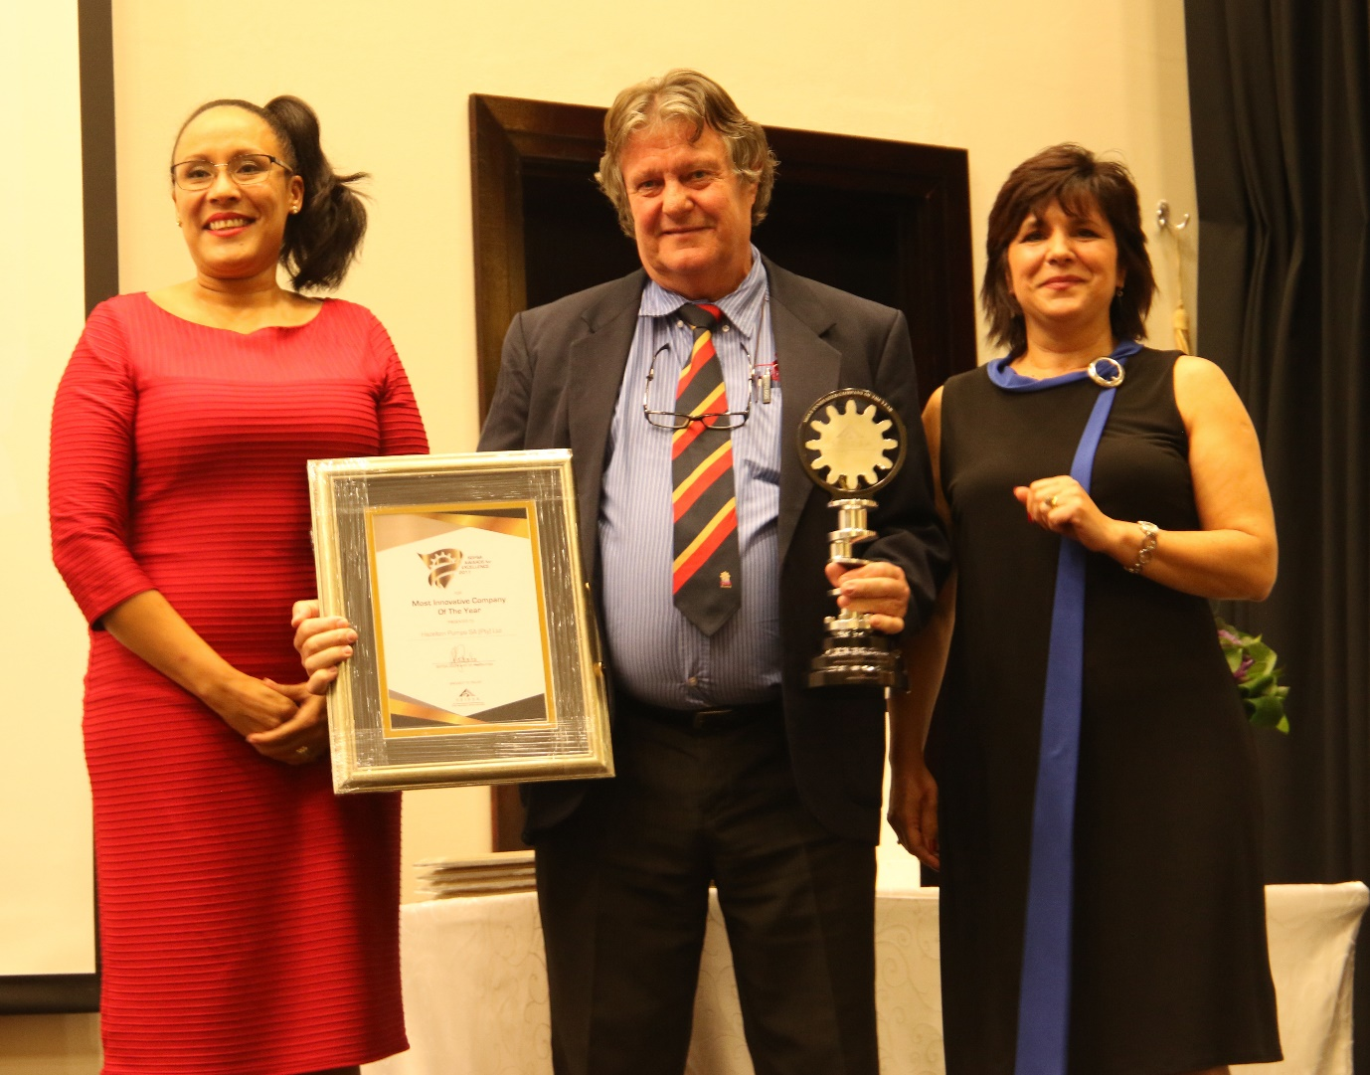
Thys Wehmeyer accepting the award for the most Innovative Company of the Year at the SEIFSA Awards of Excellence

HAZLETON PUMPS innovation saw the company registering a whopping 156% growth in turnover in 2016 and an impressive 75% growth in staff members.

Through the local manufacture of the HIPPO High-Head Series Submersible pump system and the Solid Separation System using submersible slurry pumps which are used to solve acid mining drainage problems in deep shaft mining the company has showed great ingenuity and outstanding levels of engineering it designed, developed and manufactured these specific and specialised pumps systems in accordance with ISO 9001 and SANS 60079-1, in response to their customer’s requirements and in corroboration with its customers.

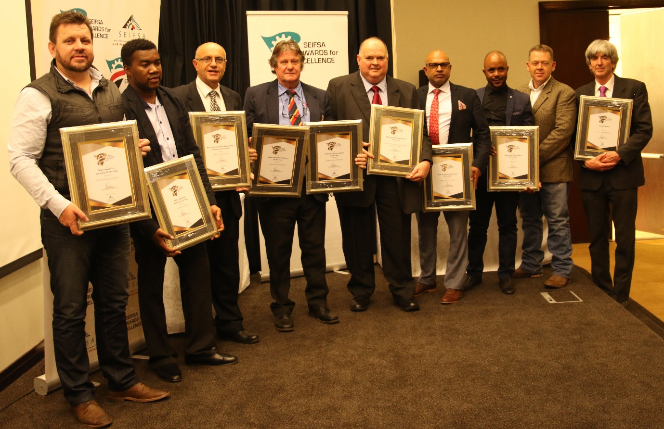
Group photo of the Award Winners at the 3rd Annual SEIFSA Awards of Excellence 2017.

The winners of the various categories at the 3rd Annual SEIFSA Awards of Excellence 2017 are:
Most Innovative Company of the Year Hazleton Pumps
Best Customer Service of the Year Hazleton Pumps
Artisan of the Year Vesco Plastics
Best Corporate Social Responsibility
of the Year ABB
Most Transformed Company of the Year Weir Minerals
Health and Safety Company of the Year SGB Group
Outstanding Contribution to SEIFSA Mr. Penson
Top Student of the Year Mr. Tsakane Themba
Association of the Year The Electrical Engineering and Allied Industries Association (EAAIA)
Company of the Year HC Heat Exchangers.

