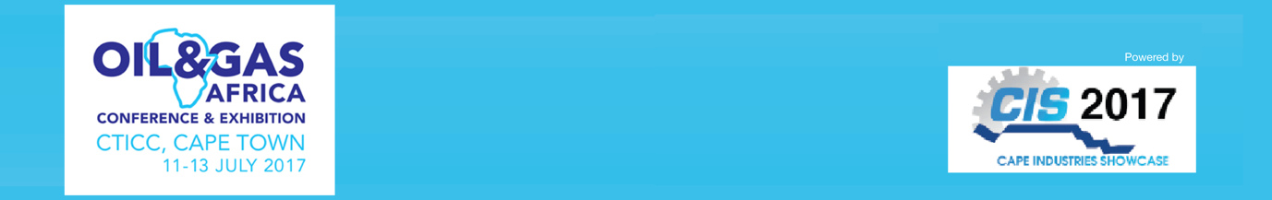

NEWS RELEASE

April 6, 2017

Why engineers from across sub-Saharan Africa will head for the Western Cape in July

Cape Town is the hub of the oil, gas & petrochem sector for sub-Saharan Africa and the city hosts Oil & Gas 2017, a three-day conference and expo

Engineers are being invited to Cape Town this July for Oil & Gas 2017 with its unique three-day conference, with presentation on issues from fracking to refining.

“Western Cape is the hub of sub-Saharan oil industry’s midstream and downstream oil industry and this year ensuring a convenient and attractive location for senior engineers,” says Brad Hook, who is organiser dmg-ems Africa’s Commercial Director.

“The conference will set the agenda for the region, influence policy and explore the economic potential focused on the importance of continued development and the associated benefit to Africa’s oil and gas sector.”

Oil & Gas 2017 also attracts international suppliers to the exhibition halls, providing them and visitors a comprehensive platform to meet prospective business partners face-to-face, says Hook.

“This is a networking event, a top-level conference and an opportunity to meet suppliers. The conference programme will cover the key future issues, including new exploration techniques, refining techniques and an examination of renewables and how they fit into government’s future energy plans.”

Oil & Gas Africa 2017 was acquired last year by global exhibition and conference organiser dmg events MEA adding to its worldwide energy portfolio that includes ADIPEC, which attracts 80,000 visitors to the UAE in the world’s largest oil expo outside of North America.

Oil & Gas Africa 2017 runs from July 11-13 at the Cape Town International Conference Centre with a three-day conference and exhibition.

Oil & Gas Africa 2017, July 11-13 at the Cape Town International Conference Centre. More details www.africaogp.com

Press information

Oil & Gas Africa 2017 runs from 11-13 July at the Cape Town International Conference Centre. It is the sole engineering supply chain expo serving the upstream, midstream and downstream sectors, incorporating oil & gas, maritime, offshore and logistics.

Cape Industries Showcase – which included Oil & Gas Africa 2017 - was acquired in March 2016 by dmg ems Africa events, part of dmg events Middle East, Asia & Africa, a wholly owned subsidiary of Daily Mail & General Trust (DMGT).

dmg events Middle East, Asia & Africa was founded in 1989 and has operated in the Middle East since 1995 and owns some the region’s biggest shows including The Hotel Show and The Big 5. Headquartered in Dubai, UAE and with satellite offices in India, South Africa and the UK, dmg events Middle East, Asia & Africa organises more than 45 events across the Middle East, Africa, Asia, North America and Europe. The events attract more than 250,000 customers every year and provide opportunities for trade professionals to do business, network and learn. For more information visit www.dmgeventsme.com
DMGT manages a balanced multinational portfolio of entrepreneurial companies, with total revenues of almost $3bn, that provide a diverse range of businesses and consumers with compelling information, analysis, insight, news and entertainment. The company employs more than 10,000 people and is listed on the London Stock Exchange. DMGT aims to provide the highest quality information, insight and services to attractive growth markets in innovative ways, building on a track record of earnings and dividend growth. For more information visit www.dmgt.com

For further information, please contact:

Gary Wright,

Head of PR & Comms, dmg-ems Africa

E: garywright@dmgeventsme.com

T: +27 (0) 11 783 7250

W: www.dmgeventsme.com

A: P O Box 650302 BENMORE 2010, South Africa

