Dear ,

Advanced automation can improve virtually any process, anywhere, and has the potential to grow the South African economy and create jobs.

Industrie 4.0 may be a relatively new term, but many enterprises across the developed world are well advanced in implementing Industrie 4.0 technologies and standards. Industry leaders participating at the upcoming Africa Automation Fair and Connected Industries conference note that Industrie 4.0, the catchphrase describing the new wave of digitised and connected automation technologies now revolutionising industry, can be applied anywhere.

The Africa Automation Fair and Connected Industries conference will be staged alongside Pollution and Waste Technology Africa from 6-8 June 2017 at the Ticketpro Dome in North Riding.

I have included a press release incorporating thought leadership from industry leaders on the progress of advanced automation in South Africa. For further information, images, or interview, please don’t hesitate to contact us.

Enjoy your day further.

Kind regards, 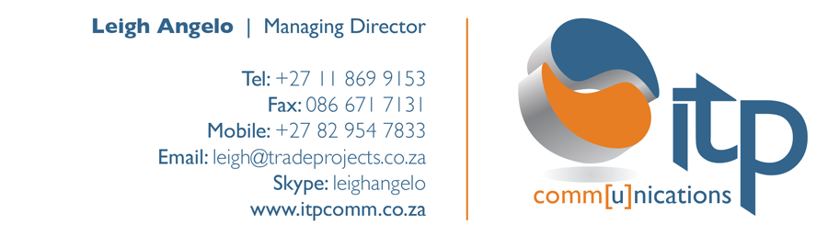

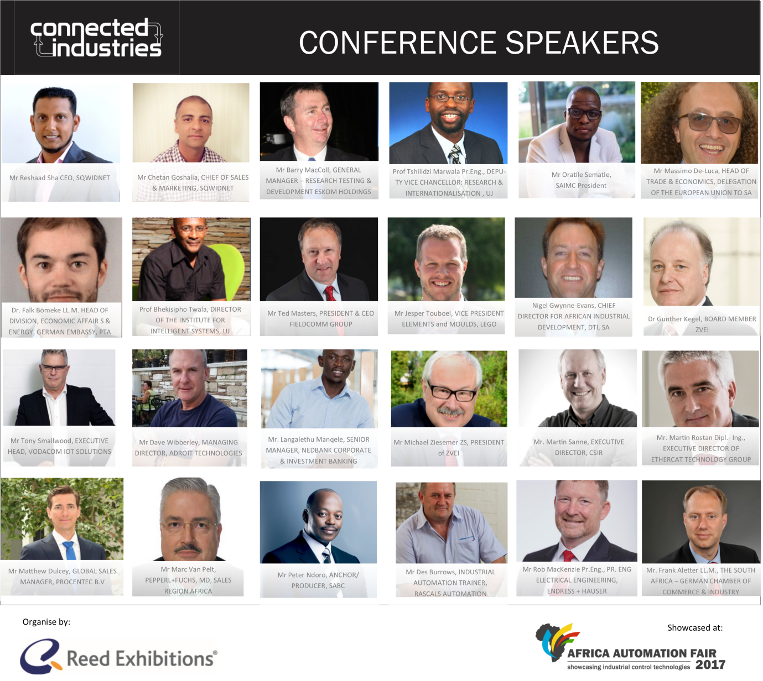

PRESS RELEASE:
Industrie 4.0 set to improve all processes, grow economy

Advanced automation can improve virtually any process, anywhere, and has the potential to grow the South African economy and create jobs.

Industry leaders participating at the upcoming Africa Automation Fair and Connected Industries conference note that Industrie 4.0, the catchphrase describing the new wave of digitised and connected automation technologies now revolutionising industry, can be applied anywhere.

Frikkie Streicher, Business Development Manager at VEGA Controls SA, says automation is not just for the manufacturing sector. VEGA’s radar technologies, for example, are in use everywhere from residential homes and farms through to petrochemical plants. “Wherever there is a process, automation can improve it,” he says. “Our instruments are used in wide variety of applications – from car service stations through to Sasol plants. We even have farmers using our technology to measure and help control their irrigation systems and water supplies; and we have collaborated with North West University on research around water saving technologies for drought-stricken areas of the Northern Cape.”

Marc Van Pelt, MD of Pepperl+Fuchs Africa and member of the board of the European Chamber of Commerce; SAIMC and IIG, notes that not all automation is the same: “Older cars, for example, are partially automated: they have a few dashboard controls making limited data available. But a fully connected car with advanced automation technologies does so much more – it tells you proactively when to go for a service, replace brake pads and so on. Not only is the availability of the car significantly improved, but also cost controls and efficiencies are improved. Germany’s Industrie 4.0 trend is about making automation systems more efficient and achieving faster and smarter responses. If you apply these principles to automation processes in manufacturing plants, the benefits are significant.”

SA lags on Industrie 4.0

Industrie 4.0 may be a relatively new term, but many enterprises across the developed world are well advanced in implementing Industrie 4.0 technologies and standards. South Africa lags, however.

Barry Elliott, Managing Director Sub-Sahara at Rockwell Automation, notes: “The majority of US manufacturers believe that Internet of Things (IoT) will have significant impact on their business over the next five years, but fully one third have no plans to develop a strategy to apply these technologies. Add to that roughly another third that are planning to develop a strategy, this leaves you with less than one third of manufacturers that have a strategy in place and are some way through the implementation thereof.”

“Putting this into a South African context, and assuming similar numbers, then progress is pretty slow. If one assumes a slower progression than the US, the numbers naturally look even worse,” he says. “That being said, South Africa has a myriad of multinational manufacturing organisations that have operations in South Africa. As these companies typically compete on a global stage, their progress in deriving value from IoT technologies can be quite high. This is heavily dependent on the industry sector they fall in, though.”

A key factor in the way of South Africa’s progress is specialised skills, say Streicher and Van Pelt.
“There is a push in South Africa to introduce specialised automation engineering degree courses in the country, which would contribute to Industrie 4.0 development,” says Van Pelt. “Currently, we do not have sufficient advanced automation skills in South Africa to drive major change. A better university skills outflow and the inclusion of more black engineers in the South African market will support efficiency in processing and boost the economy as a whole.”

The big automation picture

“The big picture we need to look at is how competitive is South Africa’s economy in global context?” Van Pelt says. “We have much catching up to do, and we have to strive to become more competitive. Automation drives the productivity and efficiencies we need to grow the economy.”

Both van Pelt and Streicher reject the notion that automation can cost jobs. “In some areas that may be true, but in general automation improves costings and strengthens the economy, which improves competitiveness and as such, results in job creation in the long term,” Van Pelt says.

Streicher notes: “Humans will always be the interface between the process and the machine, so automated industries will continue to create employment. In addition, the more automation you have, the more industry you stimulate – downstream and lateral industries emerge. So effective automation creates more industries with more jobs as a result.”

Elliott adds: “Events such as Africa Automation Fair are important for the industry as whole as they provide a platform for vendors to showcase their technologies and value propositions, but far more importantly, provide a compact and concise forum for manufacturers to see what the market has to offer them in their quest to become more productive. Whilst these types of events are often perceived to be purely targeted at technical people, there is generally significant benefit to be derived also for company managers and executives.

The implementation of an IoT strategy and the technologies that may be required to do so, is very much an executive decision because organisations will often have to implement significant change management strategies to derive significant benefits. And these aspects are all about people and organisational processes, and have little to nothing to do with technology.”

VEGA Controls SA, Pepperl+Fuchs and Rockwell Automation, will be the Platinum sponsors of the Connected Industries conference, where IoT/Industrie 4.0, its potential and challenges will come under discussion.

The Africa Automation Fair and Connected Industries conference will be staged alongside Pollution and Waste Technology Africa from 6-8 June 2017 at the Ticketpro Dome in North Riding. Organised by Reed Exhibitions, it will focus on the changes wrought by the Fourth Industrial Revolution, assessing its global impact, the technology and infrastructural requirements behind the revolution and the impact it will have on efficiency and quality. The conference has drawn both local and international attention with endorsements from Department of Science and Technology, the European Union Embassy and Chamber of Commerce; the German Embassy and Chamber of Commerce and Industry; the Black Management Forum; the Universities of Pretoria and Johannesburg; industry bodies SAIMC and the IIG and leading enterprises. For more information on the conference, delegate seats and the exhibition contact info@connectedindustries.co.za or www.africaautomationfair.com

Ends
Issued by ITP Communications on behalf of Reed Exhibitions. For further information please contact Leigh Angelo or Carol Tinline at Tel: (011) 869 9153 or email leigh@tradeprojects.co.za



