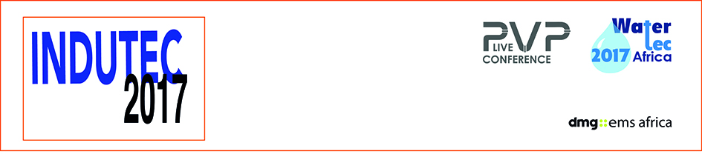

NEWS RELEASE

May 18, 2017
INDUTEC 2017 Day 2 – Why moves toward water security offer huge opportunities for innovative suppliers

Pump, valves and pipes manufacturers exhibiting in Johannesburg are told their products are vital to the future water supply that will drive economic growth

The conference agenda set the tone for the second day of INDUTEC 2017 in Johannesburg today as the preservation of this vital resource became the focus.

As visitors began arriving, many were drawn to the second day of the PVP Live conference, whose first speaker was Peter Telle of Ultra Control Valves talking about reducing water loss.

And South African based MI Power saw strong interest in the first direct current (DC) solar powered sewage pump in the country.
Peter Mango, Sales Manager of MI Power said there were huge benefits to using solar power in areas where supply might be unreliable.
“We have already met potential clients here at INDUTEC, and they were showing great interest in the pump alongside our existing borehole submersible pump,” he said. It can also be used to maintain old unused mining shafts with flow rate of up to 700,000 litres an hour.

Sustainable pumping solutions is one positive for the future but maintaining the region’s water supply is vital for economic expansion.

Leaks are a part of every water, or fluid, supply system in the world, but in southern Africa, the losses take on greater importance following three years of drought.

In South Africa, most of the country has faced some restrictions in recent months and in Cape Town real dam levels are at just 12 per cent and the authorities are set to implement an upgraded ban on external drinking water supply within weeks.

Reducing the pressure, especially during low demand, can offer huge savings, visitors to INDUTEC PVP Live 2017 conference were told yesterday.

Peter Telle explained in simple language how pressure can be reduced in three different ways and while pressure reducing valves (PRV) are the natural choice they only really operate at a 3:1 ratio (reducing pressure for example from 12 bar to 4), but sometimes that’s not enough, he said.

There are four or five pump brands on sale in South Africa, some operate by a timer, others by detecting changes in demand and alter flow automatically. They cost around Rand 50,000 ($3,700) but they are maintenance intensive and he said maintenance was “too complicated for African conditions”.

He showed the audience how a simpler system could work well in developing nations to reduce water loss through leaks and talked about a new acquired ratio valve (ARV) with no controls and a Maric flow valve, which is able to operate with soiled water.

His session acted a taster for the third day and final day of INDUTEC 2017, which hosts a one-day conference focused on preserving southern Africa’s supplies

To ensure future investment in the country and the growth of the economy, it is vital that southern Africa offers a reliable water supply to ensure foreign investment and financing improvements in supply.

INDUTEC 2017 continues tomorrow (Friday) and full details can be found on the website www.indutecafrica.com register for entry here www.indutecafrica.com/enquire-about-visiting

Press information

INDUTEC 2017, which runs from May 17 to 19 at The Gallagher Convention Centre in Johannesburg. It is operated by dmg-ems Africa, part of dmg events Middle East, Asia & Africa.

Pumps, Valves and Pipes Africa 2017, is the 10th edition of the largest and most comprehensive trade-show dedicated to the industries that are involved in the conveyance of liquids, gasses and slurries.

dmg events Middle East, Asia & Africa was founded in 1989 and has operated in the Middle East since 1995 and owns some the region’s biggest shows including The Hotel Show and The Big 5. Headquartered in Dubai, UAE and with satellite offices in India, South Africa and the UK, dmg events Middle East, Asia & Africa organises more than 45 events across the Middle East, Africa, Asia, North America and Europe. The events attract over 250,000 customers every year and provide opportunities for trade professionals to do business, network and learn. For more information visit www.dmgeventsme.com
DMGT manages a balanced multinational portfolio of entrepreneurial companies, with total revenues of almost $3bn, that provide a diverse range of businesses and consumers with compelling information, analysis, insight, news and entertainment. The company employs more than 10,000 people and is listed on the London Stock Exchange. DMGT aims to provide the highest quality information, insight and services to attractive growth markets in innovative ways, building on a track record of earnings and dividend growth. For more information visit www.dmgt.com

For further information, please contact:

Gary Wright,

Head of PR & Comms, dmg-ems Africa

E: garywright@dmgeventsme.com

T: +27 (0) 11 783 7250

W: www.dmgeventsme.com

A: P O Box 650302 BENMORE 2010, South Africa

