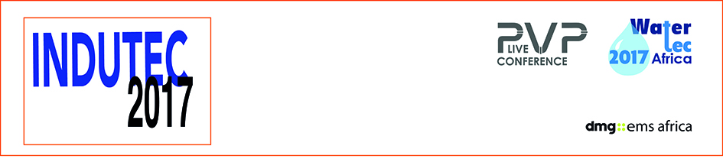

NEWS RELEASE

May 15, 2017

Why the future of Africa’s water and oil sectors is a key focus of INDUTEC 2017

From pumping systems designed in a 3D virtual world to the world’s biggest pipe producer – for three days this week Johannesburg is home to cutting edge innovation

Africa’s leading industrial technology and supply expo INDUTEC 2017 opens its doors at 10am on Wednesday (May 17).

INDUTEC is also host to two key industry conferences over the three days: PVP Live and WaterTec, both endorsed by the South African Department of Trade & Industry (the dti).

The theme of this year’s three-day expo at the Gallagher Convention Centre, Johannesburg, offers a special focus on the pumps, valves and pipes sector in sub-Saharan Africa. It embraces everything from water supply and the petroleum sector, through to chemical pumping and agriculture.

Alongside suppliers from all over the world, the first day of the PVP Live conference will focus on new technology and the opportunities for the future of the sector.

Visitors will also have the chance to sample first hand an exciting new 3D modelling programme that plans all their water, gas or fluid transfer.

PumpSim demonstrates the exact piping and pump requirements needed across any site, by simulation, and because the plan can be viewed in a virtual world, it avoids real-world issues when installation takes place.

“Because systems can be modelled in true 3D coordinates, all elevations and lengths for pipes are automatically calculated, and the Pumpsim models are useful references or ‘maps’ to show the layout and location in real systems,” says Jamie van Schoor, CEO of the African distributor of PumpSim, Dwyka Mining Services Ltd (DMS).

Alongside the dti endorsement, the South African body that represents valve and actuator manufacturers is also part of PVP 2017. The Valve and Actuator Manufacturers Cluster of South Africa (VAMCOSA) was set up in 2011 to bring local manufacturers together to create a common focus and goal for the respective industries. It also provides an effective platform for its members to lobby government.
“We believe both events are of huge importance to our industry both in highlighting our capability and the challenges our industry faces,” said Mark Wilson, VAMCOSA Champion. “The synergy of PVP 2017 with our sector is critical to the success of all three industry groups.”

And INDUTEC 2017 has attracted some of the world’s leading suppliers to Johannesburg:

Portable Energy, a division of the Atlas Copco Construction Technique business area, will showcase its range of portable, lightweight and super-efficient dewatering pumps.

DEMCA Actuation Solutions, with almost 40 years’ experience, specialise in the supply of electric multi-turn, quarter turn, linear and failsafe actuators, as well as bevel gearboxes for multi-turn applications, for over 37 years.
GM pumps will be showcasing is full range of Fluimac pump solutions at the expo.
Flowrox will also be at the show revealing a new generation of smart pumps and valve at the show called Malibu.

Kai Quan Pumps, South Africa, brings wide product selection catering for sectors including petro-chem, long distance, hot water pumps for electricity and nuclear generation facilities, firefighting, slurry and solar.

And SUPERLIT from Turkey will be showing its range, including the biggest GRP pipes in the world.
Now in its 10th edition, INDUTEC was acquired last year - along with four African shows - by dmg events Middle East, Asia & Africa, and the expo has undergone a makeover this year to bring it into line with dmg’s international portfolio.
The new owner believes Africa’s renewed growth offers opportunities to PVP suppliers in sectors as diverse as water supply and oil extraction through to agriculture, pulp & paper and construction.
“INDUTEC is well-established expo in South Africa attracting visitors and exhibitors from around the world,” says Brad Hook, organiser dmg-ems Africa’s Commercial Director. “This year we will will focus on the five key areas of the market at both the show and the conference.”
- Energy. To meet demand in the oil, gas & petrochem sector for economic pumping and transport solutions to capitalise on the continent’s reserves.
- Infrastructure. New government backed developments mean expertise is required across a diverse range - from the transportation of liquid concrete to sewage.
- Water. Focus in sub-Sahanran Africa has focused on water security with municipalities investing money in long-term solutions.
- Agriculture. Mechanisation and population growth is increasing demand for the latest pump and pipeline technology.
- Extractive industries. Africa is a world player now demanding the efficient solutions from oil and gas transportation to mining.

You can discover more about INDUTEC 2017 at www.indutecafrica.com and you can register for entry here www.indutecafrica.com/enquire-about-visiting

Press information

INDUTEC, which runs from May 17 to 19 at The Gallagher Convention Centre in Johannesburg. It is operated by dmg-ems Africa, part of dmg events Middle East, Asia & Africa.

Pumps, Valves and Pipes Africa 2017, is the 10th edition of the largest and most comprehensive trade-show dedicated to the industries that are involved in the conveyance of liquids, gasses and slurries.

dmg events Middle East, Asia & Africa was founded in 1989 and has operated in the Middle East since 1995 and owns some the region’s biggest shows including The Hotel Show and The Big 5. Headquartered in Dubai, UAE and with satellite offices in India, South Africa and the UK, dmg events Middle East, Asia & Africa organises more than 45 events across the Middle East, Africa, Asia, North America and Europe. The events attract over 250,000 customers every year and provide opportunities for trade professionals to do business, network and learn. For more information visit www.dmgeventsme.com
DMGT manages a balanced multinational portfolio of entrepreneurial companies, with total revenues of almost $3bn, that provide a diverse range of businesses and consumers with compelling information, analysis, insight, news and entertainment. The company employs more than 10,000 people and is listed on the London Stock Exchange. DMGT aims to provide the highest quality information, insight and services to attractive growth markets in innovative ways, building on a track record of earnings and dividend growth. For more information visit www.dmgt.com

For further information, please contact:

Gary Wright,

Head of PR & Comms, dmg-ems Africa

E: garywright@dmgeventsme.com

T: +27 (0) 11 783 7250

W: www.dmgeventsme.com

A: P O Box 650302 BENMORE 2010, South Africa

