SA HIPPO EXHIBITED AT THE CIM 2017 IN MONTREAL

The Canadian Institute of Mining, Metallurgy and Petroleum (CIM) was founded in 1898 and it is the leading technical society of professionals in the Canadian Minerals, Metals, Materials and Energy Industries. The CIM has over 14,600 members, convened from industry, academia and government consists of 10 Technical Societies and over 35 Branches. The members of this internationally respected, dynamic organization help to shape, lead and connect Canada’s mining industry, both within Canada and across the globe.
The purpose of the Institute, which always strived to be relevant to a growing and increasingly diverse membership, addresses recurring issues since its beginnings. Its organizational structure, relations within the Institute, membership qualifications, and finances serve a strong governance and management model. The CIM convention and exhibition is being held annually and the venue alternates between Vancouver and Montreal.
HAZLETON PUMPS, the South African family owned and managed company, has participated at the CIM exhibition in 2016 for the first time to exhibit the HIPPO Submersible Slurry pump range that has the capabilities to pump liquids containing solids.
It is the company’s objective that these capabilities be demonstrated adequately and this lead to the design and development of a model of a solid separation pumping system specifically designed to demonstrate one of the most important mining applications in which liquid containing solids could be separated from the liquid.
A working model of the HIPPO solid separation pumping system was designed using a small HIPPO submersible slurry pump installed in a tank by pumping the liquid containing solids to the cyclone where the solids are separated from the liquid and these separated solids are returned to the pump to be re-mixed and pumped thus repeating the process for demonstration purposes.
HAZLETON PUMPS is of opinion that it is essential that the company maintain a high visibility which assists in the growth of sales in Canada and therefore attends all the major exhibitions related to mining industry wherever possible.

The model of the HIPPO Solid Separation System
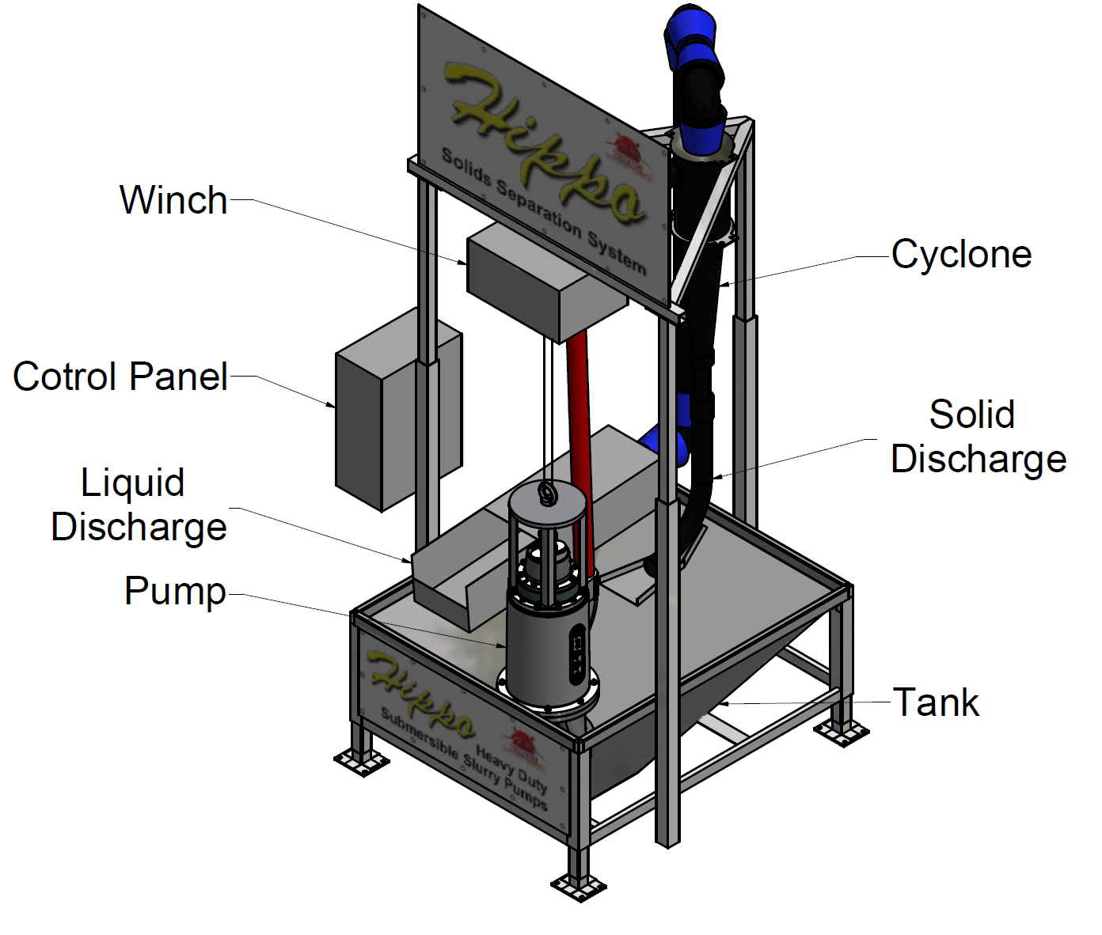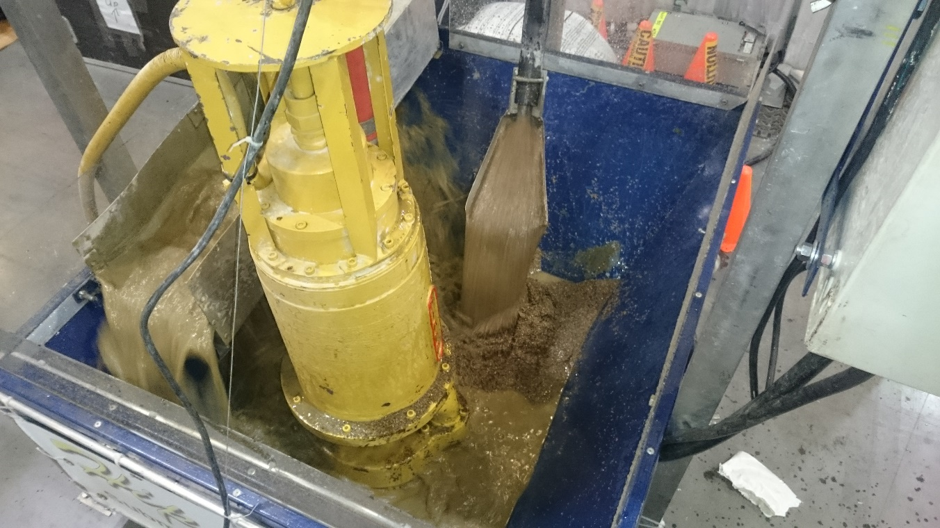
The working model of the solid separation system demonstrating the separation of the liquids which is discharged to left of the pump and the
solids to right of the pump.

