Press
Nuremberg, April 24, 2017
Hannover Messe 2017, Hall 9, Booth D35

Siemens AG  Communications  Head: Clarissa Haller | Wittelsbacherplatz 2  80333 Munich  Germany
Reference number: PR2017040223PDEN
-
New Remote Terminal Unit expands scope for telecontrol applications

- Simple implementation and monitoring of measurement stations for process data
- Cyclically controlled and event-driven transmission of process values
- Flexible link to control center and rapid integration in Sinaut plants
- Web-based engineering simplifies commissioning

The new Remote Terminal Unit Simatic RTU3010C and the functions added to the Simatic RTU3030C are extending the application scope of compact RTUs for telecontrol applications. These can be used for the simple implementation and monitoring of measurement points for important process data such as level, flow and fill level, as well as pressure and temperature, even for plants spread over a wide geographical area. The transmission of process values can be cyclically controlled or event-driven. The RTUs can be connected to any control center using different telecontrol protocols – also standardized protocols. With the support of telecontrol protocols such as Sinaut ST7, the two compact RTUs can be ideally integrated into new or existing Sinaut ST7 and Scada systems. By means of integrated inputs and outputs, sensors can be directly connected. Together with web-based engineering, this helps simplify commissioning. Fields of application for RTUs include the water and wastewater industry, agriculture and asset management.

To connect to the control center, instead of an integrated UMTS modem the Simatic RTU3010C uses external industrial routers such as Scalance M for network connection over an Industrial Ethernet interface. This lends greater flexibility when it comes to choosing a communication medium, with scope for mobile wireless network or wired network connection for instance over DSL. Power is supplied to both the compact RTUs over a DC12-24 volt interface, by a solar panel with rechargeable battery or simply using conventional batteries. The RTUs are also capable of powering the connected sensors. The new firmware version 2.0 enables additional batteries to be used, increasing the capacity to more than 70 ampere hours (Ah) and allowing significantly longer operating times without the need to change batteries.
Its robust design allows the RTU to be used under harsh ambient conditions at temperatures of between -40°C and +70ºC, and when fitted with an additional IP 68 rated protective housing, even under flood conditions. The RTUs can be remotely configured and updated with new firmware via web-based engineering. As the new firmware version V2.0 supports autoconfiguration in Sinema Remote Connect, the VPN connections to the RTUs can be simply configured using this management platform for remote networks.
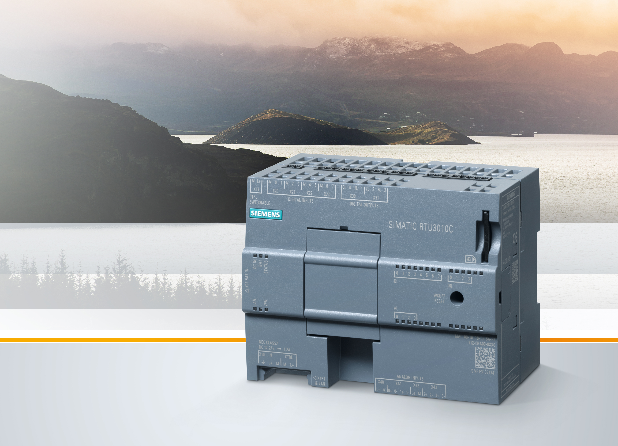
The new Remote Terminal Unit Simatic RTU3010C and the functions added to the Simatic RTU3030C are extending the application scope of compact RTUs for telecontrol applications. These can be used for the simple implementation and monitoring of measurement points for important process data such as level, flow and fill level, as well as pressure and temperature, even for plants spread over a wide geographical area.

This press release and a press picture are available at www.siemens.com/press/PR2017040223PDEN

For further information on Simatic RTU3010C, please see www.siemens.com/compact-rtu

For further information on Siemens at the Hannover Messe 2017, please see www.siemens.com/press/hm17 and www.siemens.com/hannovermesse

Contact for journalists
Dr. David Petry
Phone: +49 (9131) 72-6616; e-mail: david.petry@siemens.com

Follow us on Social Media
Twitter: www.twitter.com/siemens_press and www.twitter.com/SiemensIndustry
Blog: https://blogs.siemens.com/mediaservice-industries-en

Siemens AG (Berlin and Munich) is a global technology powerhouse that has stood for engineering excellence, innovation, quality, reliability and internationality for more than 165 years. The company is active in more than 200 countries, focusing on the areas of electrification, automation and digitalization. One of the world’s largest producers of energy-efficient, resource-saving technologies, Siemens is a leading supplier of efficient power generation and power transmission solutions and a pioneer in infrastructure solutions as well as automation, drive and software solutions for industry. The company is also a leading provider of medical imaging equipment – such as computed tomography and magnetic resonance imaging systems – and a leader in laboratory diagnostics as well as clinical IT. In fiscal 2016, which ended on September 30, 2016, Siemens generated revenue of €79.6 billion and net income of €5.6 billion. At the end of September 2016, the company had around 351,000 employees worldwide. Further information is available on the Internet at www.siemens.com.

