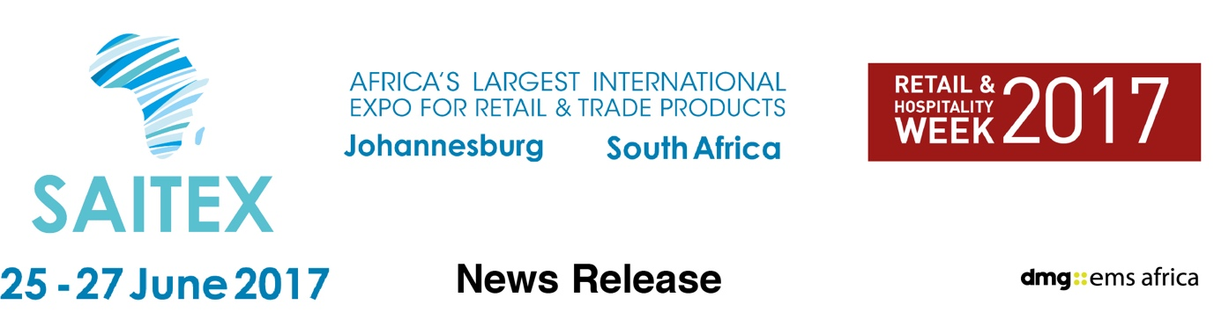

April 24, 2017

Earn while you learn at Africa’s new retail conference during the continent’s biggest product sourcing expo: SAITEX 2017

Trade Buzz 2017 offers delegates an insight into the future of retail & trade across sub-Saharan Africa with recognised career-boosting CPD certification

Some of sub-Saharan Africa’s top shopping gurus will be in Johannesburg this June for one of the biggest retail and trade events on the continent.

Trade Buzz is the three-day conference at the heart of SAITEX 2017, which is Africa’s largest international product sourcing expo.

“SAITEX offers retailers, entrepreneurs, traders and wholesalers the chance to see and meet with hundreds of international suppliers – the Trade Buzz conference is where visitors gain key knowledge and insight on exporting, importing, how to boost their business whilst also developing their career,” says David Ross, dmg events’ conference chief.

Trade Buzz has a comprehensive three-day programme focused on the retail sector including expert insight into consumer behaviour and how to get new products onto big retailers’ shelves, right through to practical sessions covering import, export and successful international expansion, with case studies.

New to Africa this year, each session earns Continuing Professional Development (CPD) accreditation for attendees. CPD has been operating around the world and international show organiser dmg events, which bought SAITEX last year, introduces it to South Africa in 2017. CPD benefits the employee, the employer and ensures its conferences are of recognised international standard.

The first day of Trade Buzz will see Tim Fry, the African Expansion Director for Danone Southern Africa, look at growth opportunities for retailers across the region.

And Derek Engelbrecht, Africa Consumer Products and Retail Sector Leader at EY, will reveal to importers and exporters the secrets of getting your products onto supermarket shelves.

The second day of Trade Buzz will focus on changing retail trends and give delegates an understanding of consumer expectations, today and in the future. One sessions titled ‘Which products should you be sourcing to satisfy and anticipate emerging market demand?’ promises a few surprises. That will be followed by a series of sessions dealing with the unique demands of different retail sectors, from furniture and clothing through to building and electronics.

SAITEX 2017 has been rebranded and relaunched this year to meet the needs of a fast-changing African market, which has seen a surge in affluent buyers. And Trade Buzz 2017 - with a packed conference programme, top speakers and training credits for delegates - sees conferences move to a new level in South Africa.

SAITEX was acquired last year by dmg events Middle East, Asia & Africa and its Africa Vice President Christine Davidson explained the decision to rebrand and refocus the show.

She said: “SAITEX has for 23 years remained the largest and most important product sourcing and trading expo in Africa, attracting exhibitors from around the globe and providing an essential forum where trade deals with Africa are discussed. It attracts Trade & Development ministers and ambassadors from all countries, focussed on setting up export and import deals, it is strategically an essential event for trade in Africa where business is done.”

SAITEX is co-located with Africa’s Big 7 - the continent’s premier food & beverage expo – and The Hotel Show Africa 2017, one of the world’s most successful hospitality event brands takes its inaugural step into Africa. The three shows together create the largest Retail & Hospitality gathering in Africa.

You can see the full Trade Buzz conference programme at www.saitexafrica.com and also register for show and conference passes.

Press information

SAITEX 2017 runs from June 25-27 at The Gallagher Convention Centre, Midrand, Johannesburg, South Africa. SAITEX is Africa's largest international product sourcing expo. It includes consumer electronics and home appliances, homeware and household, building materials supplies and tools as well as fashion and giftware. It attracts hundreds of manufacturers and suppliers showcasing the most advanced products. more details www.saitexafrica.com

It is part of Retail & Hospitality Week 2017 and co-located with Africa’s Big 7, the continent’s leading food and beverage industry trade expo, and The Hotel Show Africa 2017, which brings one of dmg events’ most successful brands to the continent for the first time.
SAITEX and Africa’s Big 7 were was acquired in 2016 by dmg::events Middle East, Asia & Africa, a wholly owned subsidiary of Daily Mail & General Trust (DMGT), run by dmg::ems Africa.

dmg::events Middle East, Asia & Africa was founded in 1989 and has operated in the Middle East since 1995 and owns some the region’s biggest shows including The Hotel Show and The Big 5. Headquartered in Dubai, UAE and with satellite offices in India, South Africa and the UK, dmg events Middle East, Asia & Africa organises more than 80 events across the Middle East, Africa, Asia, North America and Europe. The events attract more than 250,000 customers every year and provide opportunities for trade professionals to do business, network and learn. For more information visit www.dmgeventsme.com
DMGT manages a balanced multinational portfolio of entrepreneurial companies, with total revenues of almost $3bn, that provide a diverse range of businesses and consumers with compelling information, analysis, insight, news and entertainment. The company employs more than 10,000 people and is listed on the London Stock Exchange. DMGT aims to provide the highest quality information, insight and services to attractive growth markets in innovative ways, building on a track record of earnings and dividend growth. For more information visit www.dmgt.com

For further information, please contact:

Gary Wright,

Head of PR & Comms, dmg-ems Africa

E: garywright@dmgeventsme.com

T: +27 (0) 11 783 7250

W: www.dmgeventsme.com

A: P O Box 650302 BENMORE 2010, South Africa

