IMPLICATIONS OF JUNK STATUS FOR SOUTH AFRICAN INVESTORS
By Lesiba Mothata, Chief Economist, Investment Solutions

Ratings agencies have different approaches to assessing the debt issued by the National Treasury in domestic and local currency. To fund government expenditure, Treasury borrows in local currency (90% of total outstanding stock) or in foreign currency (10%) in international markets. In other words, the so-called junk status relates to 10% of total debt issued by the Treasury.

Moody’s and Fitch ratings do not differentiate between the currencies used when debt is issued. The credit quality assigned to South Africa’s total debt is similar for both local and international currency issuances. In contrast, Standard & Poor’s (S&P) provides a rating on local and foreign debt. In its latest action on South Africa, the foreign currency component of debt issued (10% of the total) has been downgraded to non-investment grade BB+ (see the figure below) and local-currency denominated debt (90%) has been pushed one notch down to BBB-, which is still investment grade.

Rating scales and outcomes for different rating agencies
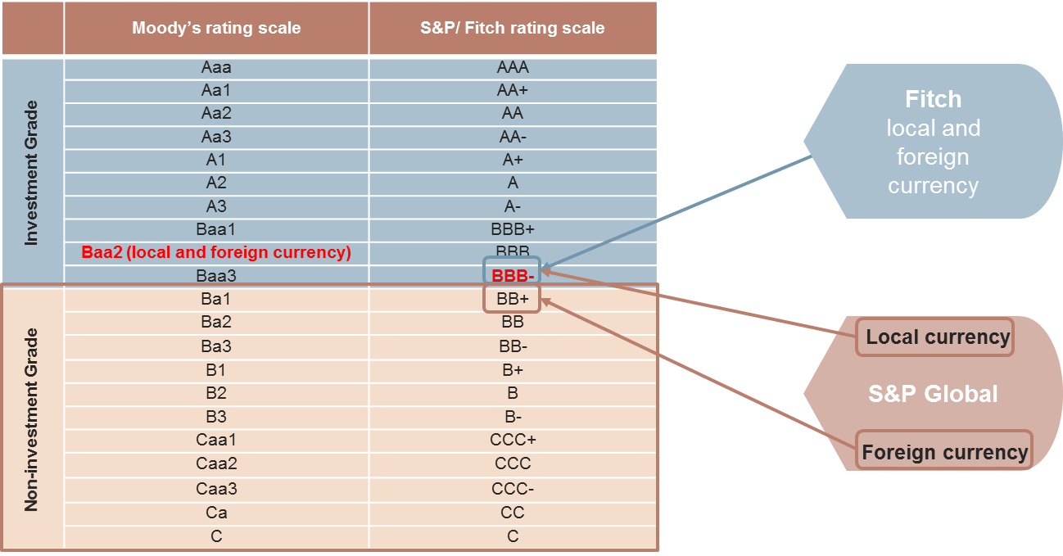
Source: Standard and Poor’s, Moody’s, Fitch, Bloomberg and Investment Solutions

S&P has become the first agency to downgrade South Africa’s sovereign debt to non-investment grade. It is expected Fitch is likely to do the same soon, an outcome which will prove challenging for South Africa given that the local dominated debt (the 90%) is likely to be non-investment grade from Fitch. The Moody’s outcome, even if it holds a more favourable outlook on South African debt relative to the other two agencies, could contribute negatively to the downward trajectory of South Africa’s ratings.

Global sovereign bond benchmarks are constructed on the basis of using the credit quality of the local component (rand) of debt issued. The requirement is that a country needs to have outstanding debt with a market capitalisation of US$50 billion, be rated investment grade by two ratings agencies and have open markets easily accessible by foreign investors. The inclusion of a country in these indices is based solely on local-denominated currency ratings.

Global bond indices and related SA weighting
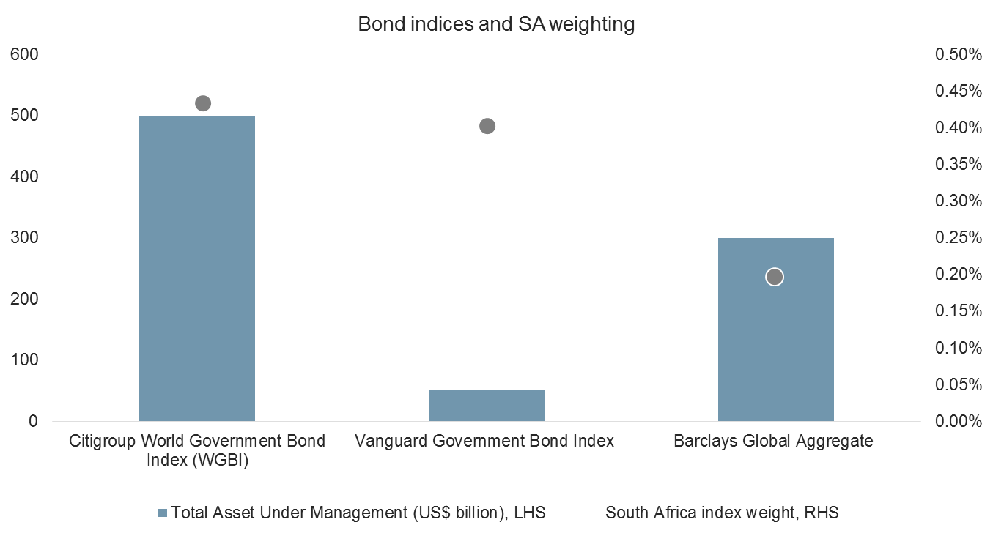
Source: International Monetary Fund, July 2016

Exit requirements for bond indices

The recent decision by S&P, although a hugely negative outcome for South Africa, does not impact the country’s eligibility in global bond indices as yet. South Africa is included in a few indices (see the figure above) with a different weighting in each. A widely-used global bond benchmark is the Citigroup World Government Bond Index (WGBI), which has clearly-stipulated exit requirements for a country. A country will be removed from the index:
- If the market capitalisation of outstanding debt falls below half entry level (in other words US$25 billion) for three consecutive months.
- If a country gets downgraded into non-investment grade by both Moody’s and S&P on its long-term domestic credit.
- If authorities deliberately introduce policies that materially change the ability of investors to replicate the returns of that country’s portion of the index.

At this stage, South Africa remains safe within global bond benchmarks as the three exit requirements are not yet triggered. All rating agencies still have South African credit quality rated in investment grade. However, increased trading volumes and further ratings downgrades could have a material impact on South Africa’s ability to raise funds as well as, to a significant degree, the flow of capital into South African bonds. According the Financial Times, South African sovereign bonds, even before the Cabinet reshuffle unfolded, saw a substantial increase in trade volumes in the European markets. South Africa’s benchmark 10-year government bond had become the fourth most heavily traded sovereign bond in Europe according to Trax. March was a record month for trading volume in South African bonds — €15 billion, the largest number on record and 52% higher than the average monthly volume since July 2013.

Lessons from other emerging market countries

Our study of emerging market countries downgraded to non-investment grade suggests the impact of junk status depends heavily on how fiscal authorities respond after the decision. Where there is agility in policy response — making hard and frugal decisions, which involves opening up the economy further, as seen in South Korea in 1998 — it took a shorter time to arrive back at investment grade (24 months). For countries with complex internal political structures and a lethargic fiscal policy response, it took a much longer time to shake off the effects of the downgrade — it took Colombia 12 years.

Risks in the market going forward

Volatility is likely to increase in local financial markets. The South African Reserve Bank (SARB) will be closely monitoring the developments in the markets to see if the ensuing sell off becomes disorderly and threatens the stability of the financial system. Should the decline in bank shares, the rise in bond yields and the fall in the rand create instability in markets through intensified capital flight, it would not be surprising to see a response from the SARB, which includes hiking interest rates, even when the recent dovish comments were premised on moderating inflation expectations.

Investors face challenges from this point forward. Depending on the type of response put together by authorities, usually, when countries get downgraded to non-investment grade, the cost of funding increases, a recession ensues, currency depreciation induces inflation, which leads to monetary tightening. The short- to medium-term impacts could prove painful.

Need for diversification

It is in times like these that investors need to hold on to a diversified and long-term investment strategy. Even as a political storm is once again battering South Africa, history has shown that, in the long-term, markets have the ability to return to fundamentals even when short-term noise, especially from the political sphere, creates much angst.

