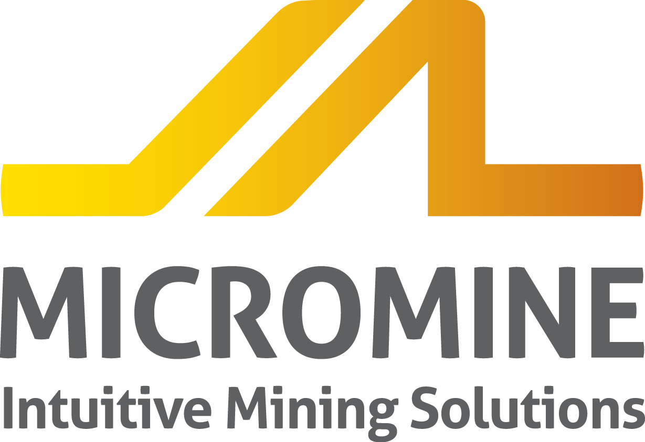IMMEDIATE RELEASE

Rosnedra Central Committee for Solid Mineral Deposit Development (Central Committee) partners with Micromine.
The Central Committee is the governing body for deposit development projects, located in Moscow Russia. In compliance with the Central Committee a mining must submit deposits prior to commencement of a project to the committee for final approval.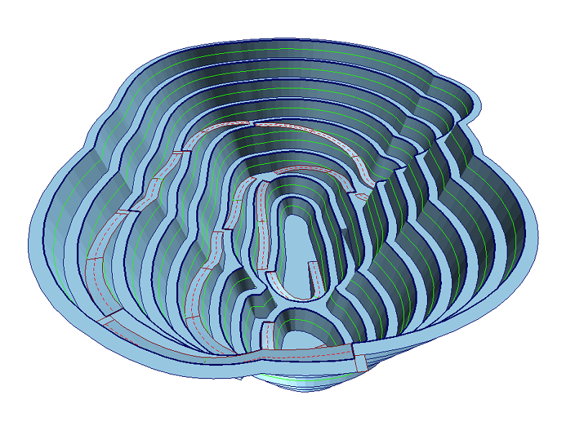
The globally Committee activities are predominantly focused on Russia’s mineral resources, base study and development. Currently, the number of GIS users is annually increasing in the mining industry, and the opportunity for Micromine to assist in GIS learnings. GIS software is being integrated into newly discovered fields, as well as to the historical businesses mining deposits for years. This is the first step in government organisation’s using information systems for mineral resource projects.
Micromine specialists have been working closely with the Central Commission since January and have now provided staff with Micromine GIS training. The emphasis of the training program has been placed on the ease of use, functionality and the interactive environment Micromine provides. Specific attention has been placed upon open pit design, wireframing and underground mine design modules.
Russian Regional Manager Boris Kurtsev commented, “Micromine provides users with an in-depth understanding of your projects, so prospective regions can be targeted more accurately, increasing the chance of your project’s success. Miners are provided with interactive and easy-to-use modelling, estimation, and design tools to simplify your day-to-day design and production tasks.”
In the future, MICROMINE Russia will provide leading exploration and 3D mining software licences for all Central Committee staff members to utilise. Micromine will be used for projects examination as the default solution. This type of innovation for governing bodies, increases convenience, adds clever tools and options for project approvals through Micromine GIS.
~END~

