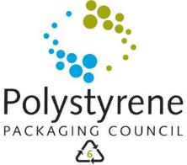


Contact: | Adri Spangenberg
Telephone no: | (082) 686-5082
Email address: | Adri.Spangenberg@polystryrenepackaging.co.za
Website: | www.polystyrenepackaging.co.za

PRESS RELEASE FOR IMMEDIATE DISTRIBUTION
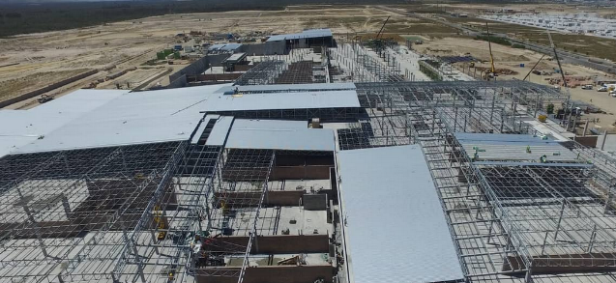
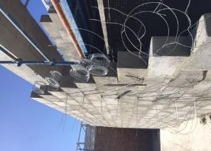
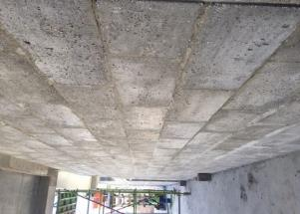
15 TONS OF RECYCLED POLYSTYRENE USED IN NEW TABLE BAY MALL CONSTRUCTION

Cape Town, 27 February 2017. More than 15 tons of recycled, Expanded Polystyrene (EPS) have already gone into the production of 20,000 Greenlite Concrete blocks used in the new Table Bay Mall that is currently being constructed. Expected to open its doors at the end of September this year, this 65 000 m² regional shopping centre is located on a 20 ha site on the corner of the R27 (West Coast Road) and Berkshire Boulevard in the heart of the rapidly growing West Coast area.
Vivid Architects / Group Five Construction contractors are at the helm of the project, and specified Greenlight Concrete blocks for use primarily on the fire escape passages owing to the product’s excellent fire rating.
“With climate change looming and the rising cost of energy, building contractors are looking at sustainable building options. Over the past 18 years, we have been involved in the manufacturing and installing of Alternative Building Technologies. We were looking for a more environmentally friendly way of implementing our insulated building systems, when we started experimenting with recycled polystyrene as the basis for our energy efficient walling systems,” explains Hilton Cowie, Technical Director of Greenlite.
Greenlite’s Insulated Concrete is the culmination of more than 18 years’ of experience and research, the blocks consist of recycled polystyrene which is used as a lightweight aggregate mixed with cement and additives to form insulated, soundproof, fireproof, water-resistant lightweight concrete blocks and screeds that have already been used in various large, commercial projects such as the Trumpet Towers in Johannesburg, the BMW Pavilion and Zeits Museum in the V&A Waterfront, Baywest Mall in Port Elizabeth and the Gautrain Station in Sandton.
“The developers were amazed at how quick and easy it was for them to build the walls using Greenlite blocks. Because these blocks are lightweight, they are easy to move around the site and the engineers saved weight loading onto the suspended concrete slabs,” Cowie says.
These blocks are proving invaluable to the construction industry where clients and contractors are able to reduce their structural concrete and steel requirements due to the lightweight nature of the walls. The highly insulated walls also offer the added benefit of further energy savings to the client over the lifespan of the building. Greenlite Concrete accepts any form of polystyrene for recycling on their premises, and is willing to assist in arranging collection of large quantities of Polystyrene.
more2/…
table bay mall construction two

“We recycle and use the polystyrene faster than we can get our hands on it. Builders Warehouse are now also exclusive stockists of our various sized Jumbo blocks and screeds, creating an even greater demand for polystyrene that we can use,” Cowie explains.
“We are very excited about the growing popularity and rapid market acceptance of this new building technology. Not only does it have a direct and positive impact on our recycling rates by diverting large volumes of post-consumer polystyrene from our country’s landfills, but it also helps to create more employment opportunities, reduce building costs and increases productivity. We are hoping to improve on our 2016 record of 2 036 tons of polystyrene that were successfully recycled through our Project Build,” concludes Adri Spangenberg, Director of the Polystyrene Packaging Council.

For more information, visit www.polystyrenepackaging.co.za or www.greenliteconcrete.co.za

ENDS

