Investing in a quality, cost effective Hawkeye Precision Borescope

In the current economic climate, many businesses are looking at ways to reduce expenses. Purchasing a high quality, yet affordable Hawkeye Precision Borescope, can result in the saving of valuable man-hours and a reduction in operational down time. Operators can quickly and easily inspect turbine blades, combustion chambers, cooling tubes in heat exchanges, gear boxes, and more, all without the need for costly and time consuming engine and system tear-down. Findings can be documented, captured on video and emailed when required. In the manufacturing and engineering sectors, an investment in a Hawkeye Borescope is both a time and cost saving mechanism.

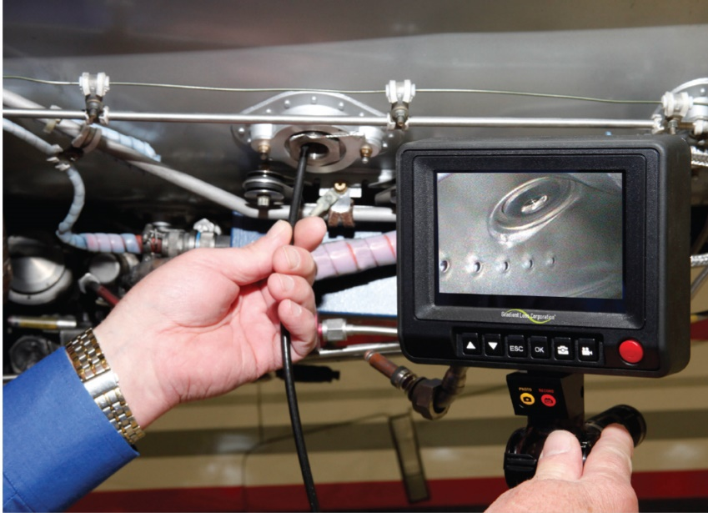

Gradient Lens Corporation, USA manufacture over 80 rigid, flexible and video Hawkeye Precision Borescopes. Hawkeye Borescopes is a well-known and trusted name for leading edge companies worldwide; for their understanding of industry requirements and manufacturing of quality and durable portable industrial borescopes.

At G.P.Agencies we will assist you in choosing the correct borescope for your application. We have a very healthy long term relationship with the manufacturer, Gradient Lens Corporation, USA. As an agent, this is a vital ingredient for any successful business. Having the backing and support of the manufacturer we are able to offer all our customers a knowledgeable and reliable service. Importantly, if required, we will attempt whenever possible to arrange for our clients to
have the opportunity to test Hawkeye Precision Borescope demonstration equipment in their own environment prior to purchase.

Contact G.P.Agencies Sales Manager, Lesley Scott via email: lesley@hawkeyeborescopes.co.za or cell: 060 529 3813 if you would like to receive a catalogue or for assistance in choosing the correct borescope or microscope for your requirements. Trade enquiries are welcome.

