 | PRESS RELEASE  - For immediate release -
  Contact | Monya Vermaak
  Telephone | (011) 314-4021
  Cell | (079) 155-6266
  Email | Monya.Vermaak@plasticssa.co.za
  Website | www.plasticsinfo.co.za

PLASTICS|SA CLEAN-UP CREWS TASKED WITH KEEPING CAPE TOWN BEAUTIFUL
DURING THREE MAJOR EVENTS
Proud event greening partner of the Cape Town Cycle Tour, SA Navy Festival and Old Mutual Two Oceans Marathon
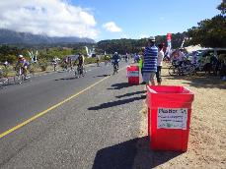
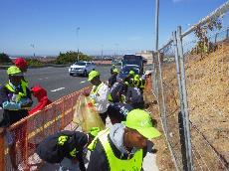
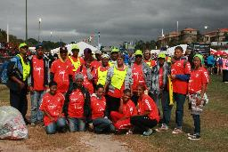
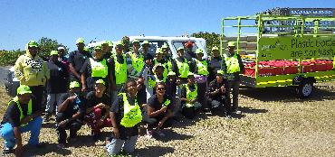
Cape Town, February 7, 2017. The Plastics|SA Clean-Up Crew has been tasked with the responsibility of ensuring that the routes and surrounding areas for three of Cape Town’s biggest spectator events are kept clean and litter-free.
For the 10th consecutive year, Plastics|SA’s Sustainability Manager, John Kieser, will be coordinating three clean-up crews to quickly and effectively pick up all waste generated by athletes and spectators who will be attending the Cape Town Cycle Tour (CTCT) on the 12th of March, SA Navy Festival taking place from the 17th to the 19th of March and the Old Mutual Two Oceans Marathon that will take place on the 15th of April 2017.
A feather in the cap for the plastics industry
“These three events take place during March and April, and attract thousands of visitors from around the country and the rest of the world who descend on the Mother City. It is no small task to ensure that all the water and energy drink sachets used by the athletes and the litter strewn by the spectators are picked up as quickly as possible and with as little disruption to the events or the traffic,” Kieser explains. This year, Plastics|SA has been given the full responsibility of greening the events, and will once again be partnering with waste management company WastePlan to ensure that all recyclable material collected is sent away for recycling.
“Over the years, the active and visible involvement of the Plastics|SA clean-up team and the PETCO branded bins and truck at these events has helped to create an awareness of the plastics industry’s dedication to ensuring that the waste footprint is kept as small as possible,” Kieser said. Each year, several truckloads of plastic waste are collected and sent away to the Kraaifontein Material Recovering Facility (MRF) for recycling, whilst food waste is sent to Noordhoek for composting.

The unsung heroes of event greening

The majority of the waste collected during these events is plastic waste, which has a high recycling value. Ensuring that this packaging is kept out of the environment and off the streets, will be a crew of 205 cleaners employed from Masiphumelele, Ocean View and Athlone, who were trained to quickly and effectively sweep the areas. The City of Cape Town also plays a major role in boosting the clean-up efforts by ensuring that the routes for these annual events are cleaned prior to the race days.

“Both the cycle race and the marathon have various refreshment stations where close to 20 000 bags each are handed out to the athletes. The SA Navy Festival sees up to 50 000 people visiting the harbour per day. On top of this, the weather at these events also plays a big role, as rainy and windy weather presents its own set of challenges for the waste collectors,” Kieser says, explaining that makeshift raincoats are often made from refuse bags and the notorious Cape Doctor could blow the litter into the bushes.

Advertising campaign to support the clean-up efforts

Whilst the clean-up crews will be playing their part on the roads, Plastics|SA will also be supporting their efforts with an extensive marketing campaign aimed at raising awareness of the important role the plastics industry plays in keeping our environment clean, and also spreading an anti-littering and recycling messages.

“A lot still needs to be done to educate the public about littering and responsible participation in large events. Our “event greening” not only provides a much-needed service to the City of Cape Town and event organisers, but also offers us a highly visible platform to showcase the Sustainability Council’s commitment to waste management and recycling. To this end, we will be supporting the clean-up efforts with a print ad campaign that will be appearing in selected in-flight and trade magazines, as well as on the large billboard at the Cape Town International Airport. Our pay-off line for the campaign will be: “When YOU recycle, we all win” and will appeal to all the cyclists and athletes who will be visiting Cape Town during the next few months to help us keep the Mother City beautiful,” explains Monya Vermaak, Marketing and Communications Executive at Plastics|SA.

Radio adverts and on-air interviews will also be heard on local Cape Town radio stations, including KFM, Smile FM, Heart FM, Radio Tygerberg and CCFM during the months of February, March and April, whilst Plastics|SA will also be exhibiting at the Cape Town International Convention Centre.

“We are very excited and proud to be part of these events and take the responsibility that has been given to us very seriously. We will aim to even improve on previous years’ successes and recycling rates,” Kieser concludes.

For more information, visit www.plasticssa.co.za.

ENDS

