SA HIPPO TO EXHIBIT AT PDAC IN TORONTO

The PDAC International Convention, Trade Show & Investors Exchange is the world's leading Convention for people, companies and organizations in, or connected with, mineral exploration. Over 900 exhibitors and 22,000 attendees from over 100 countries will attend, while technical sessions, short courses and networking events are being held. This four-day annual convention held in Toronto, Canada, has grown, stature and influence since it began in 1932 and today is the event of choice for the world's mineral industry.
The PDAC is regarded as an important event for the international mining industry which is attended by the main international players in this market and it has been established that the main decision makers in the mining industries in Canada are based in Toronto and have a big influence on the international projects especially that planned for South America and Africa and is always sourcing reliable products that could be used in their international projects in the mining industry and for this reason HAZLETON PUMPS decided to again participate in the PDAC of 2017.
HAZLETON PUMPS, the South African family owned and managed company, has participated at the PDAC exhibition in 2016 for the first time to exhibit the HIPPO Submersible Slurry pump range that has the capabilities to pump liquids containing solids.
It is our objective that these capabilities be demonstrated adequately and this lead to the design and development of a model of a solid separation pumping system specifically designed to demonstrate one of the most important mining applications in which liquid containing solids could be separated from the liquid.
A working model of the HIPPO solid separation pumping system was designed using a small HIPPO submersible slurry pump installed in a tank by pumping the liquid containing solids to the cyclone where the solids are separated from the liquid and these separated solids are returned to the pump to be re-mixed and pumped thus repeating the process for demonstration purposes.

The model of the HIPPO Solid Separation System
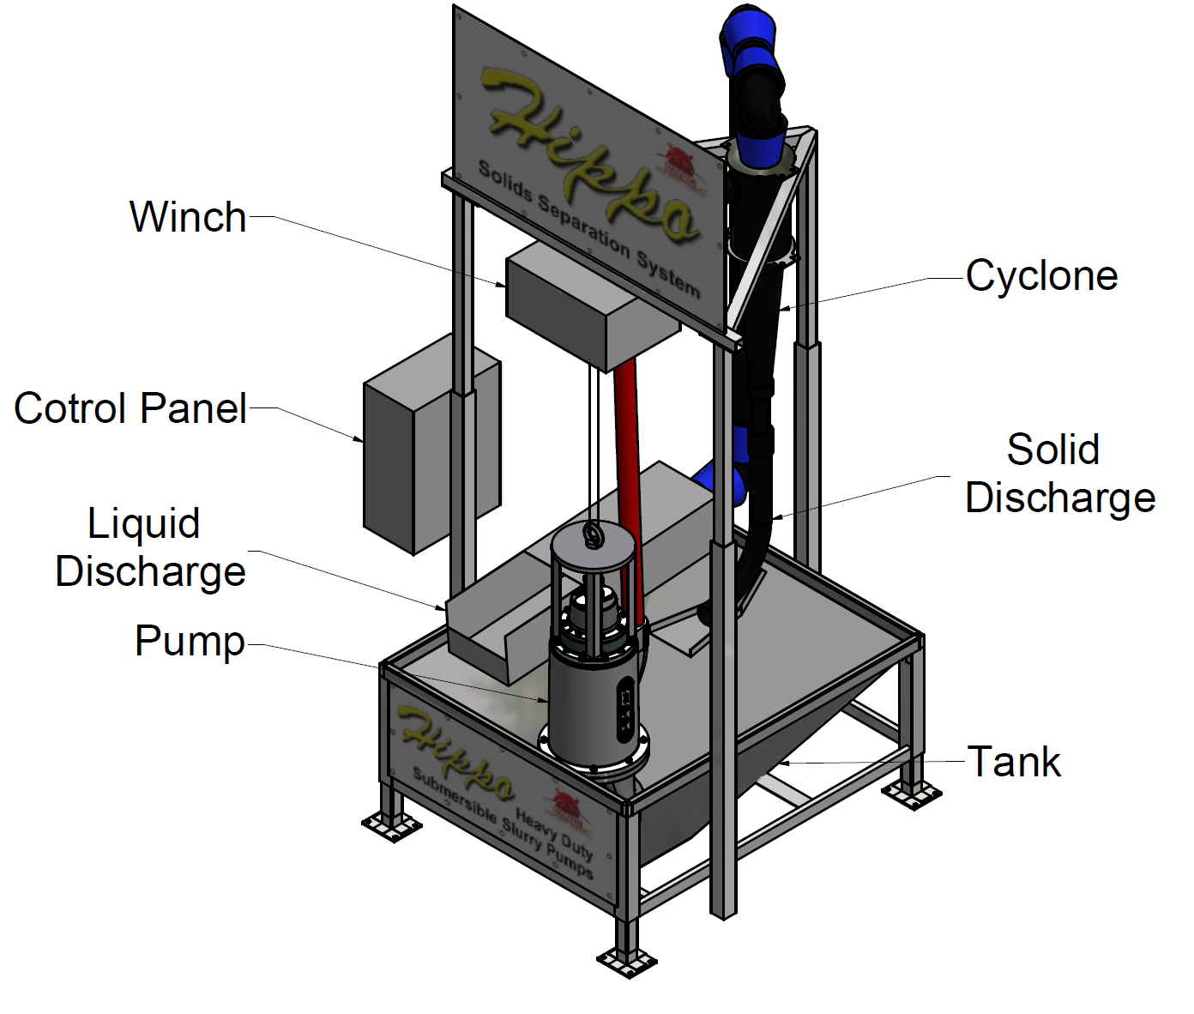
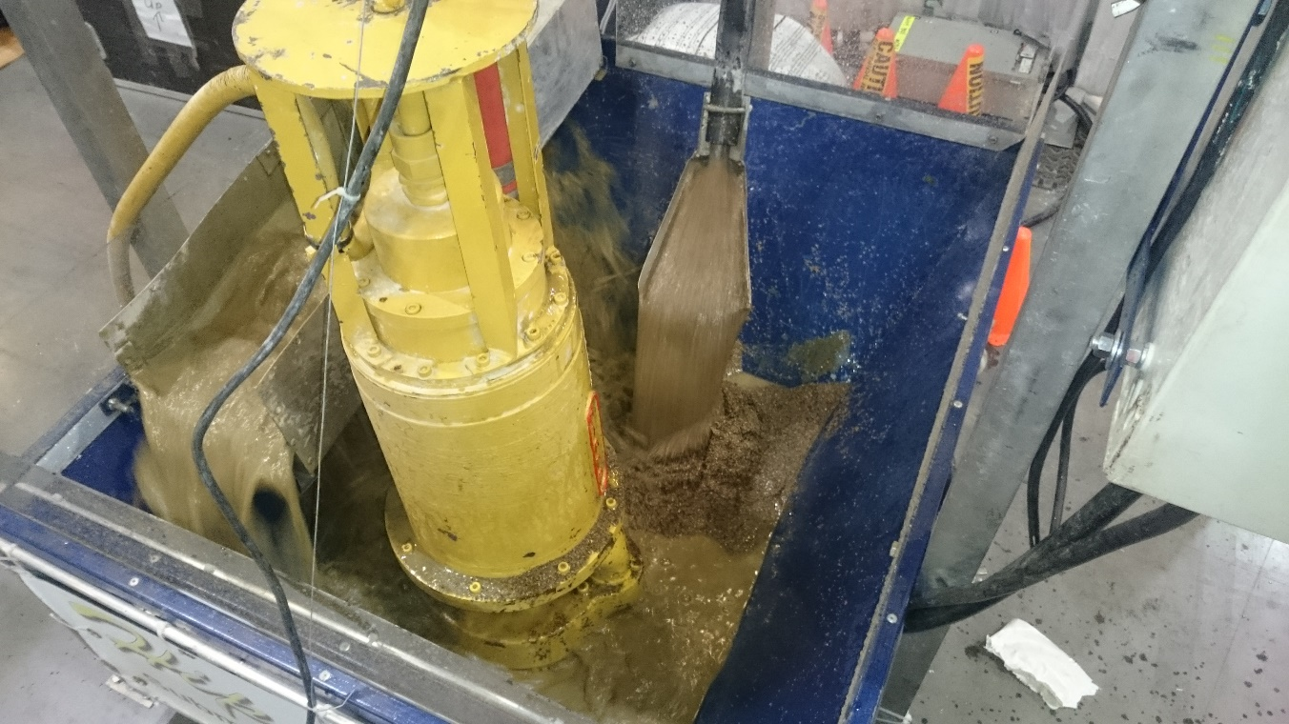
The working model of the solid separation system demonstrating the separation of the liquids which is discharged to left of the pump and the
solids to right of the pump.

Since the previous PDAC in 2016 HAZLETON PUMPS has received and completed orders from Canada in excess of R 8,5 million and to continue to expands into this market it is essential that participation is continued at this event.
The demonstration solid separation system has been stored for the past two years specifically to be used at the major mining exhibitions in Canada. HAZLETON PUMPS also successfully exhibited at the CIM in Vancouver and it is essential that the company maintain a high visibility which would assist in the growth of sales in Canada.

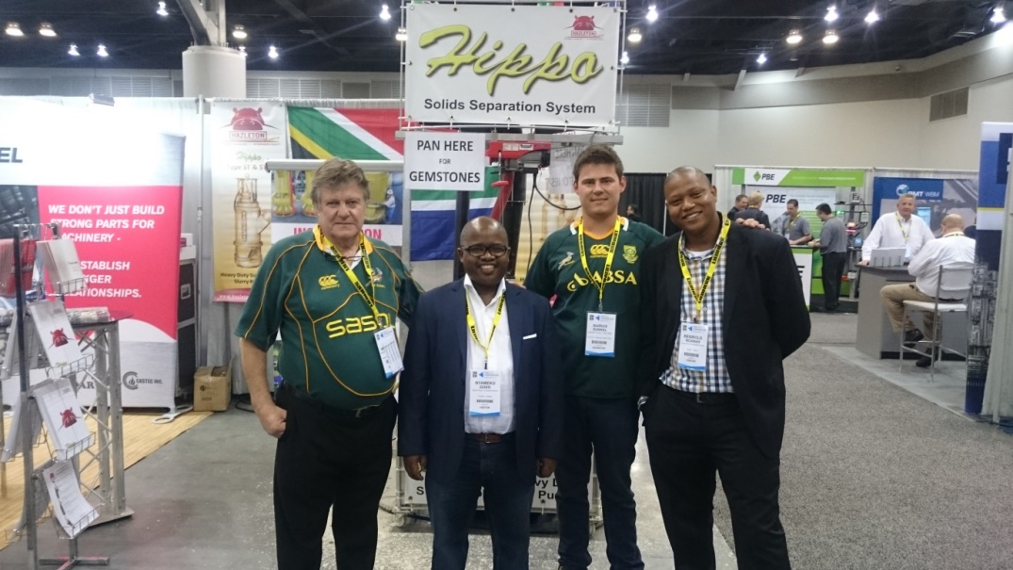
The South African Consul General, Mr. Nyameko Goso and Mr. Reginald Ncamane visiting the HAZLETON PUMPS stand at the CIM 2016.

