Contact | Delanie Bezuidenhout
Telephone | (082) 444-6866
Email | Delanie@savinyls.co.za
Website | www.savinyls.co.za
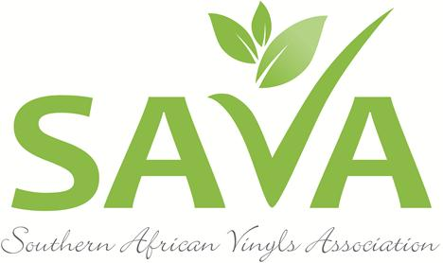

PRESS RELEASE

SAVA CONFIRMS EXCITING SPEAKERS FOR VINYLS SA 2017 CONFERENCE


Johannesburg, 8 February 2017. The Southern African Vinyls Association (SAVA) is proud to announce that it has confirmed three of the world’s leading experts on PVC as speakers ahead of its Vinyls SA 2017 Conference that will be taking place on Wednesday, 7 June 2017 at the Hilton Hotel in Sandton, Johannesburg.
Above: Peter Willis will be delivering the keynote address at SAVA’s forthcoming Vinyls SA 2017 conference

According to SAVA CEO, Delanie Bezuidenhout, this year’s event will build on the success of the Association’s first Vinyls SA 2014 Conference that took place on the back of the Global Vinyls Council’s (GVC) first bi-annual meeting hosted on the African continent.

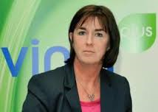
“Our first conference attracted more than 100 delegates from around the country and as far afield as Argentina! Like the first event, delegates who will be attending this year’s event can again look forward to a full and varied programme of original papers and presentations by visiting international and local experts who will be sharing the stage and their expertise on various matters relating to manufacturing, use and recycling of PVC,” Delanie says.
Above: Dr Brigitte Dero, General Manager of the European Council for Vinyl Manufacturers and VinylsPlus

Local and international PVC experts share the stage

“This year, we are pleased to confirm that several of the world’s leading experts will be returning to South Africa to present their latest findings and research as it relates to PVC,” Delanie says. Confirmed speakers for the Vinyls SA 2017 conference include:

- Peter Willis – Senior Associate, University of Cambridge Institute for Sustainability Leadership (CISL) who will be delivering the key-note address on the day.
- Ian Lilja – of the Vinyl Council of Australia (VCA), who will be delivering an update on the VCA Product Stewardship Programme
- Dr Brigitte Dero – General Manager of the European Council for Vinyl Manufacturers and VinylsPlus, who will be providing an expert overview of the European Regulatory and Policy Context
- Gerhard Kuhn – Senior Economist at the IDC, who will be looking at the South African Economy and the various opportunities and challenges it presents for the local PVC industry.
- Renier Snyman – DPI Plastics: SABS? SANS? SATAS? Navigating the world of standards!

Industry Awards

A highlight of the conference will be an awards session where SAVA will recognize the achievements and contributions made by individuals and SAVA member companies within the PVC industry. “We will be issuing the call for nominations shortly and are extremely excited about the awards session, a first for our industry, and also see it as an opportunity to publically thank and recognize those industry champions who are passionate about guiding the PVC industry to achieve the goals we have set in terms of sustainability,” Delanie explains.

Opportunity to get involved
SAVA has issued a call for papers to the PVC industry and conference organisers are currently working through the submissions. The final programme will be released in April. “However, we will still consider late submissions if the content is topical, relevant and presents and interesting point of view,” Delanie says.
Other ways in which to get involved in the Vinyls SA 2017 event, is through making the most of the various sponsorship opportunities available.

“We have various packages available for companies who want to partner with us in the hosting of this prestigious event,” Delanie says. Packages range from R50 000 for a Headline Sponsor, to R5 000 for a Bronze sponsorship. Limited exhibition opportunities are also available, as are advertising opportunities in the conference programme.

“We know that the vinyls industry both locally and internationally is on the cusp of having to make important changes as it faces various challenges in an ever-evolving arena. The timing of this year’s event is therefore critical. We encourage everybody who is in some way involved in, or associated with, the PVC industry to attend Vinyls SA 2017 as we learn from international best practice models, but also chart a way forward for our own course,” Delanie concludes.

For more information or to register, visit www.savinyls.co.za or email Delanie@savinyls.co.za.

ENDS

