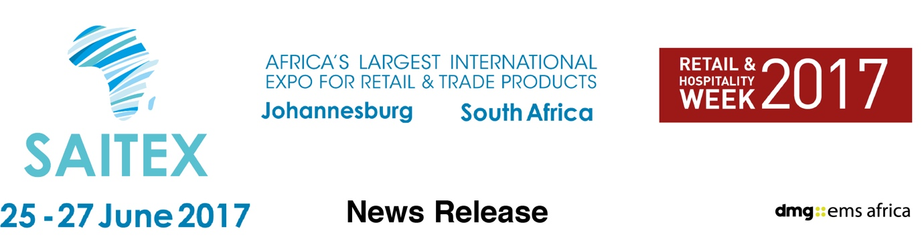

February 8, 2017

Africa’s largest product sourcing expo rebranded in 2017 to ‘meet buyers’ demands’

Trade buyers arriving in Johannesburg this year are promised an exciting new SAITEX event offering more new products that meet the demands of increasingly discerning African consumers

Africa’s largest international product sourcing expo has been rebranded and relaunched this year to meet the needs of a fast-changing African market, which has seen a surge in affluent buyers.

For more than 20 years SAITEX, in Johannesburg, has attracted retail and trade buyers from across Africa who meet exhibitors with products from all over the world.

In Africa the number of middle income consumers has rocketed with online shopping enjoying one of the fastest growth rates in the world as affluent shoppers take advantage of the latest technology.

“In Africa more people now own smart phones than televisions,” said Christine Davidson, vice president of show organiser dmg::ems Africa.

“Consumers browse retail sectors from around the world, so they are more selective and understand the market – whether that’s electronic goods or clothing or a thousand products in between. The competition has never been greater and consumers have never been more aware.

“The retail industry knows this and SAITEX provides the forum for them to source the right products, where they can also meet face-to-face with those suppliers and establish successful partnerships.”

The success of SAITEX draws buyers from across the continent, offering South African businesses exhibiting at the show the same export opportunity to set up new supply chains.

SAITEX was acquired last year by dmg events Middle East, Asia & Africa and its Africa Vice President Christine Davidson explained the decision to rebrand and refocus the show.

“The rebrand and repositioning is reflected in everything we do in terms of content, visitor & exhibitor engagement, show collateral and website,” says Davidson.

“SAITEX is a unique show with a unique heritage, which dmg::events is proud to own. Last year it attracted more than 400 exhibitors from 25 countries. In 2017 we will incorporate the changes in the rapidly changing retail sector into this great show, on the most exciting continent in the world.”

Alongside SAITEX a new conference Trade Buzz 2017 offers attendees information on the latest trends, challenges and outlook for the retail and wholesale trade in Africa.

SAITEX 2017 is at The Gallagher Convention Centre, Johannesburg, from June 25 to 27, as part of Retail & Hospitality Week 2017.

SAITEX is co-located with Africa’s Big 7 - the continent’s largest food & beverage expo – and The Hotel Show Africa 2017, one of the world’s most successful hospitality event brands owned by dmg::events launching in Africa.

Press information

SAITEX 2017 runs from June 25-27 at The Gallagher Convention Centre, Midrand, Johannesburg, South Africa. SAITEX is Africa's largest international product sourcing expo. It includes consumer electronics and home appliances, homeware and household, building materials supplies and tools as well as fashion and giftware. It attracts hundreds of manufacturers and suppliers showcasing the most advanced products. more details www.saitexafrica.com

It is part of Retail & Hospitality Week 2017 and co-located with Africa’s Big 7, the continent’s leading food and beverage industry trade expo, and The Hotel Show Africa 2017, which brings one of dmg events’ most successful brands to the continent for the first time.
SAITEX and Africa’s Big 7 were was acquired in 2016 by dmg::events Middle East, Asia & Africa, a wholly owned subsidiary of Daily Mail & General Trust (DMGT), run by dmg::ems Africa.

dmg::events Middle East, Asia & Africa was founded in 1989 and has operated in the Middle East since 1995 and owns some the region’s biggest shows including The Hotel Show and The Big 5. Headquartered in Dubai, UAE and with satellite offices in India, South Africa and the UK, dmg events Middle East, Asia & Africa organises more than 80 events across the Middle East, Africa, Asia, North America and Europe. The events attract more than 250,000 customers every year and provide opportunities for trade professionals to do business, network and learn. For more information visit www.dmgeventsme.com
DMGT manages a balanced multinational portfolio of entrepreneurial companies, with total revenues of almost $3bn, that provide a diverse range of businesses and consumers with compelling information, analysis, insight, news and entertainment. The company employs more than 10,000 people and is listed on the London Stock Exchange. DMGT aims to provide the highest quality information, insight and services to attractive growth markets in innovative ways, building on a track record of earnings and dividend growth. For more information visit www.dmgt.com

For further information, please contact:

Gary Wright,

Head of PR & Comms, dmg-ems Africa

E: garywright@dmgeventsme.com

T: +27 (0) 11 783 7250

W: www.dmgeventsme.com

A: P O Box 650302 BENMORE 2010, South Africa

