SA HIPPO AGAIN FLOWN TO CANADA

Two HIPPO 350kW Medium Voltage Submersible Slurry pumps would have been returned by the Canadian National Resources Limited (CNRL) to South Africa for repair and upgrade in May 2016. These pumps are being used to pump liquids containing solids, contaminated with tar sludge during where the runoff from the process plants is being pumped to the tailings dams.

Due to the forest fires at the beginning of May 2016 that ravaged Alberta, causing Fort McMurray and the surrounding oil sands fields to be totally evacuated, the pumps are now expected to arrive in South Africa during February 2017.


Fort MacMurray during the wild fires that ravaged the town and
surrounds during May 1026 which caused the town to be evacuated.

With the competitive cost of manufacturing in South Africa, assisted by the current exchange rate, HAZLETON PUMPS has the opportunity to repair and upgrade the HIPPO Medium Voltage Submersible Slurry pumps in South Africa that have been in operation since 2000 in Fort McMurray, Canada. The total cost saving having the HIPPO Medium Voltage Submersible Slurry pumps repaired in South Africa will be at least 30% less compared to the cost of having the repairs done in Canada.

The main challenge when repairing pumps from Canada in South Africa that needed to be overcame is the long delivery periods due to the lead time for shipping as well as clearing by customs. To overcome this problem HAZLETON PUMPS has introduced a “service exchange program” with our international clients in which at least two pumps will be available in stock on a service exchange basis to be exported immediately when the repair pumps arrive in South Africa, utilizing the same sea freight container.

With the delays caused by the fires CNRL has requested that one of the service exchange pump be flown back to Canada even before the two pumps for upgrade and repairs had arrived in South Africa.

In 2013 HAZLETON PUMPS received an urgent order to manufacture two 250-300M HIPPO Submersible Slurry Pumps which were flown out to Canada to assist in avoiding the threat of pollution by preventing the tailings dams spilling over in the surrounding water ways. These pumps each weighed in excess of 5 Tons, and had to be flown on two separate flights as the combined weight was too heavy to be loaded on the same flight.

The HIPPO Medium Voltage Slurry service exchange pump weighing 5,5 ton was flown out of South Africa to Canada and arrived in Fort McMurray during October 2016. The pump was installed on arrival at the CNRL Plant in Fort McMurray, Canada.

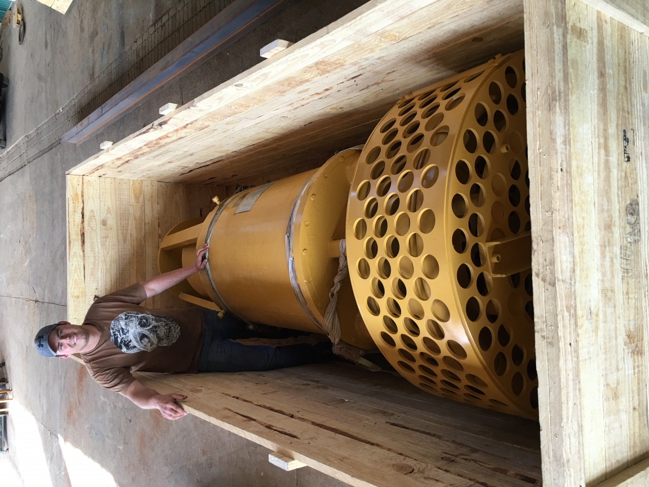
Marius Sunkel inspecting the 5,5 ton HIPPO Slurry Submersible
Pump being crated before being flown to Canada

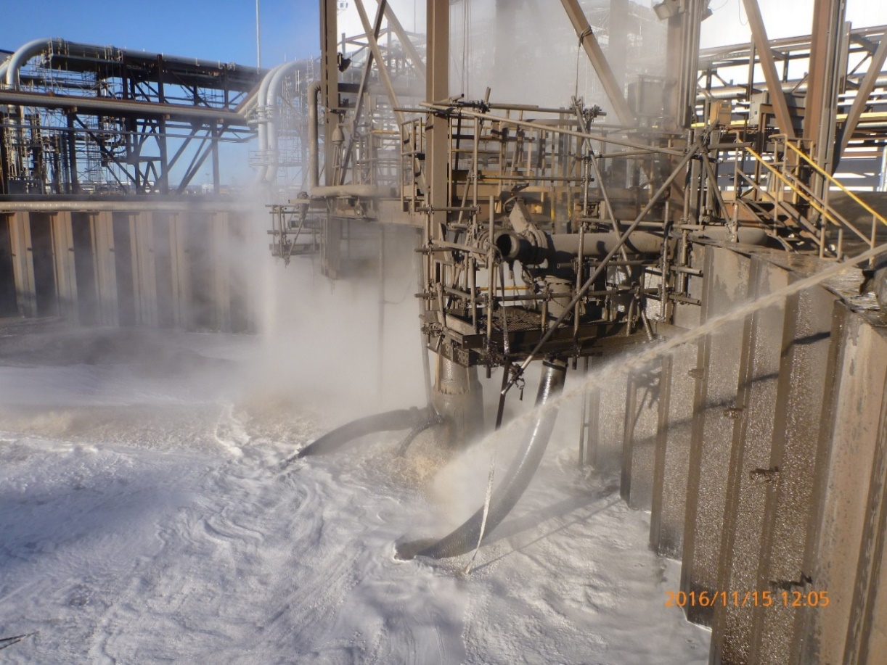
The HIPPO Slurry Submersible Pump being commissioned at
the CNRL Plant in Fort McMurray, Canada

High pressure hot water, causing a vapour mist as can be seen in the photograph, is used to prevent the liquid from freezing as the operating temperature can be as low as -40ºC which is required to enable the pumping of the tar sludge during the process.

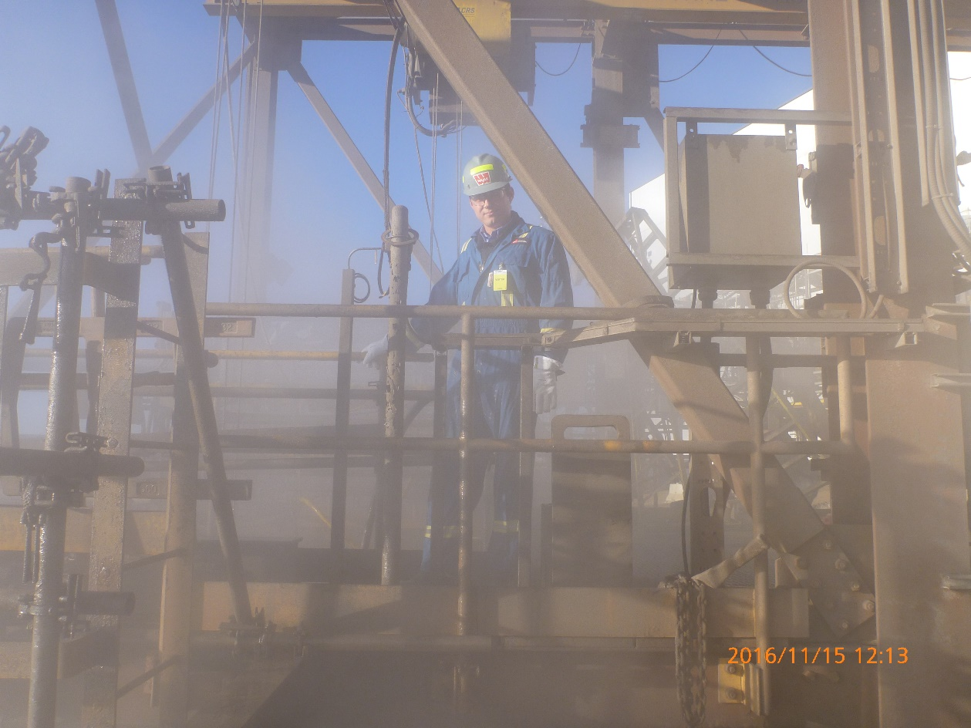
Marius Sunkel commissioning the HIPPO Slurry
Submersible Pump in Canada at the CNRL Plant.

HAZLETON PUMPS is responsible for the commissioning of all the HIPPO Medium Voltage Submersible Slurry pumps at the CNRL Plant and this was successfully accomplished on 15 November 2016.

