DRAGFLOW ANNOUNCES FOUR NEW CONTRACTS FOR CUSTOM DREDGERS

The last quarter of the 2016 has been a busy time for DRAGFLOW technical and manufacturing teams as we received four important orders for custom-made dredgers.

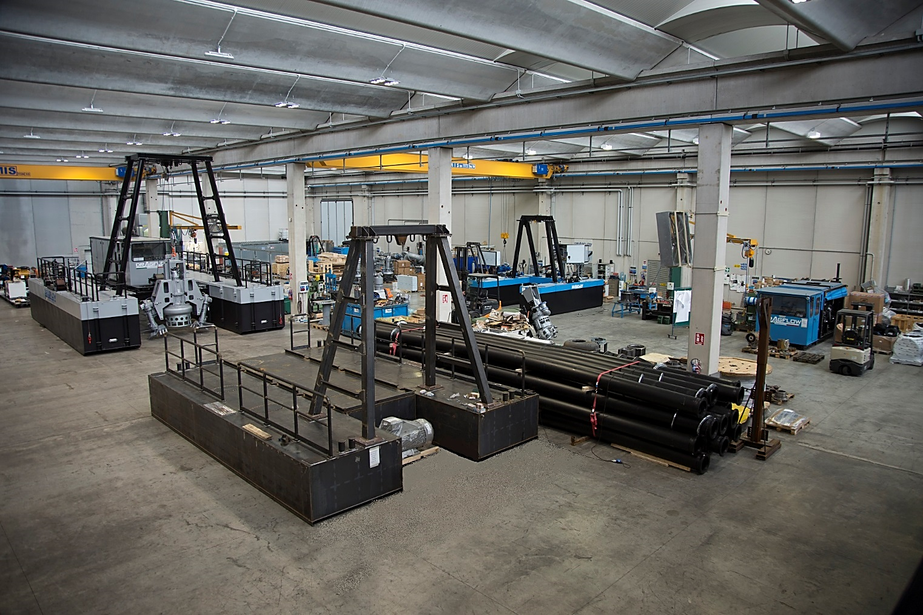

In the first place. A contract for five (5) dredgers, model DRH300E23 has won for sand and gravel extraction in Middle East. The dredgers are equipped with a DRAGFLOW Hydraulic pump model HY300 and a CAT C13 engine. They will operate at minus 40m depth for sand extraction. The material is delivered at 1 km distance, with a 350mm hose.

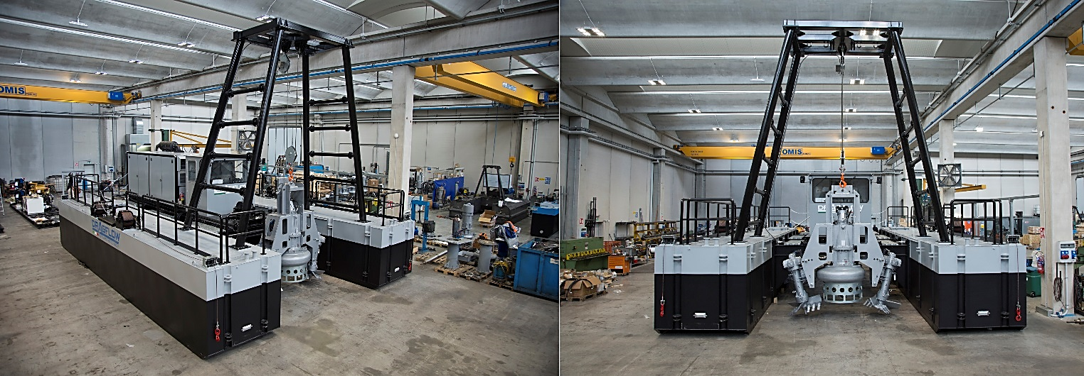

A second contract has been signed with a large company, leader in processing aggregates for concrete, cement and asphalt production, with facilities in 90 countries. They selected a DRAGFLOW Remote Controlled Dredge model DRP120, equipped with a DRAGFLOW electric pump EL1204, with 2 electric excavators EXEL20, to dredge a settlement pond, fed by the aggregates washing plant.
Our dredging system is unique thanks to the compact dimensions that still guarantee optimal performances. Based on the client's request, the DRAGFLOW dredge can be controlled remotely or through the on-board panels, and it includes a PLC that supervises all parameters and the dredge location during the operation. In case the side excavators are blocked with material or large objects, these can be unblocked automatically by the PLC inverting the cutter heads rotational direction. The dredging unit can also work partially outside the water, thanks to the custom-designed water cooling system of the dredge. The dredge is also equipped with a high-pressure water jet-ring system to dredge the mud also when the water level is minimum.

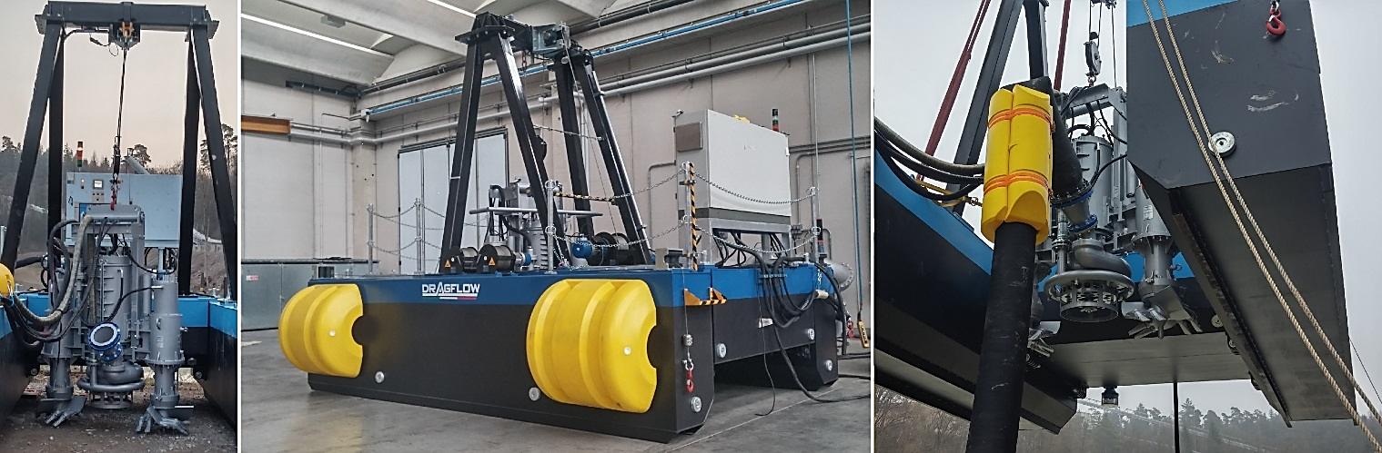

One of theworld's largest mining companies ordered a DRAGFLOW Dredge DRH85/160E22 for an iron mine in Brazil. The iron ore, mixed with water, is pumped from the mine to the shore for more than 500 km through a “Mineral Duct” (mineral duct pipeline). Once the mineral arrives to the port terminal, it gets separated from the water and loaded on barges for the ocean transportation. Along this long pipeline there are some booster stations and speed control valves. When those are under maintenance they need to stop the pumping to the shore and material coming from the plant is diverted and discharged into tailing pond. Here is where the DRAGFLOW dredge will be positioned.
The iron tailings will be dredged and returned to the circuit going to the coast. It is crucial for the project to maintain the maximum capacity of this pond in case they need to deal with emergencies.
The tailings have a high content of Iron with specific gravity up to 4,9 kg/dm3. Only a super duty dredging pump with an oversize motor could do the job. The dredging unit is composed by a DRAGFLOW hydraulic pump HY85/180 with two hydraulic excavators EXHY20 and jet-ring system. The hydraulic power pack on the dredge is equipped with an electric motor and the power cord is floating from the shore to the power pack. The dredge can be controlled by one operator inside the control cabin or directly from the shore through a wireless joystick.

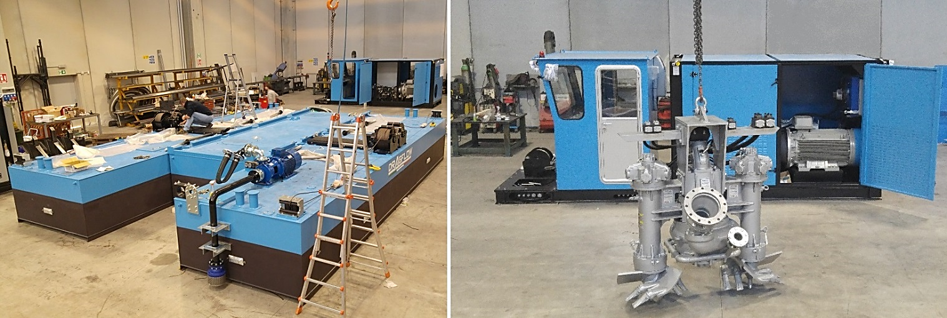

Finally, DRAGFLOW just delivered two Remote Controlled Dredgers model DRP60 to the biggest phosphate mining company in Morocco. The dredgers have a capacity of 400m3/h as well as a water jets system to help break the settled material and increase the overall efficiency of the project. The dredgers will be used on two tailing dams to pump processed phosphate ore back the plant for reprocessing. The dredgers are part of a slurry pipeline in which three other DRAGFLOW pumps are being used, including a 300HP electric submersible slurry pump. The proposed solution proved to be the most reliable proposal due to its compact construction, ease of use and the robustness that characterizes DRAGFLOW pumps around the world.



