AUMUND India celebrates 20 Years of successful business
Chennai, November 2016

When AUMUND India opened up 20 years ago in Chennai it was a small sales organisation of only 6 people. But since then it has grown and developed to such an extent that it now includes engineering, software development, manufacturing, and exports of engineering services and components among its activities, and comprises 50 people.
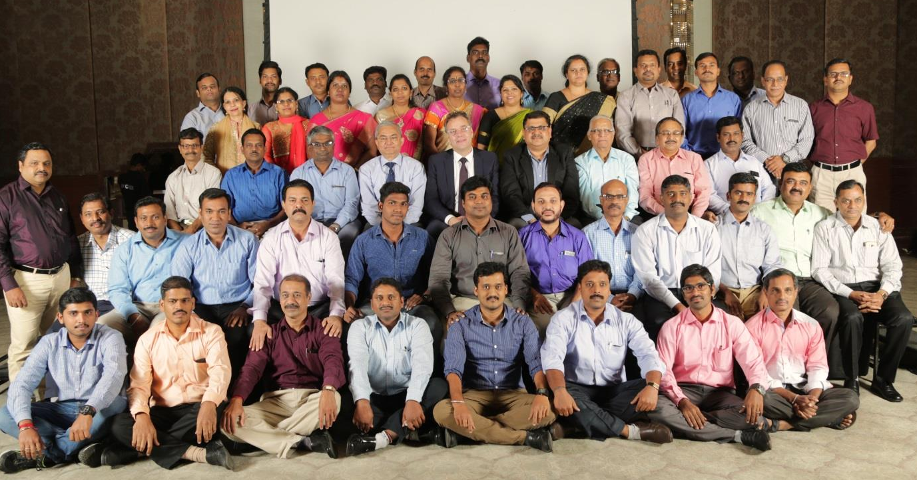
Day of celebration: the AUMUND India team with Prasad Rao, AUMUND Board Member,
Andreas Klottka, Managing Director AUMUND Holding, Raju Gupta, Managing Director AUMUND India (3rd row, in the middle)

A.D. Prasad Rao and Raju Gupta were the two key personnel who started the operation. At the time both had business backgrounds in the cement industry, Prasad Rao more in marketing and Raju Gupta in project management and engineering. Together they operated as joint Managing Directors until 2012, when Prasad Rao retired from executive duties, but the business has continued to rely on his experience since then as a Board member. Raju Gupta, meanwhile, has operated as sole Managing Director since Prasad Rao’s retirement.

AUMUND India has achieved several notable milestones over the course of its first 20 years; initiating Calculation and Parametric Programming, Project Engineering for major cement plants, RDM localization, and production of Elevators, Pan Conveyors, Silo discharge gates, Samson® Feeders and Scraper Conveyors, sold by AUMUND subsidiaries around the world. Within the global AUMUND Group, AUMUND India has become the second technical centre outside of AUMUND Fördertechnik GmbH in Germany. It is expected that AUMUND India will play a bigger role in future in supporting the Group, especially in Engineering and Project Management.

About the AUMUND Group
The AUMUND Group is active worldwide. The conveying and storage specialists have special expertise at their disposal when dealing with bulk materials. With their high degree of individuality, both its technically sophisticated as well as innovative products have contributed to the AUMUND Group today being a market leader in many areas of conveying and storage technology. The manufacturing companies AUMUND Fördertechnik GmbH (Rheinberg, Germany), SCHADE Lagertechnik GmbH (Gelsenkirchen, Germany), SAMSON Materials Handling Ltd. (Ely, England), as well as AUMUND Logistic GmbH (Rheinberg, Germany) are consolidated under the umbrella of the AUMUND Group. In conjunction with the headquarters of the manufacturing companies, the global conveying and storage technology business is spearheaded through a total of ten locations in Asia, Europe, North and South America and a total of five warehouses in Germany, USA, Brazil, Hong Kong and Riyadh.

AUMUND Engineering Private Ltd.
2nd Floor, Lakshmi Neela Rite Choice
Chambers 9, Bazulla Road
T. Nagar Chennai – 600 017 / India
aumund@vsnl.com

Press office

AUMUND Holding B.V.
Wilhelminapark 40
5911 EE Venlo / The Netherlands
Phone: +31 77 32 00 111
marketing@aumund-holding.nl
www.aumund.com

