
PRESS RELEASE
Contact: | Monya Vermaak
Telephone no: | (011) 314-4021 | 
Email address: | Monya.Vermaak@plasticssa.co.za
Website: | www.plasticsinfo.co.za

PLASTICS|SA HELPS INDUSTRY MEMBERS PREPARE FOR AN UNCERTAIN FUTURE

Energy experts give advice on how to face the current economic downturn
by implementing energy and water solutions

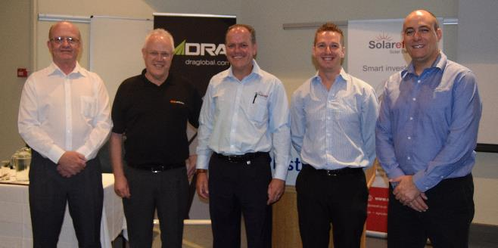
Johannesburg, 14 November 2016. The Sustainability Council of Plastics|SA and DRA Global Engineering Consultants hosted a seminar entitled “Preparing for an uncertain future” in which a panel of sustainability experts presented their thoughts on how companies could remain competitive in the face of the current economic downturn by implementing energy and water solutions.
L to R: Wynand Van Der Merwe (NCPC), Chris Yelland (EE Publishers), Gerard Grobler (Solareff), Jacques (PlasticsǀSA), Miquel de Santos (DRA Global)

The event took place at the Plastics|SA head office in Midrand, and was attended by more than 30 guests, which included recycling companies, plastic manufacturers, energy consultants and media.

According to Jacques Lightfoot, Sustainability Manager of Plastics|SA, energy and water solutions are of integral importance for the plastics industry. “Resource efficiency is one of our key strategies. By hosting seminars such as these, we are fulfilling our mandate and facilitating an important link between service providers and the plastics industry which needs guidance on how to remain competitive and profitable,” he says.

Speakers at the seminar included well known journalist and winner of the SANEA Journalism Award for ‘special efforts within the field of journalism, to promote greater understanding of energy and its role in sustaining human endeavours’, Chris Yelland, who presented on the topic “Making sense of energy in a chaotic environment”. Yelland was followed by Maggie Matumba and Wynand Van Der Merwe of the National Cleaner Production Centre of South Africa (NCPC-SA) - a national governmental programme that promotes the implementation of resource efficiency and cleaner production methodologies to assist industry to lower costs through reduced energy, water and materials usage, and waste management.

more 2/…
uncertain future summit two

The final speaker of the day was Miguel Dos Santos of DRA - a multi-disciplinary global engineering group that delivers mining, mineral processing, energy, agriculture, water treatment and infrastructure services from concept to commissioning and comprehensive operations and maintenance services.

“In South Africa we are feeling the strain of ever-increasing energy costs and the uncertainty of supply as the National Power Grid struggles to meet our energy demands. Businesses have to seriously consider turning to alternative energy sources to mitigate the impact of these factors,” Dos Santos said.

“I am very impressed with the commitment to industrial symbiosis I have seen amongst South African companies,” said Linsey Dyer, DRA’s Business Development Manager. “One of the keys to resource efficiency is allowing companies to use each other’s unused or residual resources, such as materials, energy, water, waste, assets, logistics and expertise. Although still a relatively new concept in South Africa, business leaders here are keen to embrace this concept which results in numerous mutual economic, social and environmental benefits,” she says.

“I greatly benefited from attending the seminar,” commented Renier Snyman of DPI Plastics. “It was very insightful and a bit concerning to hear the experts’ take on the true state of the energy and water supply in the country. These are issues that affect every business directly, and it was valuable to hear what some of the short term and long term steps are that we can take to help us prepare for the years to come”.

The link to our web page on this subject to download or view the presentations http://www.plasticsinfo.co.za/2016/11/10/preparing-uncertain-future/

ENDS

