
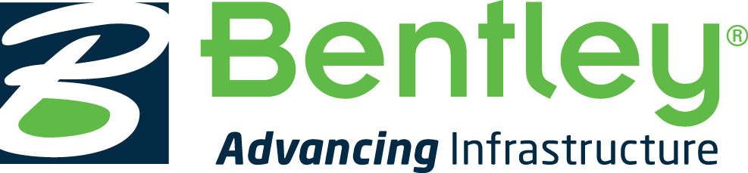

News Release
Press Contacts:
Gail McGrew
+1 610 458 2752
gail.mcgrew@bentley.com
Follow us on Twitter:
@BentleySystems

Press Information
Topcon Positioning Group
CorpComm@topcon.com
USA: Staci Fitzgerald, +1 925-245-8610
Europe: Stuart Proctor, +31 10 458 50 77
www.topconpositioning.com

Bentley Systems and Topcon join forces to advance cloud services for ‘constructioneering’

Engineers’ connected data environments will span survey and construction processes for comprehensive project delivery benefits

LONDON – The Year in Infrastructure 2016 Conference – 2 November 2016 – Topcon Positioning Group, a world leader in positioning instruments for survey and construction, and Bentley Systems, a leading global provider of comprehensive software solutions for advancing infrastructure, today announced their joint intentions to connect cloud services for constructioneering. During the keynote presentations, the companies’ CEOs presented new construction workflows designed to increase efficiency and productivity with enhanced integration between their respective cloud services.

Each company will bring to market cloud-based solution offerings, which include services of both and provide construction workflows not previously possible. Initially, Bentley Systems will offer its ProjectWise CONNECT Edition users seamless connectivity with MAGNET Enterprise, and Topcon will incorporate ContextCapture image processing for its mass data collection via unmanned aerial systems (UAS).

“Topcon and Bentley share a vision about the advancements we can achieve through what I call the continuous representation of reality,” said Ray O’Connor, president and CEO, Topcon Positioning Group. “We also share a commitment to rolling up our sleeves and working together to make possible tangible results and real benefits for our customers as we advance constructioneering. I believe that our strategic collaboration will continue to integrate surveying, engineering, and construction, improving outcomes for project delivery.”

Greg Bentley, CEO, Bentley Systems, said, “To date, surveying, engineering, and construction industries have separately advanced to 3D technologies. But unbelievably, until now, 3D models have been recreated—rather than reused—at each phase. It’s been exciting to work with Topcon to introduce constructioneering so that our engineering users can start from the reality-captured survey context and leverage and update their digital engineering models through the construction process. Our joint cloud service innovations for constructing and improving roadways, including as-built capture, are enabling the highest level of workflow automation. I believe that Topcon will continue to pioneer new positioning devices to take advantage of every emerging opportunity, and we are enthusiastic about working with them to advance constructioneering into the mainstream for infrastructure projects around the world.”

Compared to traditional workflows between design and construction in which data from survey and digital engineering models can be lost and inefficiently recreated, constructioneering empowers engineers to extend their role within both surveying and construction.

Cloud services first bring the construction site conditions to the engineers so their work starts with an accurate model of the current 3D context—as captured by Topcon UAS photogrammetry and laser scanners—and then processed into engineering-ready 3D reality meshes by Bentley’s ContextCapture software. Cloud services subsequently convey the engineers’ work directly to construction processes in the field. This automation process—achieved through the connection between Topcon MAGNET cloud service and Bentley’s ProjectWise CONNECT Edition cloud services—improves project delivery, with design performed in context, and the resulting digital engineering models feeding the 3D machine control that guides the construction machinery.
Topcon and Bentley expect to expand the constructioneering workflow to further applications for infrastructure services.

About Topcon Positioning Group

Topcon Positioning Group is headquartered in Livermore, California, USA (topconpositioning.com). Its European head office is in Capelle a/d IJssel, the Netherlands (topconpositioning.eu). Topcon Positioning Group designs, manufactures, and distributes precise positioning products and solutions for the global surveying, construction, agriculture, civil engineering, BIM, mapping and GIS, asset management, and mobile control markets. Its brands include Topcon, Sokkia, Tierra, Wachendorff Elektronik, Digi-Star, RDS Technology, and NORAC. Topcon Corporation (topcon.com), founded in 1932, is traded on the Tokyo Stock Exchange (7732).

About Bentley Systems

Bentley Systems is a global leader in providing architects, engineers, geospatial professionals, constructors, and owner-operators with comprehensive software solutions for advancing the design, construction, and operations of infrastructure. Bentley users leverage information mobility across disciplines and throughout the infrastructure lifecycle to deliver better-performing projects and assets. Bentley solutions encompass MicroStation applications for information modeling, ProjectWise collaboration services to deliver integrated projects, and AssetWise operations services to achieve intelligent infrastructure – complemented by worldwide professional services and comprehensive managed services.

Founded in 1984, Bentley has more than 3,000 colleagues in over 50 countries, more than $600 million in annual revenues, and since 2009 has invested more than $1 billion in research, development, and acquisitions.

Additional information about Bentley is available at www.bentley.com. For Bentley news as it happens, subscribe to an RSS feed of Bentley press releases and news alerts. Visit The Year in Infrastructure Conference website for information on Bentley’s premier thought-leadership event. To view a searchable collection of innovative infrastructure projects from the annual Be Inspired Awards, access Bentley’s Infrastructure Yearbooks. To access a professional networking site that enables members of the infrastructure community to connect, communicate, and learn from each other, visit Bentley Communities.

To download the Bentley Infrastructure 500 Top Owners ranking, a unique global compendium of the top public- and private-sector owners of infrastructure based on the value of their cumulative infrastructure investments, visit BI 500.
# # #
Bentley, the “B” Bentley logo, Be, Bentley Institute, MicroStation, AssetWise, and ProjectWise are either registered or unregistered trademarks or service marks of Bentley Systems, Incorporated or one of its direct or indirect wholly owned subsidiaries. All other brands and product names are trademarks of their respective owners.

