
S
Contact: Louise Muller
Company: SAPPMA
Phone: (011) 314-4021
Email: Admin@sappma.co.za
Website: www.sappma.co.za

PRESS RELEASE

SAPPMA APPOINTS NEW BOARD MEMBERS AT ITS 12TH AGM
“As times get tougher, the need for an effective association in the value chain of plastics pipe only increases”

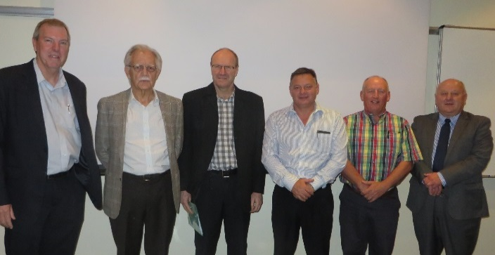
Johannesburg, 20 October 2016. The South African Plastic Pipes Manufacturers Association (SAPPMA) held their 12th Annual General Meeting in Midrand on the 5th October 2016.
FLTR: Brett Kimber, Jan Venter (SAPPMA CEO), Terence Hobson, Steve du Toit, Wally van Coller and Bernhard Mahl (Chairman)

Speaking to the more than 40 captains of industry that were in attendance, Chief Executive Officer Jan Venter reiterated that SAPPMA’s main focus this coming year will continue to be improving the long-term health of the plastics pipe industry.

He also made use of the opportunity to thank the team of volunteers serving on SAPPMA’s Technical Committee, for striving towards ensuring good product quality, an adherence to industry standards, accessing and sharing technical information, and delivering ongoing training and marketing services.

“The value of the Technical Committee cannot be overemphasized. Since its modest beginnings in 2005 it has been the main generator of improvement in the very wide variety of technical aspects of the plastic pipe industry. In order to further improve and streamline its effectiveness there will be a meeting /workshop early in the New year aimed at exploring new ways and means to continue fulfilling this mandate,” Venter said.

Four new SAPPMA members were elected to serve on the board. Brett Kimber (Marley Pipe Systems), Steve du Toit (DPI Plastics), Terence Hobson (Sun Ace) and Wally van Coller (Rare Plastics) will be joining Bernhard Mahl (Safripol) and CP Bandaru (Flotek) who will be continuing their two-year period as Directors.

The winners of the annual Merit Awards were also announced, a tradition that was instituted in 2008 with the aim of recognizing and rewarding the input and effort of individual SAPPMA members. Renier Snyman (DPI Plastics), Ian Venter (Marley Pipe Systems) and George Diliyannis (Safripol) were awarded the 2016 Merit Awards for their contributions and frequency of attending meetings.

more 2/…
sappma agm 2016 two

Looking ahead, Venter emphasized that as times get tougher on the socio-economic front, the need for an effective association in the value chain of plastics pipe only increases. “SAPPMA will continue to do all they can to improve the long-term viability of the plastics pipe industry in general and the members in particular. In terms of the mandate confirmed at the Special Quality Meeting held earlier this year, our main focus continue to be on ensuring top quality plastic pipes and installations. To this end, we have revised the Association’s Code of Conduct – particularly in terms of action in cases of repeated transgressions. We will also be updating the SAPPMA Technical Manual to reflect this amendment when it is reprinted in the first half of 2017.”

For more information about SAPPMA, visit www.sappma.co.za

ENDS

For media enquiries, contact:
Monique Holtzhausen
Aim Marketing & Communications Consultants
Tel: (021) 531-0313
Cell: (071) 083-5219
Email: Monique@aimmarketign.co.za

