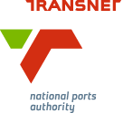
MEDIA RELEASE

SA Ports Geared for 2016/17 Cruise Season

[Durban, South Africa, 26 October 2016] South Africa’s ports are ramping up for another busy cruise season with at least 14 luxury cruise lines and 20 vessels of varying sizes set to ferry international and domestic tourists across the country’s port cities.

The 2016/17 South African cruise season kicks off on 1 November. MSC SINFONIA – the largest and most popular cruise ship in the local cruise calendar – will be a highlight when she arrives in her homeport of Durban in the early hours of Tuesday, 1 November on a journey from Venice, Italy, carrying 2600 European and South African passengers.

The ship has been accommodated at the Port of Durban’s longer M berth since last year after being lengthened by 24 metres and undergoing a multi-million Euro revamp.

Also returning this season are Oceania Cruises with its vessels INSIGNIA and NAUTICA, Regent Seven Sea Cruises with VOYAGER, Silversea Cruises with SILVER CLOUD, MS AMADEA, owned by Amadea Shipping Company, and Hapag-Lloyd Cruises’ EUROPA.

Cunard Lines will again bring two prestigious vessels to the country this year, QUEEN MARY 2 and QUEEN ELIZABETH, both of which will call at Cape Town and Port Elizabeth.

Australian ship, OCEAN DREAM, chartered by Peace Boat, and Semester at Sea’s charter ship, WORLD ODYSSEY, once again make once-off calls this season to Cape Town bringing international students to the country as part of their respective global study programmes.

New vessels this season include LE LYRIAL, which was built only last year for Compagnie du Ponant. The vessel will call at Durban and Cape Town.

Another newcomer is AZAMARA run by Azamara Club Cruises, which will call at Cape Town. Germany-based travel agency Phoenix Reisen which sailed South Africa last season with the MS ALBATROS, will bring its MV ARTANIA to Cape Town this season.

In Durban, cruise vessels other than MSC SINFONIA continue to use the port’s N-Shed, which was upgraded ahead of the 2015/16 cruise season in a joint exercise between TNPA and MSC Cruises. N-Shed now boasts a number of new features for an improved passenger experience such as new signage, immigration and check-in desks, a new fast track lounge, new baggage scanners and conveyor belt, an air-conditioning system, extra seating, balustrades, turnstiles and sail shades, new ramps and a back-up generator and UPS in the event of load shedding. TNPA has also made a number of changes to its operational processes to ensure visitors to the passenger terminal enjoy a smoother boarding and disembarkation.

The Port of Durban is set to award its tender for the development a new passenger terminal by February 2017.

Meanwhile in Cape Town the V&A Waterfront (Pty) Ltd has taken over operation of the passenger terminal as part of its contract for operation, maintenance and transfer of ownership of the Cape Town passenger terminal back to TNPA after a period of 20 years. The Cape Town facility will remain at E berth, Duncan Dock, in the Port of Cape Town. V&A Waterfront’s focus is primarily on enhancing the cruise passenger experience. The operator completed the first phase of improvements at the terminal ahead of the last cruise season as part of a three-phase growth plan.

Both passenger terminal projects fall under the Section 56 allowance of the National Ports Act 12 of 2005 which mandates TNPA to enter into agreements with private companies to design, develop, construct, maintain and operate facilities to ensure the provision of port services.

Cruise liner calls to South Africa throughout the season include the following, although dates may be subject to change.

** indicates a vessel’s first call to South Africa this season.

Vessel | Cruise Line | Calls
NOVEMBER
MSC SINFONIA ** | MSC Cruises | Durban – 1 November
MS EUROPA 2** | Hapag-Lloyd | Cape Town – 3 to 4 November  Port Elizabeth – 6 to 7 November  Richards Bay – 10 November
MSC SINFONIA | MSC Cruises | Durban – 5 November, returning  Durban – 7 November
RMS ST HELENA ** |  | Cape Town – 8 to 10 November
MV ARTANIA ** | Phoenix Reisen | Cape Town – 9 to 12 November  Port Elizabeth – 14 November  East London – 15 November  Richards Bay – 18 November
MSC SINFONIA | MSC Cruises | Durban – 11 November
SEVEN SEAS NAVIGATOR ** | Regent Seven Seas Cruises | Port Elizabeth – 14 November  Cape Town – 15 to 16 November  Richards Bay – 19 November
MSC SINFONIA | MSC Cruises | Durban – 18 November, returning  Durban – 21 November
SEVEN SEAS NAVIGATOR | Regent Seven Seas Cruises | Durban – 21 to 22 November  East London – 23 November
INSIGNIA ** | Oceania Cruises | Durban – 22 November  Richards Bay – 24 November  Cape Town – 28 to 29 November
MSC SINFONIA | MSC Cruises | Durban – 25 November, returning  Durban – 28 November
RMS ST HELENA |  | Cape Town – 28 November to 1 December
SEVEN SEAS NAVIGATOR | Regent Seven Seas Cruises | Cape Town – 30 November to 2 December
DECEMBER
RMS ST HELENA |  | Cape Town – 28 November to 1 December
SEVEN SEAS NAVIGATOR | Regent Seven Seas Cruises | Cape Town – 30 November to 2 December
MSC SINFONIA | MSC Cruises | Durban – 2 December, returning  Durban – 5 December
MSC SINFONIA | MSC Cruises | Durban – 9 December, returning  Durban – 12 December
AKADEMIK TRESHNIKOV | (polar research vessel) | Cape Town – 15 to 20 December
MSC SINFONIA | MSC Cruises | Durban – 16 December, returning  Durban – 19 December
NAUTICA ** | Oceania Cruises | Richards Bay – 17 December  Cape Town – 20 to 21 December  Richards Bay – 24 December  Durban – 26 to 27 December  Port Elizabeth – 29 December
SILVER CLOUD ** | Silversea Cruises | Richards Bay – 15 December  Port Elizabeth – 19 December  Cape Town – 21 December  Port Elizabeth – 27 December  East London – 28 December  Richards Bay – 30 December
MSC SINFONIA | MSC Cruises | Durban – 26 December
RMS ST HELENA |  | Cape Town – 27 to 30 December
VOYAGER ** | Regent Seven Seas Cruises | Durban – 30 to 31 December
JANUARY
MSC SINFONIA | MSC Cruises | Durban – 1 January
M/V LE LYRIAL ** | Compagnie du Ponant | Durban – 1 January
SILVER CLOUD | Silversea Cruises | Cape Town – 3 to 4 January
MSC SINFONIA | MSC Cruises | Durban – 6 January
NAUTICA | Oceania Cruises | Cape Town – 4 to 6 January  Port Elizabeth – 8 January  Richards Bay – 11 January
MSC SINFONIA | MSC Cruises | Cape Town – 9 January
OCEAN DREAM ** | Peace Boat | Cape Town – 11 January
SILVER CLOUD | Silversea Cruises | Port Elizabeth – 10 January  Durban – 12 January  Richards Bay – 13 January
RMS ST HELENA |  | Cape Town – 11 to 13 January
MSC SINFONIA | MSC Cruises | Cape Town – 13 January, returning 15 January
SILVER CLOUD | Silversea Cruises | Cape Town – 17 to 18 January  Port Elizabeth – 20 January
MSC SINFONIA | MSC Cruises | Cape Town – 20 January
RMS ST HELENA |  | Cape Town – 22 to 24 January
MSC SINFONIA | MSC Cruises | Cape Town – 23 January  Port Elizabeth – 25 January
AMADEA ** | Amadea Shipping Company | Richards Bay – 23 January  [see additional calls below]
SILVER CLOUD | Silversea Cruises | Richards Bay – 23 January  Durban – 25 January
QUEEN MARY II ** | Cunard Lines | Cape Town - 26 to 27 January
MSC SINFONIA | MSC Cruises | Durban – 27 January
AMADEA | Amadea Shipping Company | East London – 26 January  Port Elizabeth – 27 January  Cape Town - 29 January to 1 February
SILVER CLOUD | Silversea Cruises | Cape Town – 28 January
QUEEN MARY II | Cunard Lines | Port Elizabeth – 29 January
MSC SINFONIA | MSC Cruises | Durban – 29 January
AMADEA | Amadea Shipping Company | Cape Town - 29 January to 1 February
SILVER CLOUD | Silversea Cruises | Port Elizabeth – 30 January
FEBRUARY
AMADEA | Amadea Shipping Company | Cape Town - 29 January to 1 February
SUN PRINCESS ** | Princess Cruises | Cape Town – 2 to 4 February
SILVER CLOUD | Silversea Cruises | Richards Bay – 2 February  Durban – 4 February  Cape Town – 7 February  Port Elizabeth – 9 February
MSC SINFONIA | MSC Cruises | Durban – 3 February, returning  Durban – 6 February
MSC SINFONIA | MSC Cruises | Durban – 10 February, returning  Durban – 13 February
SILVER CLOUD | Silversea Cruises | Richards Bay – 12 February  Durban – 14 February
MSC SINFONIA | MSC Cruises | Durban – 17 February, returning  Durban – 20 February
SILVER CLOUD | Silversea Cruises | Cape Town – 17 February  Port Elizabeth – 19 February  Richards Bay – 22 February  Durban – 24 February
MSC SINFONIA | MSC Cruises | Durban – 24 February, returning  Durban – 27 February
SILVER CLOUD | Silversea Cruises | Cape Town – 27 February
MARCH
SILVER CLOUD | Silversea Cruises | Port Elizabeth – 1 March  Durban – 3 March  Richards Bay – 4 March
MSC SINFONIA | MSC Cruises | Durban – 3 March, returning  Durban – 6 March
RMS ST HELENA |  | Cape Town – 3 to 5 March
MSC SINFONIA | MSC Cruises | Durban – 10 March, returning  Durban – 13 March
MSC SINFONIA | MSC Cruises | Durban – 17 March
AKADEMIK TRESHNIKOV | (polar research vessel) | Cape Town – 18 to 22 March
WORLD ODYSSEY** | Semester at Sea | Cape Town – 19 to 24 March
RMS ST HELENA |  | Cape Town – 23 to 25 March
SILVER CLOUD | Silversea Cruises | Durban – 24 March
M/V LE LYRIAL | Compagnie du Ponant | Cape Town - 24 – 26 March
MSC SINFONIA | MSC Cruises | Durban – 24 March, returning  Durban – 27 March
MSC SINFONIA | MSC Cruises | Durban – 27 March, returning  Durban – 31 March
SILVER EXPLORER ** | Silversea Cruises | Cape Town - 29-30 March
VOYAGER | Regent Seven Seas Cruises | Richards Bay – 25 March  Cape Town – 31 March to 2 April
APRIL
VOYAGER | Regent Seven Seas Cruises | Cape Town – 31 March to 2 April
MSC SINFONIA | MSC Cruises | Durban – 3 April
MSC SINFONIA | MSC Cruises | Durban – 7 April
MSC SINFONIA | MSC Cruises | Durban – 10 April
RMS ST HELENA |  | Cape Town – 12 to 14 April
MSC SINFONIA | MSC Cruises | Durban – 14 April
MSC SINFONIA | MSC Cruises | Durban – 17 April
QUEEN ELIZABETH ** | Cunard Lines | Port Elizabeth – 17 April  Cape Town - 19-20 April
MSC SINFONIA | MSC Cruises | Cape Town – 20 April
MSC SINFONIA | MSC Cruises | Cape Town – 24 April
MSC SINFONIA | MSC Cruises | Cape Town – 28 April
MSC SINFONIA | MSC Cruises | Cape Town – 30 April
MAY
RMS ST HELENA |  | Cape Town – 2 to 4 May
MSC SINFONIA | MSC Cruises | Cape Town – 5 May
AZAMARA ** | Azamara Club Cruises | Cape Town - 14 – 17 May
RMS ST HELENA |  | Cape Town – 22 to 24 April

Ends

Image Gallery overleaf

Image Gallery:
Below Middle: Oceania Cruises’ NAUTICA is a smaller ship with port calls including Richards Bay, Durban, Port Elizabeth, and Cape Town this season before setting sail for Singapore and Hong Kong in December. Oceania Cruises also has its INSIGNIA sailing in South Africa this season.
Below Right: RMS St Helena is a unique cargo-passenger ship that sails to the island of St Helena. She is one of the last working Royal Mail ships in the world. Her final voyages are in 2016.
Below Left: MSC Cruises’ MSC SINFONIA will be accommodated at her homeport in Durban as well as the Port of Cape Town.

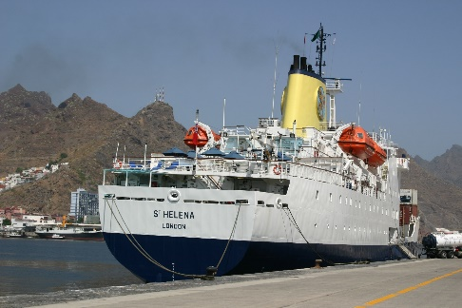
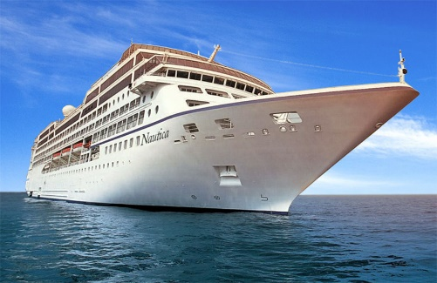
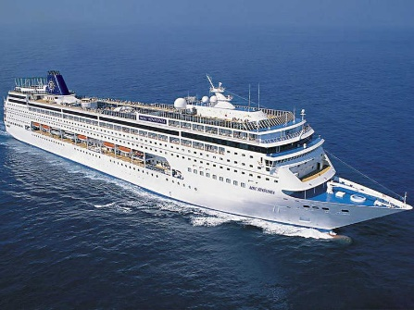
Below Right: WORLD ODYSSEY, chartered by Semester At Sea. For more than 50 years the organisation has worked with various shipping lines to charter vessels that serve as a floating home and university campus taking 600 undergraduate students to the farthest reaches of the globe every semester, giving deeper meaning to education, experiential learning, and community. The ship calls at Cape Town in March.

Below Middle: QUEEN ELIZABETH is the second largest ship constructed for Cunard Lines, exceeded only by Queen Mary 2, and is capable of carrying around 2,000 passengers. She will call at Cape Town and Port Elizabeth in April.
Below Left: OCEAN DREAM is chartered by Japan-based international non-governmental and non-profit organisation, Peace Boat, which works to promote peace, human rights, equal and sustainable development and respect for the environment. Educational activities aboard the ship include peace education workshops and lectures, language classes and cultural programmes.

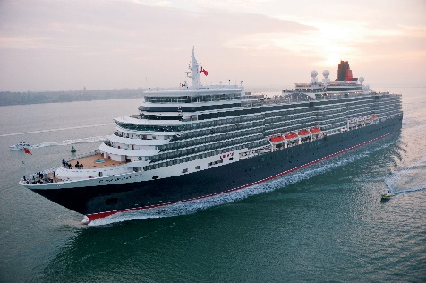
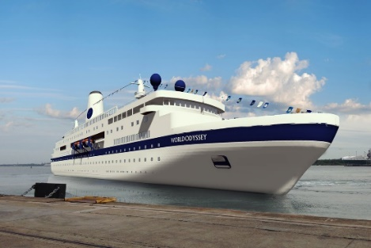
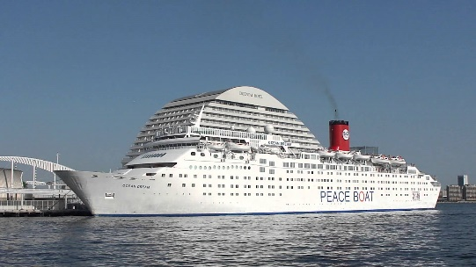

About Transnet National Ports Authority
Transnet National Ports Authority (TNPA) is one of five operating divisions of Transnet SOC Ltd. The National Ports Authority is responsible for the safe, effective and efficient economic functioning of the national port system, which it manages in a landlord capacity. It provides port infrastructure and marine services at the eight commercial seaports in South Africa – Richards Bay, Durban, Saldanha, Cape Town, Port Elizabeth, East London, Mossel Bay and Ngqura. It operates within a legislative and regulatory environment and is governed by the National Ports Act (Act No. 12 of 2005). For more information visit www.transnetnationalportsauthority.net.



Issued by:
Lunga Ngcobo
GM: Corporate Affairs
Transnet National Ports Authority
Tel: 011 351 9013
Lunga.Ngcobo@transnet.net

On behalf of:
Richard Vallihu
Chief Executive
Transnet National Ports Authority

