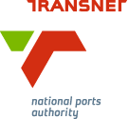
MEDIA RELEASE

Port projects tweaked to suit market

[Durban, South Africa, 26 October 2016] Transnet National Ports Authority (TNPA) said it had built flexibility into the tender specifications for Operation Phakisa new build projects at its ports in order to meet the current economic climate.

Speaking at the African Ports Evolution 2016 Conference in Durban last week, Ricky Bhikraj, Executive Manager for Capacity and Enablement at TNPA and Programme Director of the Authority’s Operation Phakisa programme, said: “The global economic slowdown and lower oil price has had implications for new facilities being built by TNPA under the government’s Operation Phakisa initiative. We remain committed to advancing these projects but will continue to realign our expectations with the expectations of investors in order to come up with collaborative solutions that are matched with market risk. We have built in the potential to scale projects up as required.”

TNPA is playing a key role in the South African government’s Operation Phakisa: Oceans Economy initiative that aims to grow the economy through marine transport and manufacturing.

Greenfield projects earmarked include new capacity creation projects at the Ports of Saldanha, Richards Bay and East London. These are planned as public participation partnerships (PSPs).

At the Port of Saldanha three key facilities are envisaged to service the offshore oil and gas industry supported by developments in the Saldanha Bay Industrial Development Zone (IDZ). A bidder is expected to be appointed by the end of December 2016 to develop South Africa’s first offshore supply base, which could operate as an Oil and Gas multipurpose terminal if the market dictates this in the initial phase. The expression of interest closed on 2 August for lengthening of the Port’s Mossgas finger jetty to accommodate rigs repairs and TNPA was now considering responses. The expression of interest for the construction and operation of a new dedicated deepwater rig repair berth as berth 205 also closed in August.

At the Port of Richards Bay TNPA is looking into procuring a flexible ship repair facility through the private sector. This would allow the industry to identify opportunities in oil and gas support, ship repair and associated marine manufacturing activities supported by the Richards Bay IDZ at the port. Potential sites for these projects are identified as the undeveloped Causarina area of the port and the repair quay.

In East London TNPA is looking at creating a new boat building industry with a focus on potential niche markets of tug boats and navy vessels which includes the currently underutilised Dry Dock complex. This would require the upgrade and refurbishment of the existing dry dock infrastructure and the old and slipway. The expression of interest for the project closed in August 2016.

All the new build projects under Operation Phakisa are expected to be fully operational by December 2019.

Bhikraj said TNPA was at an advanced stage of refurbishing existing ship repair facilities at the ports of Durban, East London, Port Elizabeth, Mossel Bay and Cape Town.

In the Port of Port Elizabeth the boat repair facility has been refurbished and extended and a new 90 ton boat hoist and 40 ton slipway have been introduced. This has increased the port’s servicing capacity from three to 10 fishing trawlers.

In Durban the dry dock’s outer caisson was refurbished at a cost of R35 million while the rehabilitation options for the dry dock’s inner caisson have been finalised for tender. A concrete refurbishment programme is scheduled to be completed by the end of October. New cranes are being procured towards the modernisation of the precinct’s Workshop 24 and pump house. The existing floating dock was also being assessed by specialists to determine the possibility and extent of repairs required ahead of a decision to build a new large floating dock locally.

The Port of Cape Town’s Synchrolift Traverser repairs were completed in February 2016. Specialist studies are underway for the refurbishments and upgrades at the Sturrock Dry Dock and Robinson Dry Dock. New circulating pumps have been installed at the Sturrock Dry Dock.

Transnet National Ports Authority will be replacing ten cranes at the Durban Dry Dock complex and ten cranes at the Cape Town Dry Dock complex. Transnet SOC Ltd is developing a procurement strategy and finalising the governance process to partner with original equipment manufacturers to supply 20 cranes as part of Operation Phakisa. The envisaged partnerships will serve to localise manufacturing capability in the production and supply of cranes.

For further information about African Ports Evolution, visit http://www.portsevolution.com/

Ends

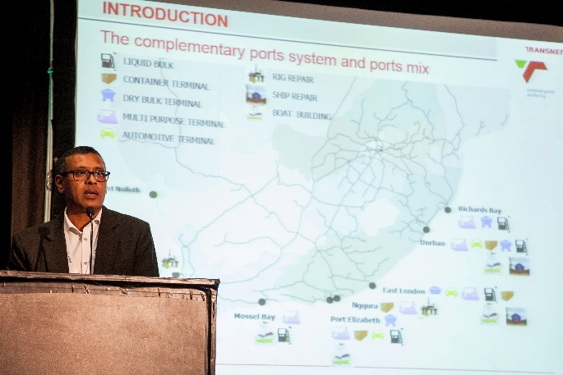
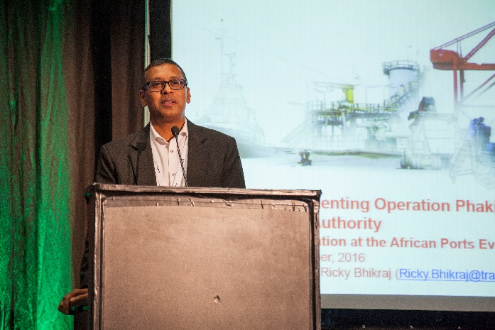
Image Gallery
Below: Ricky Bhikraj, Executive Manager for Capacity and Enablement at TNPA and Programme Director of the Authority’s Operation Phakisa programme, addressing delegates at the African Ports Evolution conference on Wednesday, 19 October.

About Transnet National Ports Authority
Transnet National Ports Authority (TNPA) is one of five operating divisions of Transnet SOC Ltd. The National Ports Authority is responsible for the safe, effective and efficient economic functioning of the national port system, which it manages in a landlord capacity. It provides port infrastructure and marine services at the eight commercial seaports in South Africa – Richards Bay, Durban, Saldanha, Cape Town, Port Elizabeth, East London, Mossel Bay and Ngqura. It operates within a legislative and regulatory environment and is governed by the National Ports Act (Act No. 12 of 2005). For more information visit www.transnetnationalportsauthority.net.



Issued by:
Ayanda Mantshongo
Corporate Affairs Manager
Port of Durban
Transnet National Ports Authority

On behalf of:
Moshe Motlohi
Port Manager
Port of Durban
Transnet National Ports Authority

For media queries and request for interviews, please contact:
Nompumelelo Kunene
PR & Media Manager
Port of Durban
Transnet National Ports Authority
Tel. 031 361 8973
Cell. 081 046 6087
nompumelelo.kunene2@transnet.net

