PRESS RELEASE
Presentation title: An African Rare Earth Story
Presenter: Derick R de Wit, Associate Director, Venmyn Deloitte, South Africa
Date: Thursday 20 October 2016
Time: 17:00 for 17:30
Venue: Worley Parsons, 39 Melrose Boulevard, Melrose Arch.

The Southern African Institute of Mining and Metallurgy (SAIMM) Johannesburg branch held its monthly technical presentation at Worley Parsons in Johannesburg last Thursday, 20 October 2016.
SAIMM Johannesburg branch chairman John Arthur Luckmann introduced presenter Derick R de Wit from Venmyn Deloitte, South Africa and in a few words explained purpose of presentation and importance of the “An African Rare Earth Story” for mining and metallurgy professionals working in Southern African mining industry.
Presenter depicted holistically the REEs as the 15 chemically similar lanthanide elements which appear together at the bottom of the Periodic Table. Two other elements, yttrium and scandium, have similar chemical properties, and are often also referred to as REEs. The rare earth elements can be divided into “light” and “heavy” REEs. According to the U.S. DoE, “critical” REEs refer to “the stuff you need the most but can’t get enough of.”
Derick described all the names of the REEs as follows; anthanum (La), cerium (Ce), praseodymium (Pr), neodymium (Nd), promethium (Pm), samarium (Sm), europium (Eu), gadolinium (Gd), erbium (Tb), dysprosium (Dy), holmium (Ho), erbium (Er), thulium (Tm), ytterbium(Yb), lutetium (Lu), yttrium (Y) and showed their position in the Periodic Table illustrated below.
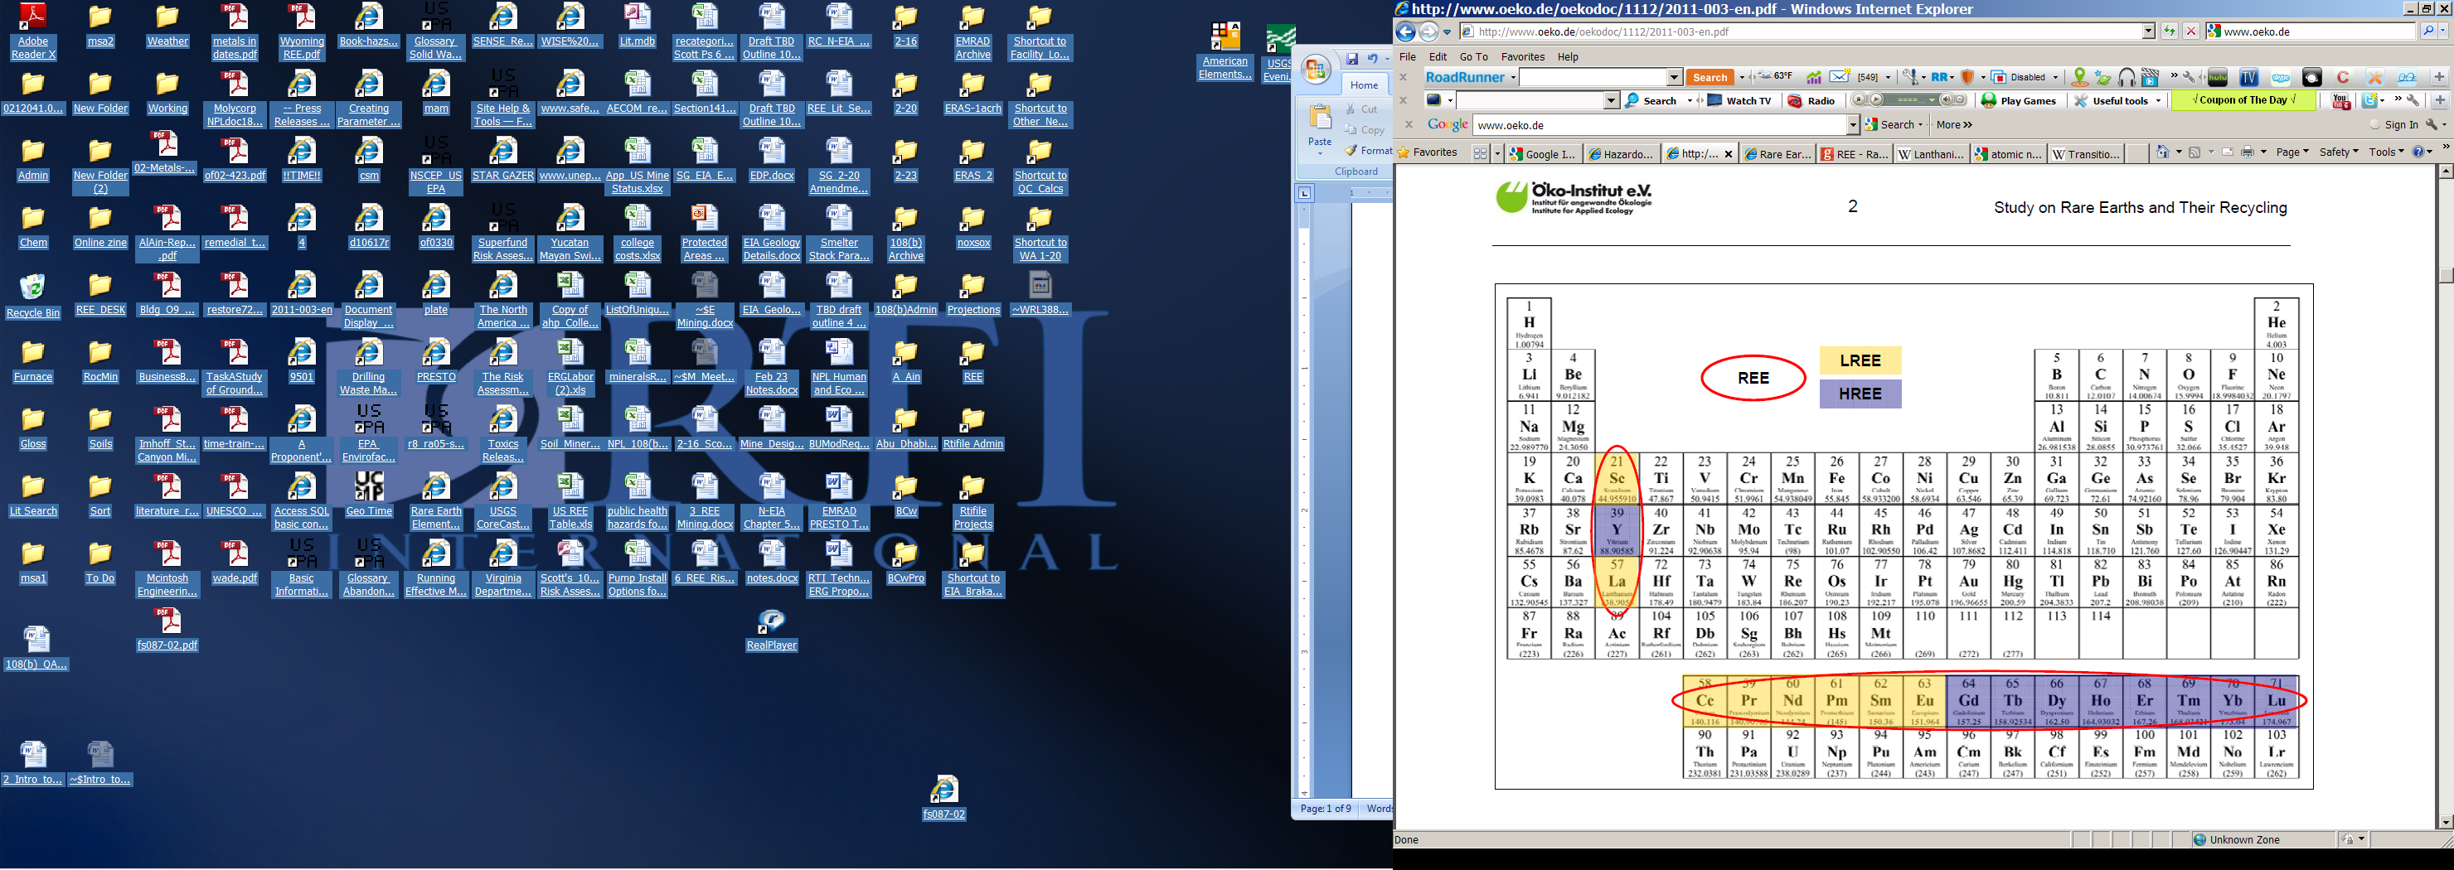
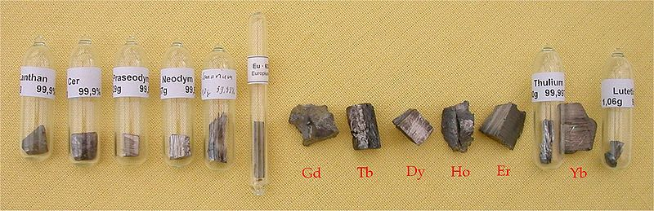

Derick also described how those rare earths used for, and further down he added that REEs are vital to many modern technologies and most of them have no substitutes and are indispensable in many applications as he depicted in a table below.
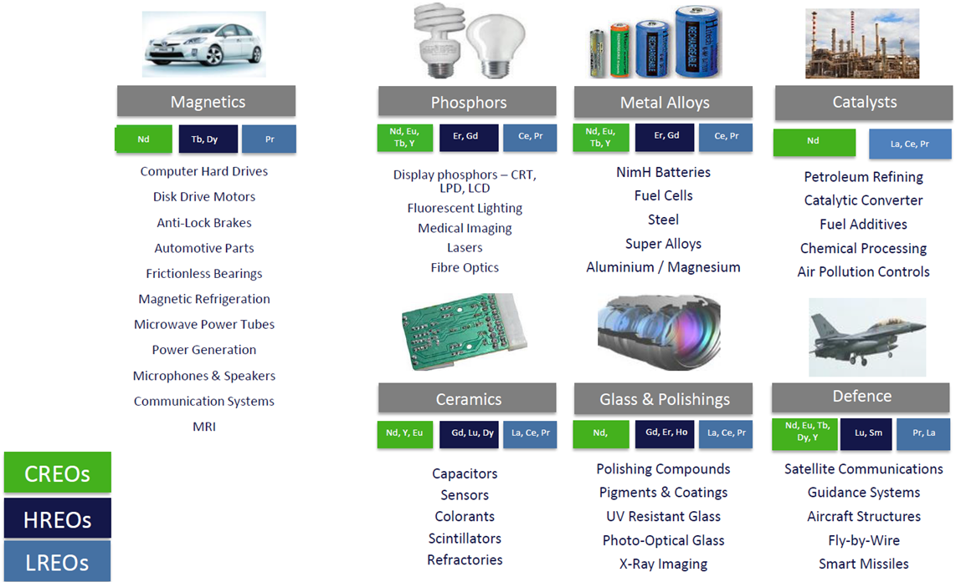

To indicate an importance of rare earth elements in our daily life Derick has used an example of a modern automobile where he has portrayed how REEs are applicable in a currently manufactured car.

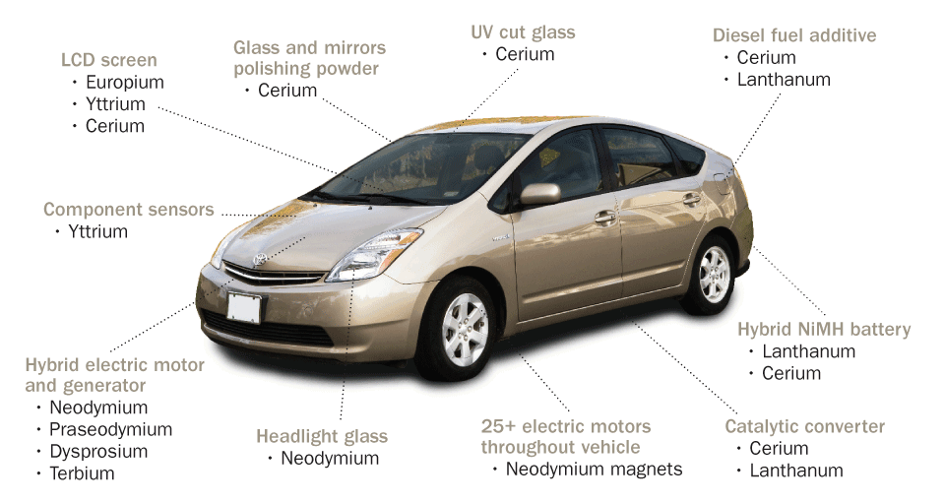
After presentation was completed several questions from the floor were posed to the presenter by the mining professionals’ who were interested in the rare earth elements applications and in mining technologies to mine those REEs.
Following session of questions the presentation attendees were invited to the bar area for cocktails and drinks where more questions were extended to Derick from other professionals who missed an opportunity during questions session.
Enclose please find some photos taken during presentation.
Kind regards
John Arthur Luckmann
Chairman, SAIMM Johannesburg Branch

