HAZLETON PUMPS CEO and Founder wins prestigious AABLA Award as Industrialist of the Year for Southern Africa
The All Africa Business Leaders Awards (AABLA™) in partnership with CNBC Africa honour remarkable leadership and salute game changers of business on the continent for their continuing commitment to excellence, developing best practices and innovative strategies.
CNBC Africa is proud to continue the tradition established by the awards that define and celebrate vision, the spirit of achievement and excellence in business leadership in Africa. The AABLA™ distinguish and honour leaders who have contributed and shaped the African economy, and are visionaries behind today’s outstanding businesses.
Winners of the Awards exemplify the best in African leadership. They epitomize the core values of a successful leader, strength, innovation, ingenuity, knowledge and foresight – values that are imperative to carving out powerful business in a Pan-African and global economy.
In a process that takes months, with regional finals in West, East and Southern Africa, the pioneering and innovative business leaders of Africa in their respective fields will be whittled down to just five game-changing individuals.

SOUTHERN AFRICA WINNERS - 2016
Young Business Leader of the Year Linda Olagunju
Founder of DLO Energy Resources
Entrepreneur of the Year Stephen Saad
Group CEO of Aspen Pharmacare
Business Woman of the Year Lindani Dhlamini
CEO of Sekela Xabiso
Innovator of the Year Ryan Harrison and Stacey Brewer
Co - Founders of Spark Schools
Industrialist of the Year Mathys Wehmeyer
Founder and CEO of Hazleton Pumps
Company of the Year Discovery
Business Leader of the Year Adrian Gore
Founder and CEO of Discovery
Lifetime Achievement Award Brian Joffe
Founder of Bid Corporation

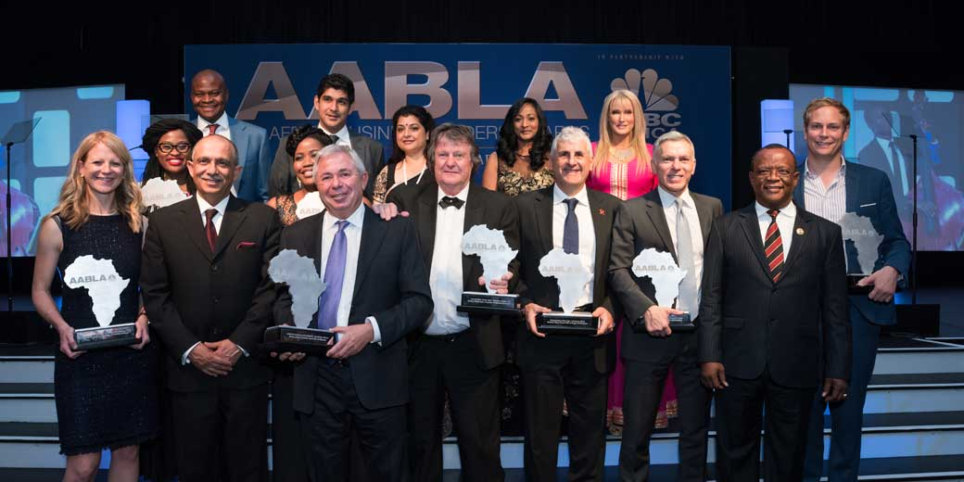

Group photo of the AABLA Winners 2016 – Southern Africa section

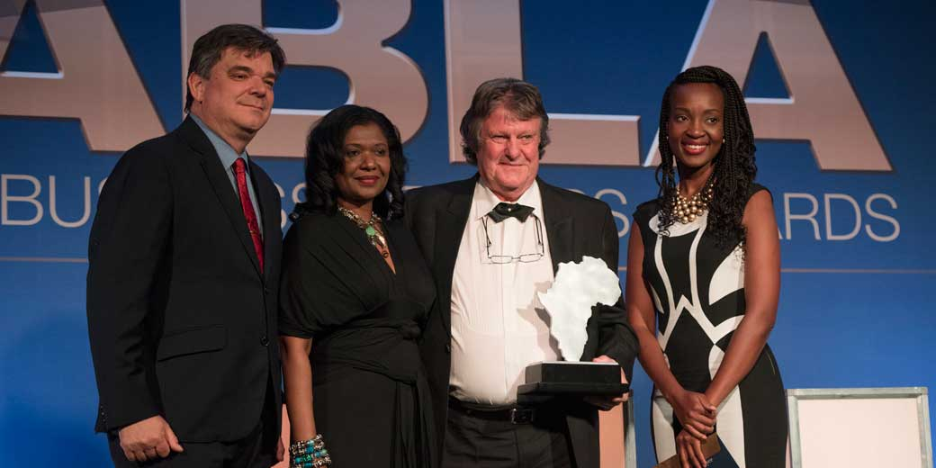
Mathys Wehmeyer, CEO and Founder HAZLETON PUMPS, receives the award for
INDUSTRIALIST OF THE YEAR – Southern Africa

Thys Wehmeyer is the CEO and Founder of Hazleton Pumps, a family owned enterprise located in Centurion, Gauteng (South Africa), won the Industrialist of the Year for the Southern African region. The approach followed by this company is to build long-term committed sustainable customer relationships. Specific, specialised pumps are designed, developed and manufactured in collaboration with customers in order to meet their individual and customized requirements.
The 2016 winners of the 6th annual All Africa Business Leaders Awards in partnership with CNBC Africa (AABLA) will be announced at the Sandton Convention Centre in Johannesburg, on 11 November 2016.

