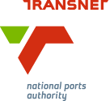
MEDIA RELEASE

TNPA Women Scoop Coveted Awards

[Durban, South Africa, 19 October 2016] Transnet National Port Authority women flew the flag high at the Women in Transport Awards which took place at the Durban ICC on 18 October 2016.

The Women in Transport Awards is a collaborative platform co-located with the African Ports Evolution conference and exhibition, and is dedicated to recognising excellence within the rail and maritime industry in Africa.

The prestigious awards ceremony was attended by a number of decision makers, business leaders and various stakeholders from the transport and maritime industry, with Deputy Minister of Transport Lydia Sindisiwe Chikunga delivering the keynote address.

TNPA’s Sylvia Siyo, who is an acting Ship Repair Manager in the Port of Durban, walked away with the Best Head of Department in Transport award.

Khomotjo Mphahlele, a Senior Marine Training Facilitator at the Transnet Maritime School of Excellence (MSoE), also scooped the award for Best Skills Contributor.

Siyo’s tenure at Transnet extends over 16 years. Since 2012 she has been Deputy Dockyard Manager at TNPA’s
Workshop 24 in the Port of Durban’s Ship Repair Precinct. Prior to that she spent two years with Transnet Engineering: Coach Business as Customer Service Manager, six years with Transnet Rail Engineering: Locomotive Maintenance as a Technical Supervisor, and five years with the then Spoornet as a diesel electric artisan.

In the Best Head of Department in Transport category, Siyo competed against six other finalists including three of her own colleagues. Other TNPA finalists in the category included Nandipha Mtsokoba, who is presently employed as a Senior Engineer leading the Presidential Operation Phakisa initiative in the Port of Durban’s Ship Repair Precinct, together with Captain Pinky Zungu who was appointed as the Port of Durban’s first black female Deputy Harbour Master: Nautical in May 2016 and Silindile Mkhabela, who is presently the Senior Operations Manager in the Port of Durban’s Maydon Wharf Precinct.

At the Transnet MSoE located in Bayhead, Durban, Khomotjo Mphahlele facilitates marine related courses to future skippers and tug masters, able seafarers and General Purpose Ratings. She also compiles and updates training material to remain abreast of the dynamic nature of the industry.

Having started her career as a fitter and turner, Mphahlele then moved on to manufacturing and assembly in the automotive sector before pursuing maritime studies in 2003. She started sailing as a cadet in 2005 and obtained a Certificate of competence at SAMSA in 2007. She sailed on board research ships, bulk carriers, petroleum tankers and diamond mining ships. In addition to her role at the MSoE, her passion for sharing knowledge has seen her deliver lessons to educators from Kwa-Zulu Natal schools offering maritime subjects through a project facilitated by the eThekwini Maritime Cluster’s Skills and Training Programme.

Moshe Motlohi, Durban Port Manager, said: “We are very pleased to have these hard working females in the port being recognised in this national prestigious awards.

Motlohi added: “The maritime sector used to be one that was closed off to the historically disadvantaged, including women, with only 2% of women globally estimated to be involved in the shipping industry. TNPA has solid strategies in place to attract and develop women in the industry and these winners and finalists are testament to the success of many of our programmes.”

Transnet National Ports Authority manages eight commercial seaports in South Africa in a landlord role and is responsible for the port system’s infrastructure, operation, marine services, and legislative and regulatory obligations. The company is a critical contributor towards Transnet SOC Ltd’s Market Demand Strategy and the South African government’s Operation Phakisa: Oceans Economy initiatives.

To view the full list of finalists in the Women in Transport Awards, visit: http://www.womenintransport.co.za/images/WITA-Finalists-101016.pdf

Ends

Image Gallery

Below: Khomotjo Mphahlele (left), a Senior Marine Training Facilitator at the Transnet Maritime School of Excellence (MSoE), receiving the award for Best Skills Contributor from Captain Thembela Taboshe, Master Mariner and Ship Surveyor/ Deck Examiner.
Below: Sylvia Siyo, Acting Ship Repair Manager in the Port of Durban (left), receiving the Best Head of Department in Transport award from Catherine Larkin, Executive Director of the Chartered Institute of Logistics and Transport.

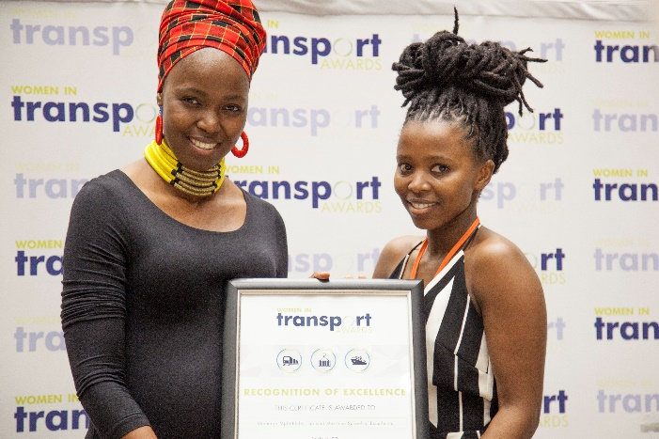
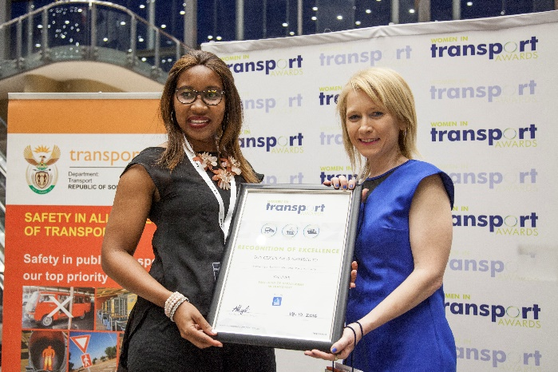

About Transnet National Ports Authority
Transnet National Ports Authority (TNPA) is one of five operating divisions of Transnet SOC Ltd. The National Ports Authority is responsible for the safe, effective and efficient economic functioning of the national port system, which it manages in a landlord capacity. It provides port infrastructure and marine services at the eight commercial seaports in South Africa – Richards Bay, Durban, Saldanha, Cape Town, Port Elizabeth, East London, Mossel Bay and Ngqura. It operates within a legislative and regulatory environment and is governed by the National Ports Act (Act No. 12 of 2005). For more information visit www.transnetnationalportsauthority.net.



Issued by:
Ayanda Mantshongo
Corporate Affairs Manager
Port of Durban
Transnet National Ports Authority

On behalf of:
Moshe Motlohi
Port Manager
Port of Durban
Transnet National Ports Authority

For media queries and request for interviews, please contact:
Nompumelelo Kunene
PR & Media Manager
Port of Durban
Transnet National Ports Authority
Tel. 031 361 8973
Cell. 081 046 6087
nompumelelo.kunene2@transnet.net

