Contact: | Monya Vermaak
Telephone no: | (011) 314-4021
Email address: | Monya.Vermaak@plasticssa.co.za | PRESS RELEASE
Website: | www.plasticsinfo.co.za


Plastics|SA joins DTI on trade mission to Ghana

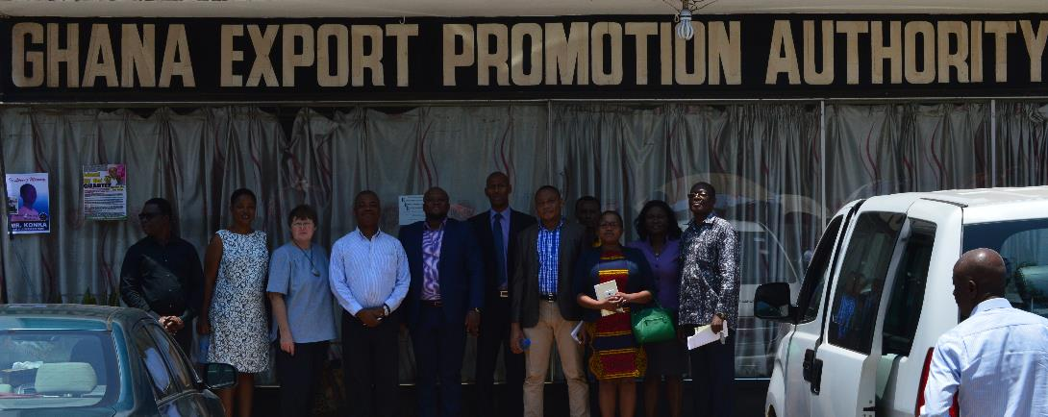

Exciting export opportunities exist for the South African plastics industry as part of the plastics industry’s Export Development Programme (PEDP)

Johannesburg, 17 October 2016. Plastics|SA was recently part of a delegation that joined the Department of Trade and Investment (DTI) on a special trade mission to Accra, Ghana. The delegation consisted of senior officials from the Eastern Cape Development Corporation (ECDC), the Western Cape’s official trade and investment promotion agency (WESGRO) and Plastics|SA.
According to Tobela Tapula, Manager: Corporate and Government Affairs, it was important for Plastics|SA to participate in this mission in order to explore possible export opportunities for the South African plastics industry to the Republic of Ghana. Located along the Gulf of Guinea and the Atlantic Ocean, in the sub-region of West Africa, Ghana is considered an important trade partner bordered by the Ivory Coast in the west, Burkina Faso in the north, Togo in the east and the Gulf of Guinea and Atlantic Ocean in the south.
“There are numerous exciting investment opportunities for South African plastics companies, especially in the agro-processing and food packaging sectors, which we wanted to investigate as part of our Plastics Export Development Programme (PEDP) which aims to grow the industry’s export base beyond the SADC economic bloc,” Tapula explained.

As part of their trade mission, the Plastics|SA delegation (consisting Tobela Tapula and Annabe Pretorius) held discussions with local plastics companies operating in the West African region, including Ghana Plastic Manufacturers Association, Poly Tank, Global Plastic Industries and Aspiring Syringes Manufacturer.

The Ghana Plastic Manufacturers Association represents 95 % of their local plastics industry and comprises of 110 plastics manufacturers. The country’s national consumption was approximately 815 000 tons in 2015. In terms of recycling, large emphasis is placed on PET bottles in Ghana, owing to the fact that the recycling industry in this country is still very small. The majority of the plastic they collect is baled and exported (primarily to China).

more 2/…
Ghana plastics trade mission two

“From our talks it became clear that Ghana would welcome South African plastics companies entering their market – especially in the plastics pipes and packaging sub-sectors. They also asked us to provide them with more information about the Plastics|SA Constitution, Programme of Action and other supporting documentation, as they would like to participate with us in global and regional plastics related initiatives,” Tapula said.

“From a corporate governance point of view, our meetings were extremely relevant because we now know which policies, regulations and government institutions to engage with around issues of trade and investment in Ghana. We will continue to explore these and other opportunities for our members in order to unlock the numerous benefits of cross-border trade and investment,” Tapula concluded.

For more information, visit www.plasticsinfo.co.za

ENDS

