CGG Congratulates Gilles Lambaré on SEG Reginald Fessenden Award

Paris, France – October 19, 2016

Gilles Lambaré, Research Director, EAME, Subsurface Imaging, CGG, has been distinguished with the Society of Exploration Geophysicists’ (SEG) Reginald Fessenden Award in recognition of his initiation of the concept of common-angle migration and demonstration of the potential of that approach to seismic imaging.
The Reginald Fessenden Award is given to a person who has made a specific technical contribution to exploration geophysics, such as an invention or a theoretical or conceptual advancement, which, in the opinion of the Honors and Awards Committee and the Board of Directors, merits special recognition.
Lambaré was selected to receive the Award jointly with Sheng Xu of Statoil, one of his former PhD students when he was associate professor at the Geophysical Research Center of the Paris School of Mines from 1995 to 2005. During that period, they realized that conventional offset migration suffered from artifacts in complex media and proposed to consider angle gathers as a solution. Their concept of sorting data according to a physical parameter (angle) rather than an acquisition parameter (offset) represented at that time a significant improvement in seismic imaging and the landmark paper they published on common-angle migration in Geophysics (November-December, 2001) is still widely cited today.
Colin Murdoch, Executive Vice President, Subsurface Imaging, CGG, said: “When Gilles and Sheng Xu later worked as colleagues at CGG, they and their teams translated the concept of common-angle migration into a major breakthrough technology, known as reverse time migration (RTM) 3D gathers, which became a differentiating capability for CGG and extended our leadership position in wide-azimuth (WAZ) imaging. This achievement was one of many outstanding contributions Gilles has made during his distinguished career. He has always shown a true, inspirational passion for geophysics and its advancement, giving generously of his time to pursue many academic, research and editorial responsibilities. He fully deserves the recognition that comes with this prestigious SEG Award.”
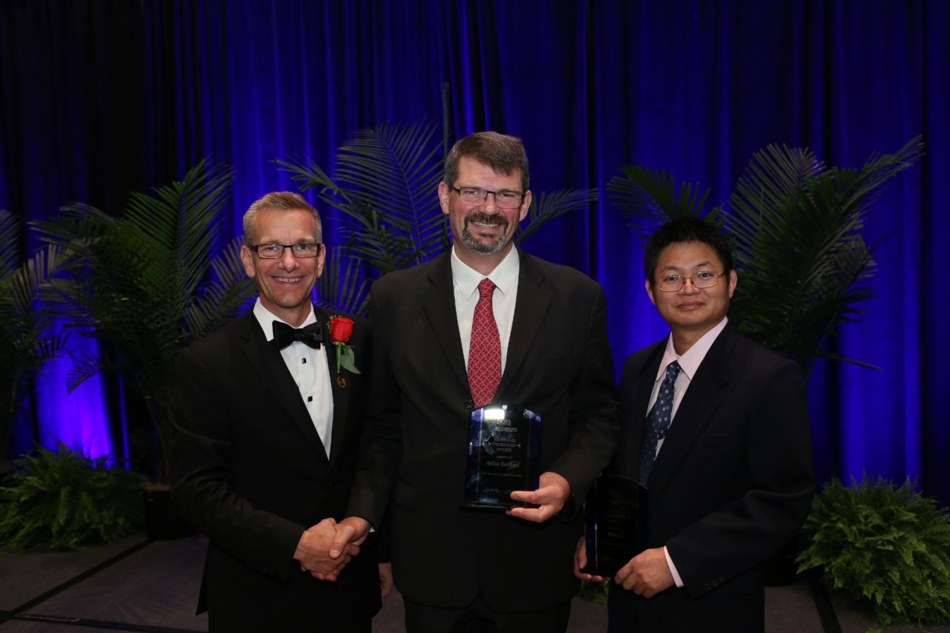
Gilles Lambaré, CGG, (center) and Sheng Xu, Statoil, (right) being jointly presented with the SEG Reginald Fessenden Award by SEG President, John Bradford (left) (image courtesy of SEG).

About CGG
CGG (www.cgg.com) is a fully integrated Geoscience company providing leading geological, geophysical and reservoir capabilities to its broad base of customers primarily from the global oil and gas industry. Through its three complementary businesses of Equipment, Acquisition and Geology, Geophysics & Reservoir (GGR), CGG brings value across all aspects of natural resource exploration and exploitation.
CGG employs more than 6,500 people around the world, all with a Passion for Geoscience and working together to deliver the best solutions to its customers.

Contacts
Subsurface Imaging  John Bastnagel  Tel: + 1 832 351 1183  E-mail: john.bastnagel@cgg.com | Media Relations  Sara Pink-Zerling  Tel: +33 1 64 47 38 83  E-mail: media.relations@cgg.com

