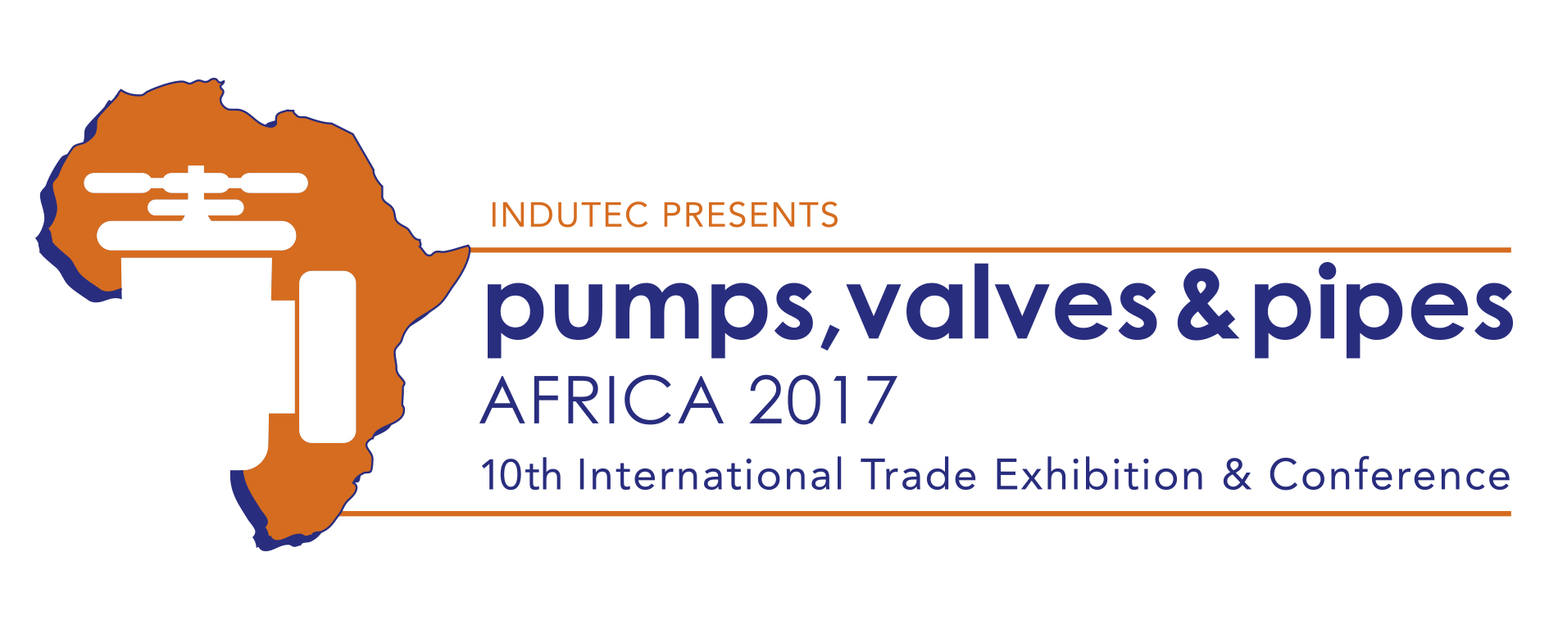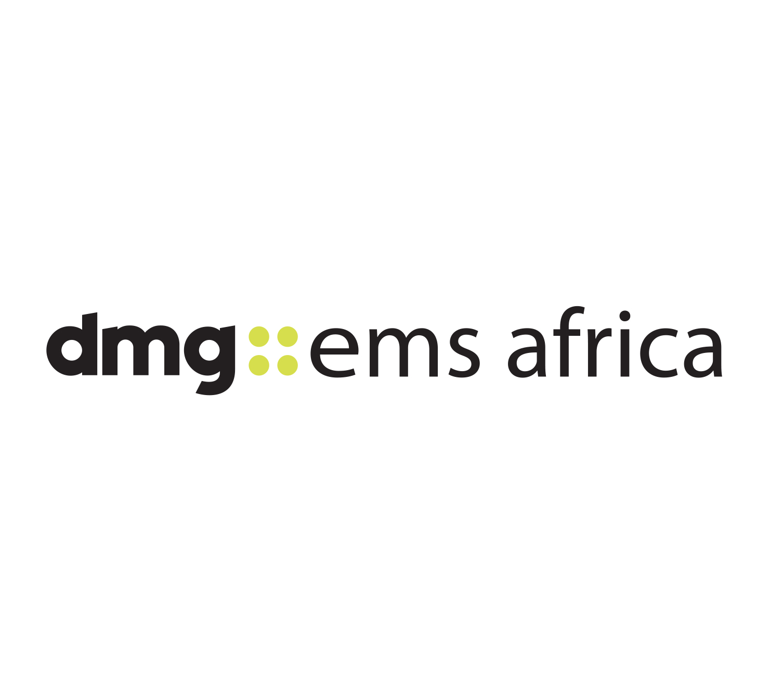

October 6, 2016

NEWS RELEASE

Expo 2017 focuses on Africa’s growth opportunities for pumps, valves and pipes sector

New owners announce special three-days conference that brings together the PVP sector at Johannesburg’s INDUTEC exhibition

Africa’s biggest trade show for pumps, valves and pipes will have a new international focus at INDUTEC when it opens in Johannesburg for three days under new ownership next year.

Pumps, Valves & Pipes Africa 2017, presented by INDUTEC, is the largest and most comprehensive trade-show dedicated to the industries involved in the conveyance of liquids, gasses and slurries.

This is the 10th edition and PVP 2017, which takes place at The Gallagher Conference Centre in Johannesburg, South Africa, from May 17 to 19.

The show’s new owner dmg-ems Africa has today announced that the expo will also host a three-day conference, PVP Live 2017, with leading international industry speakers. E ach seminar attracts certified professional development (CPD) recognition in line with dmg’s policy of supporting career progression for delegates.

“INDUTEC is well-established expo in South Africa attracting visitors and exhibitors from around the world,” says Brad Hook, organiser dmg-ems Africa’s Commercial Director. “This year PVP will focus on the five key areas of the market at both the show and the conference.”

Africa’s growth is offering new opportunities to PVP suppliers in sectors as diverse as water supply and oil extraction through to agriculture and construction.

There are five key areas for suppliers and buyers at PVP 2017:

• Energy
To meet demand in the oil, gas & petrochem sector for economic pumping and transport solutions to capitalise on the continent’s reserves.
• Infrastructure
New government backed developments mean expertise is required across a diverse range - from the transportation of liquid concrete to sewage.
• Water
This vital resource needs increasingly sophisticated management to meet the continent’s future demands
• Agriculture
Mechanisation and population growth is increasing demand for the latest pump and pipeline technology.
• Extractive industries
Africa is a world player now demanding the efficient solutions from oil and gas transportation to mining.

“These are the key growth and investment areas across southern Africa and under new ownership dmg has identified the markets and the visitors, buyers and specifiers, which we will match with the pumps, valves and pipes supply chains,” says Hook.

“And all of this is tied to the future economic success of the continent. In the energy sector, oil and gas production are vital for growth, while across the extractive sector cost-effective solutions are vital.”

Find out more about visiting the show, exhibiting or attending the conference at
www.indutecafrica.com

Press information

Pumps, Valves and Pipes Africa 2017, is the 10th edition of the largest and most comprehensive trade-show dedicated to the industries that are involved in the conveyance of liquids, gasses and slurries. It part of INDUTEC, which runs from May 17 to 19 at The Gallagher Convention Centre in Johannesburg. It is operated by dmg-ems Africa, part of dmg events Middle East, Asia & Africa.

dmg events Middle East, Asia & Africa was founded in 1989 and has operated in the Middle East since 1995 and owns some the region’s biggest shows including The Hotel Show and The Big 5. Headquartered in Dubai, UAE and with satellite offices in India, South Africa and the UK, dmg events Middle East, Asia & Africa organises more than 45 events across the Middle East, Africa, Asia, North America and Europe. The events attract over 250,000 customers every year and provide opportunities for trade professionals to do business, network and learn. For more information visit www.dmgeventsme.com
DMGT manages a balanced multinational portfolio of entrepreneurial companies, with total revenues of almost $3bn, that provide a diverse range of businesses and consumers with compelling information, analysis, insight, news and entertainment. The company employs more than 10,000 people and is listed on the London Stock Exchange. DMGT aims to provide the highest quality information, insight and services to attractive growth markets in innovative ways, building on a track record of earnings and dividend growth. For more information visit www.dmgt.com

For further information, please contact:

Gary Wright,

Head of PR & Comms, dmg-ems Africa

E: garywright@dmgeventsme.com

T: +27 (0) 11 783 7250

W: www.dmgeventsme.com

A: P O Box 650302 BENMORE 2010, South Africa

