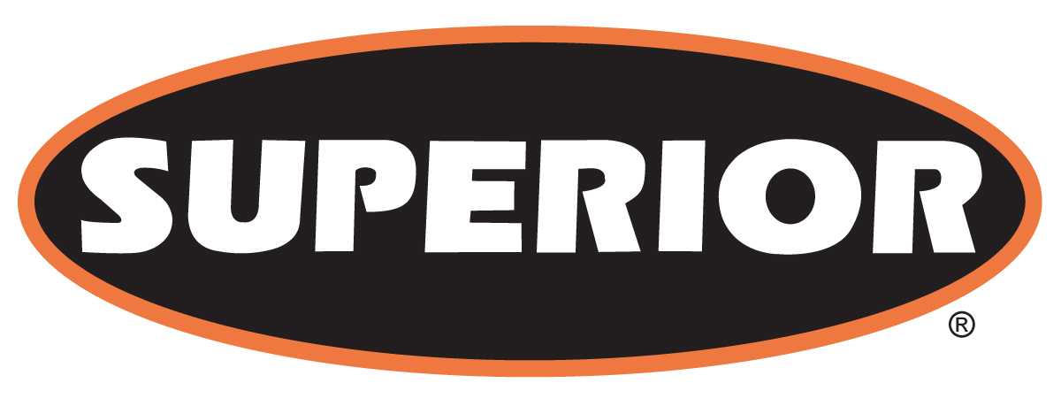

FOR IMMEDIATE RELEASE

October 3, 2016

Superior Debuts Expanded Line of Mine Duty Idlers at MINExpo International 2016

Morris, Minn. — Superior Industries Inc., a U.S. based manufacturer and global supplier of bulk material processing and handling systems, debuted an expanded line of Mine Duty Idlers at MINExpo International 2016 in Las Vegas, Nevada, USA.

Exclusive to Superior, a new double tube (DT) design features inner and outer tube construction giving the idler increased rigidity for higher load ratings. This design has a 20% higher load rating than CEMA, which improves service life. The inner tube insulates the bearing from vibration, reducing misalignment and increasing the life of the bearing. As the outer shelf wears, the inner tube maintains the structural integrity of the roller.

The double tube models are available in belt widths up to 120” and are equipped with bearing sizes up to 60mm. According to Superior, this double tube product line has proven capabilities, having tested at some of the highest capacity iron ore mines in the world.

Unrivaled in the market, the 30mm bearing DX Idler is designed with a ¼” thick wall for added durability.

About Superior Industries, Inc.
Superior Industries engineers and manufactures groundbreaking, bulk material handling equipment and cutting-edge components. From its headquarters in Morris, Minnesota, USA, the manufacturing firm supplies bulk crushing, screening, washing and conveying systems for industries including construction aggregates, mining, bulk terminals, agriculture, power and biomass. In addition to its home plant in Minnesota, the 43-year-old Superior operates from additional engineering and manufacturing plants in Alberta, Canada; Arizona, USA; Georgia, USA; Michigan, USA; Nebraska, USA; and New Brunswick, Canada.

For more information, contact:
Corey Poppe, Marketing Communication Manager
315 East State Highway 28
Morris, Minnesota 56267 U.S.A.
+1 (320) 589-2406
corey.poppe@superior-ind.com
http://www.superior-ind.com/
http://www.facebook.com/superiorindustries

