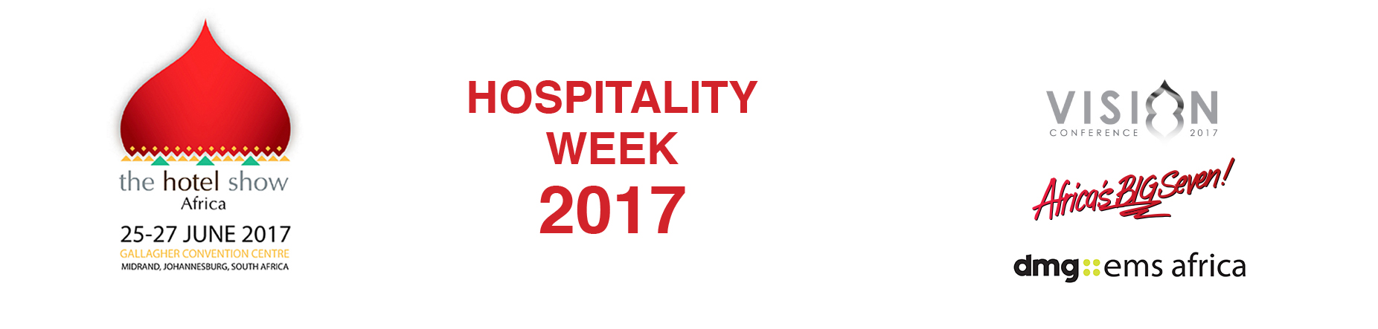

September 26, 2016

NEWS RELEASE

CEO of FEDHASA says The Hotel Show 2017 is a boost to the continent’s tourism and hospitality sector

Southern Africa’s biggest hospitality association teams up with The Hotel Show brand for new launch

The organisers of The Hotel Show, one of the world’s most successful exhibitions, today announced a strategic partnership with Federated Hospitality Association of Southern Africa (FEDHASA) for its Africa launch.

The Hotel Show Africa 2017 takes place in Johannesburg from June 25 to 27 organised by dmg-ems Africa, part of dmg events Middle East, Asia & Africa, which revealed in June it would bring the format to the continent.

“The arrival of The Hotel Show brings a recognised global brand to Africa and we are pleased that dmg has chosen South Africa,” says Tshifhiwa Tshivhengwa, CEO of FEDHASA.

“The Hotel Show Africa will bring a new focus to the Africa hospitality industry and with it a network of potential owners, operators, buyers, investors and developers from leading hotel and restaurant names.

Tshivhengwa said: “A forum such as this brings a wealth of opportunity for owners, managers and suppliers in terms of connecting with each other, meeting new contacts, generating business but also for gaining essential insight and knowledge share, and FEDHASA is pleased to be a part of it.”

Vice President of dmg-ems events Christine Davidson said: “I am very excited to bring such a fantastic industry event to Africa. Tourism growth is dependent upon having the right infrastructure and understanding the direction of the market worldwide.

“The new show provides a platform for local and international hospitality industry to come together here, in South Africa, to discuss future opportunities as well as challenges. It will bring a renewed energy and focus on this exceptional continent.”

Tschivhengwa agreed it was a useful boost to the tourist industry across southern Africa. He said: “From a tourism perspective, the product offering in southern Africa is very good. For the future we need to encourage international operators of waterparks, theme parks and tourist attractions to invest here as well as more hoteliers and restaurateurs. The Hotel Show Africa is a major step in bringing the continent to the attention of the world’s hospitality influencers.”

Tourism is one of the most important contributors to GDP in South Africa. Today travel and tourism is around 9.5% per cent of GDP and employs around 700,000 people. That is forecast to increase as the government recognises it is vital for economic growth.

Davidson confirmed that The Hotel Show Africa 2017 is one of the most important launches next year: “Tourism is vital to the growth of the African economy – creating jobs and bringing foreign investment.

“The hospitality industry in Africa is such an important one for both foreign income and jobs but there are many opportunities still to be realised, the introduction of The Hotel Show is a direct recognition of the sector’s potential. South Africa is the ideal location for the event, offering a gateway to the African market.”

“For our members The Hotel Show will be a showcase and offer an insight and a chance to source and buy products and services,” said Tshivhengwa.

“International buyers will have the opportunity to come to Africa, understand what’s going on here and of course, to source products from local suppliers.”

The Vision Conference attracts hundreds of delegates in the Middle East and that formula of industry experts sharing knowledge and insight provides an essential learning forum.

Tshivhengwa said: “Captains of industry will present African solutions and discuss new trends. They can reveal how they have implemented expansion and share their experience and reveal the lessons learned.”

Find out more about visiting the show, exhibiting or attending the conference at www.thehotelshowafrica.com.

Press information

The Hotel Show Africa 2017 is a geo-clone of The Hotel Show Dubai, the biggest event in the Middle East. It will bring together national and international exhibitors to showcase hospitality products for restaurants, cafes, bars and hotels, right through to food & beverage service outlets.
The Hotel Show Africa 2017 and The Vision Conference run from June 25-27 at The Gallagher Convention Centre, Midrand, Johannesburg, South Africa. It will focus on new trends in the hospitality sector, covering everything from technology to kitchen equipment, cleaning services to interior design, and furnishings to tableware. The event will also introduce the successful Vision Conference, a vibrant knowledge platform set to attract hundreds of senior industry leaders to discuss trends, debate challenges and spotlight opportunities in the African hospitality sector. www.thehotelshowafrica.com

It is part of Hospitality & Retail Week 2017 includes Africa’s Big 7, the continent’s largest food and beverage industry trade expo, and SAITEX 2017, Africa's most prominent platform for retail and trade.

dmg events Middle East, Asia & Africa was founded in 1989 and has operated in the Middle East since 1995 and owns some the region’s biggest shows including The Hotel Show and The Big 5. Headquartered in Dubai, UAE and with satellite offices in India, South Africa and the UK, dmg events Middle East, Asia & Africa organises more than 45 events across the Middle East, Africa, Asia, North America and Europe. The events attract over 250,000 customers every year and provide opportunities for trade professionals to do business, network and learn. For more information visit www.dmgeventsme.com
DMGT manages a balanced multinational portfolio of entrepreneurial companies, with total revenues of almost $3bn, that provide a diverse range of businesses and consumers with compelling information, analysis, insight, news and entertainment. The company employs more than 10,000 people and is listed on the London Stock Exchange. DMGT aims to provide the highest quality information, insight and services to attractive growth markets in innovative ways, building on a track record of earnings and dividend growth. For more information visit www.dmgt.com

For further information, please contact:

Gary Wright,

Head of PR & Comms, dmg-ems Africa

E: garywright@dmgeventsme.com

T: +27 (0) 11 783 7250

W: www.dmgeventsme.com

A: P O Box 650302 BENMORE 2010, South Africa

