Who can increase precision for simulating plastic injection processes?

Mougins, France, 23 September 2016

Short version

Today, REM3D® is THE new rheology software for optimizing plastic injection processes. Offering innovative functions with a highly parallel solver and fully automated adaptive remeshing technology, this software is a simple and effective solution that offers a very high level of accuracy for: - High added value 3D technical parts, - reinforced plastics – multi-material injection, and – polyurethane foam injection/expansion. To reinforce our range of services, Transvalor has added the very latest generation characterization equipment for PU foams. This way, our clients benefit from a one-stop solution for precision modeling, fed by extremely reliable data. The space and aeronautics field is also privileged with simulations for shaping heavily loaded polymer matrices and support for particle migration during run-off.

Building on the strength of its first commercial successes, REM3D® continues its development with the introduction, coming soon, of new coupled models covering fiber orientations for enhanced prediction of final in-use properties of reinforced parts.

-End-
Words: 152
Characters: 924
Characters (including spaces): 1076

Long version

The REM3D® simulation software from French company Transvalor is THE new tool when it comes to rheology software. By providing accurate real-life results, the solution reduces cycle times and the costs involved in planning, rolling out and monitoring the injection process.

Unique features:

Thanks to its fully automated adaptive remeshing technology, the software now allows highly accurate simulations of all of the most complex processes like fluid assisted injection, co-injection as well as the injection of all kinds of loaded polymers. AAA (Adaptive-Automatic-Anisotropic) remeshing is intended to dynamically adapt meshing to every calculation increment, working locally to match criteria that are specific to every simulation thereby automatically ensuring very fine meshing. This offers the assurance that thermal effects will be very accurately taken into account, and hence a very good prediction of run-offs. AAA remeshing is managed in a fully automated and extremely simple way: users do not need to have any expertise in numerical parameter setting.

Investing in polyurethane foam characterization:

Transvalor is the player of reference when it comes to simulating PU foam injection/expansion applications. The predictive nature of the simulation is strongly dependent on the inherent quality of the input data and especially the kinetic-rheological properties of the foams. To provide one-stop service for clients, the company has added very latest generation characterization equipment: the ‘Foam Qualification System FOAMAT®’. This system can measure all of the physical parameters of polyurethane foams. This raw data is then processed and directly converted into a material datasheet for use in the REM3D® software. This unique service guarantees that software users have access to preeminently accurate modeling fed by extremely reliable data.

The influence of fiber orientation and particles on flows:

For reinforced plastics, Transvalor continues its development work with the introduction of strong coupling between polymer flows and fiber presence. Hence REM3D® can clearly highlight the impact of fiber ratios and orientations on polymer flows. The pressure fields are also modified, thereby affecting shrinkage and deformation calculations for the finished part after ejection. The program uses a novel tensorial graphic representation to show fiber orientations. This unique representation mode is used to intuitively view the direction in which the fibers are oriented across the thickness of the part, from core to outer skin. Lastly, the software now allows simulating the forming of a highly loaded polymer matrix taking into account the migration of these particles during run-off so as to determine the influence of these particles distributions on the implementation faults and the end properties of these parts.

Serving productivity:

Simulation is used to better manage the processes and accelerate design lead times. Manufacturing processes can easily be optimized so as to obtain low rejection rates and to use as little material as possible. The REM3D® software applies exclusive solver implementation for simulating processes on highly parallel architectures using up to 64 cores. Hence, the calculation times are significantly reduced, contributing to reducing design lead times. Lastly simulation results can be immediately exported to structure calculation software ensuring a unique competitive advantage when processing the entire manufacturing sequence.

Easy innovation:

Thanks to the rich function set and versatility of the product, innovative processes can be imagined freely and tested virtually. Hence the specific foam injection-expansion simulation module perfectly illustrates the advantages born of this new innovative technology. Thanks to this one of a kind module, designers can anticipate any problems that may arise with mold balancing as well as the losses from vents, hence accurately determining the amount of material to inject and the optimum positioning of the vents to ensure uniform material distribution. In all sectors that use foam injection-expansion processes, this software brings truly predictive solutions like the accurate mapping of the part's density.

Transvalor was founded in 1984. Its close links with applied Research mean that it can integrate an ongoing flow of scientific developments in a software suite dedicated to forming materials. The technology used combined with the expertise of our industrial partners means that we can make simulation a true production optimization tool.

-End-
Words: 668
Characters: 3878
Characters (including spaces): 4538

Contact:
TRANSVALOR S.A.
Parc de Haute Technologie
694 Avenue du Dr. Maurice Donat
06255 Mougins cedex - France
Web: www.transvalor.com
E-mail: marketing@transvalor.com

Media Contact (French, English):
Stéphane Andrietti
Marketing & Communications Director
+33(0) 492 92 42 11
stephane.andrietti@transvalor.com

Media Contact (French, English):
Dr. Laurence Ville
Product Manager REM3D®
+33(0) 492 92 38 52
laurence.ville@transvalor.com

Company logo:

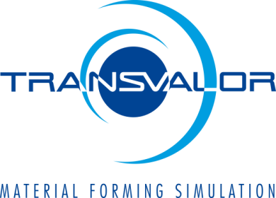

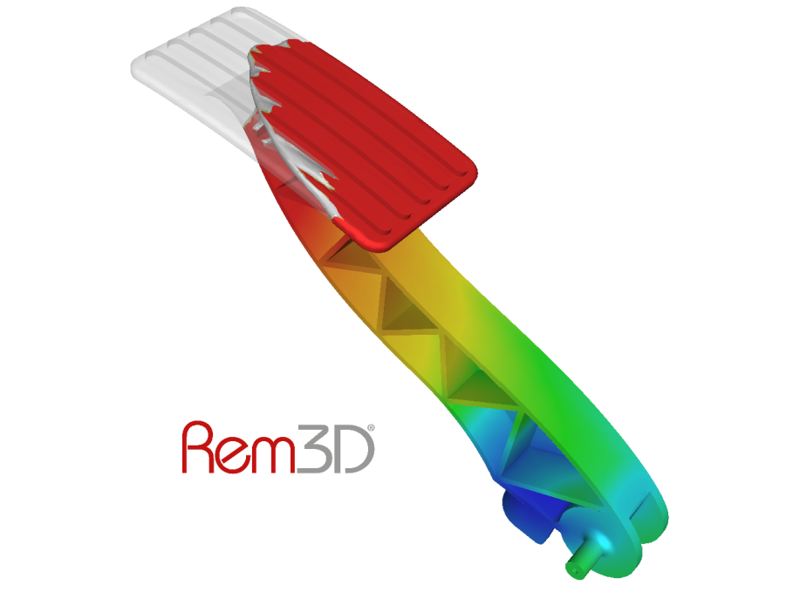

Figure 1: Accelerator pedal made from reinforced PA66: Filling time progression

