DAVID BROWN SANTASALO
Information Pack

Electra Mining Africa 2016 | 12-16 September 2016

PRESS RELEASE

DAVID BROWN SANTASALO BRINGS ITS GEAR MANUFACTURING CENTRE OF EXCELLENCE TO ELECTRA MINING AT ITS FIRST EXHIBITION IN AFRICA SINCE ITS MERGE

09 September 2016 – At its first Electra Mining Africa as a merged company, David Brown Santasalo’s exhibition stand promises to engage, inform and entertain visitors with innovative virtual reality technology as well as proven hardware.
David Brown Santasalo’s stand in Hall 7, number C04, will showcase a variety of gearing technology, not least it’s robust, low-noise CX conveyor drive and a girth gear segment - both of which are no stranger to relentless mining environments.
However, this year David Brown Santasalo’s piece de resistance will be its innovative, interactive Leap Motion device which will allow visitors to explore gearing technology in a 360-degree virtual reality platform, as well as break apart products to find out how they are manufactured. The Leap Motion software is controlled purely by hand gestures so visitors can experience all elements of a gearbox without the need for heavy lifting equipment or a service engineer!
In addition, David Brown Santasalo will be bringing its Mining Centre of Excellence to Electra Mining for all to see. Normally based in Benoni, Gauteng, the company’s manufacturing plant can be toured from the comfort of David Brown Santasalo’s stand using virtual reality headsets. Visitors to the stand will be able to see how gears are manufactured and engage in the technology that ensures they’re robust and reliable in-situ – all without leaving the exhibition hall.
Nico Basson, Managing Director of David Brown Santasalo South Africa explains: “We are excited to be attending Electra Mining this year, not least because it’s our first exhibition in Africa as our merged company; David Brown Santasalo.
“As David Brown, we have been manufacturing gears in South Africa since 1947, and our aim for Electra Mining was to showcase our proven gearing technology in an innovative and engaging way. There is a huge amount of technology available and what better way to use it than to allow visitors to really dig deep into our gear engineering techniques and find out more about David Brown Santasalo’s proven reliability.”
Since David Brown and Santasalo merged in June 2016, the company now has more than 1,000 employees globally, 7 major manufacturing plants and 23 service centres across 6 continents and is ideally equipped to serve its growing customer base in commodities, marine, defence, power, industrial and consumer end markets.
In Africa, David Brown Santasalo operates a Mining Centre of Excellence, which is renowned for delivering robust conveyor drives, mill drives and girth gears to Africa’s mining industry.

For more information, visit David Brown Santasalo at Electra Mining Africa 2016, Hall 7 stand C04 or email: media@dbsantasalo.com.

ABOUT DAVID BROWN SANTASALO

David Brown and Santasalo, two of the world’s leading mechanical power transmission companies merged on June 1st to create David Brown Santasalo, a new, truly global force in the gear industry.
With more than 1,000 employees, 7 major manufacturing plants and 23 service centres across 6 continents, the business is ideally equipped to serve its growing customer base in commodities, marine, defence, power, industrial and consumer end markets.
With over 280 years of combined gear engineering leadership and substantial geographic expansion over the last decade into high growth countries such as China, India, Indonesia and the Philippines, David Brown Santasalo is well positioned as a world leader in its field.
Under Clyde Blowers Capital ownership, David Brown Santasalo has benefitted from significant investment in world-class manufacturing, new product development and service centre expansion.
Through its highly responsive and capable local teams, David Brown Santasalo brings the connectivity and responsiveness to support the specific needs of over 5,000 customers worldwide.
Thomas Burley, Chief Executive Officer, David Brown Santasalo explains:
“I am delighted to have this opportunity to lead a business with such a diverse, international team. We now combine extensive sales and service presence in all regions with a world-class engineering and manufacturing capability. David Brown Santasalo covers varied end markets including naval ships, minerals processing and the manufacture of a wide range of pulp and paper products. Across all these markets, our core differentiator is our fundamental capability to design and engineer gear systems for the world’s most demanding applications. We are committed to maintaining and growing this through continued investment in our people and manufacturing capabilities over the coming years.
“Our strategy comprises three main elements:
- To continue to expand our sales and service network, becoming ever more local to our diverse customer base
- To use our in depth gear engineering knowledge to enhance our product offering and support our customers in their end markets
- To invest further in world-class manufacturing, ensuring we have full production capability in key regions to meet the growing demand for our products.”

Jim McColl, Chairman and CEO, Clyde Blowers Capital adds:
“In bringing together David Brown and Santasalo, we have created a large scale industrial gearing business with proven management, highly complementary products, a unique global service network and increasingly efficient manufacturing. Whilst both have progressed well independently, we now have a business with all the necessary attributes to further grow and develop as an industry leader.
“Clyde Blowers is committed to invest in the business over the coming years, including acquisitions that further enhance its position in key markets. We look forward to continue working with the leadership team at David Brown Santasalo, as we have done successfully to reach this stage.”

David Brown Santasalo is an excellent example of Clyde Blowers’ proven model of identifying and acquiring industrial businesses with strong growth potential. Clyde Blowers’ strategic and operational expertise enables this potential to be realised, meeting the long-term needs of investors, customers and employees.

ENDS –

DAVID BROWN SANTASALO’S GLOBAL CAPABILITIES

With more than 30 locations worldwide, David Brown Santasalo has a truly global coverage. David Brown Santasalo operates gear manufacturing, service and sales facilities in key locations in both the Northern and Southern Hemispheres.
Manufacturing capabilities in China, Finland, France, India, UK, South Africa and Canada ensure David Brown Santasalo can produce a wide range of high quality products for many types of applications.

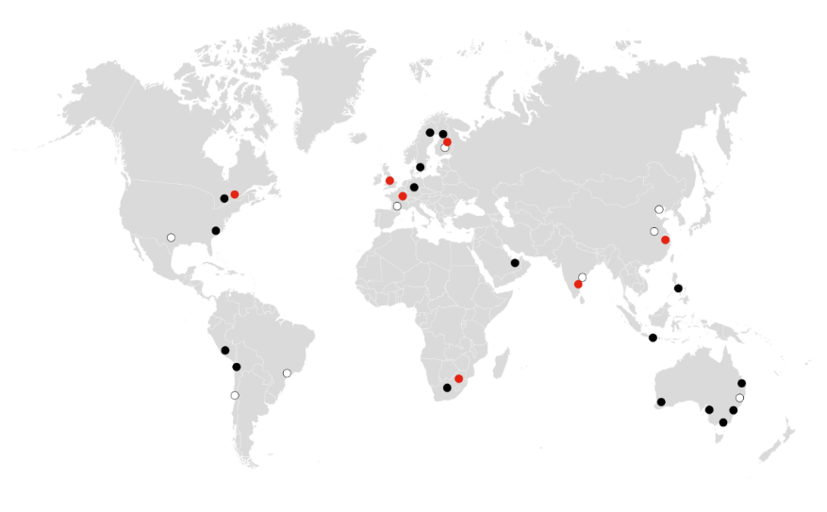
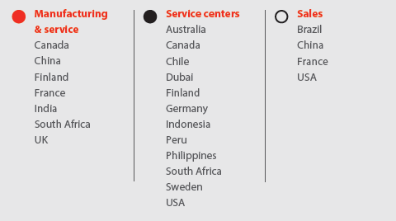

EXPERT SERVICE OF ALL GEARBOX BRANDS

David Brown Santasalo is the service provider of choice for many of the world’s leading industrial companies. With more than three centuries of combined gearbox design and manufacturing expertise, David Brown Santasalo understands how to maintain and service even the most difficult, mission-critical gearboxes to ensure optimal results and long gearbox life – regardless of the brand.

Our global service network provides support and technical expertise where and when you need it.

A Rich Brand Heritage
At the heart of David Brown Santasalo is a rich engineering heritage based on almost three centuries of combined industry leadership. Over the years we have acquired key brands to strengthen and grow our business and we are the experts when it comes to providing service support for our heritage brands.

- AEI (Associated Electric Industries)
- ASEA
- Benoni Engineering Works
- Bostock and Bramley
- BTH (British Thomson Houston)
- David Brown
- GEC Alstom Gears
- GEC Marine & Industrial Gears
- Hamworthy Transmissions
- Hygate Transmissions
- Jackson Gears
- John Welsh
- Maag Italia
- Metso Drives
- Metropolitan Vickers
- Modern Wheel Drive
- Moventas
- Paramount Gears
- Power Plant Gears
- Rauma Repola
- Sadi
- Sala
- Santasalo
- Sonnerdale Richardson
- Sauerwald (SaWa)
- Turbine Gears
- UniGear
- Valmet Power Transmission

MEET THE TEAM


Tracey Petkovic, Sales & Marketing Administrator
Tracey is a key contact for Sales & Marketing, having been with the business for 8 years.
Tel: 0117480087
Email: tracey.petkovic@dbsantasalo.com

Albert Steyn, Proposals – Service & Repair
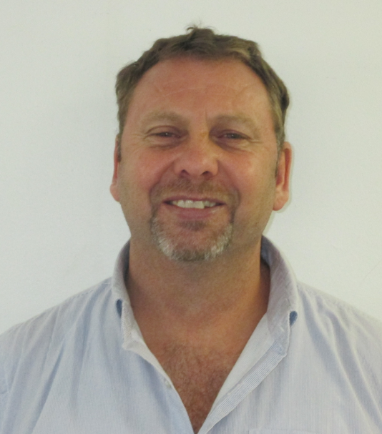
Albert began his DBS career at Benoni Engineering Works (BEW) before it was bought by David Brown. Albert has long standing experience in gear manufacturing and joined the proposals team in 2007.
Tel: 0117480000
Email: albert.steyn@dbsantasalo.com
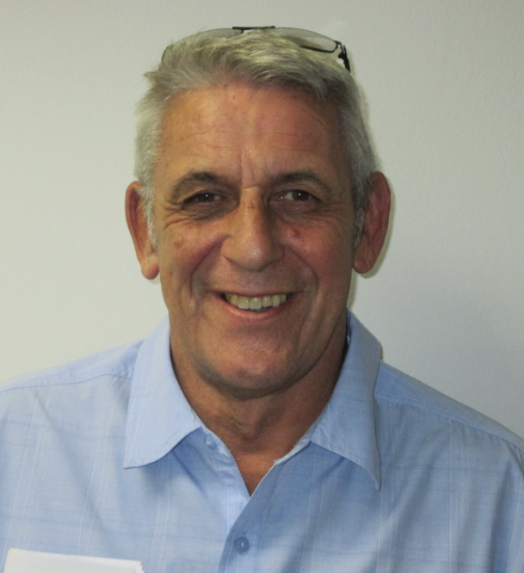
Bill Gorman, Business Development Director
Bill has been with David Brown Santasalo for more than 33 years and has longstanding expertise in Sales & Marketing. During his time at David Brown Santasalo, Bill has lead key accounts such as Eskom and has a full breadth of product knowledge.
Tel: 083 625 2684
Email: bill.gorman@dbsantasalo.com
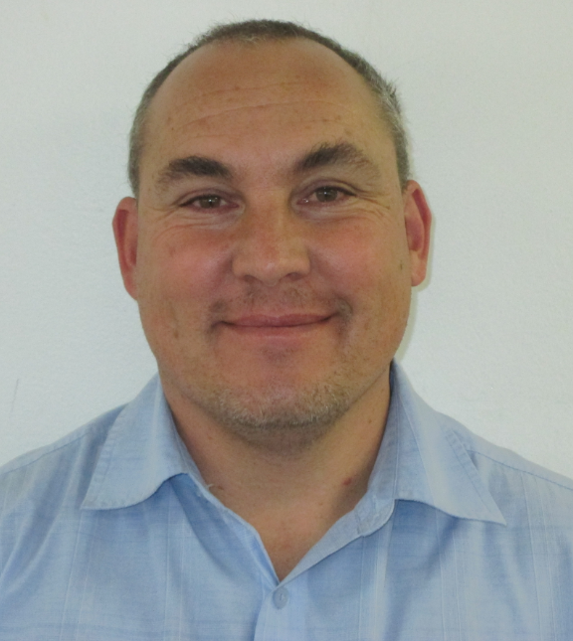
Brett Weinmann, External Sales Representative
Brett joined David Brown Santasalo almost 2 years ago and has experience in technical sales and product management.
Tel: 0810132761
Email: brett.weinmann@dbsantasalo.com

Dave Halkerd, Sales Engineer Mpumalanga Area
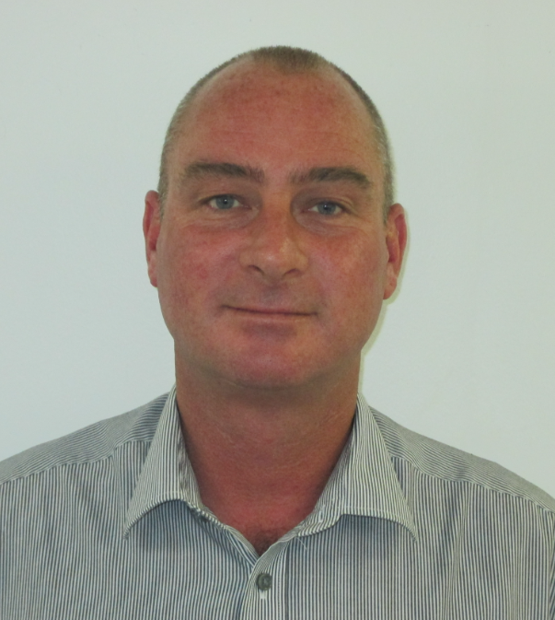
Dave has 24 years’ experience in the power transmission industry, including geared motors and industrial gear systems.
Tel: 083 625 2682
Email: dave.halkerd@dbsantasalo.com

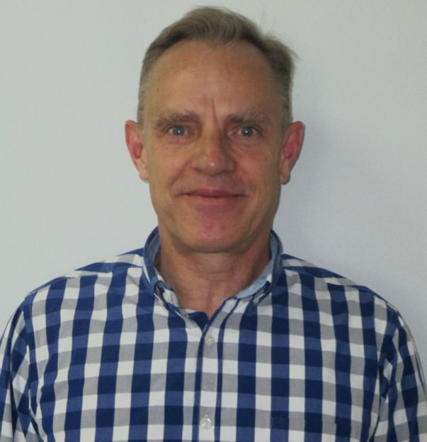
David Main, Senior Sales Manager
David recently joined the David Brown Santasalo team as a Senior Sales Manager and has a wealth of gear industry knowledge, having held positions with Flender Siemens and Hansen-Sumitomo.
Tel: 083 227 5555
Email: david.main@dbsantasalo.com
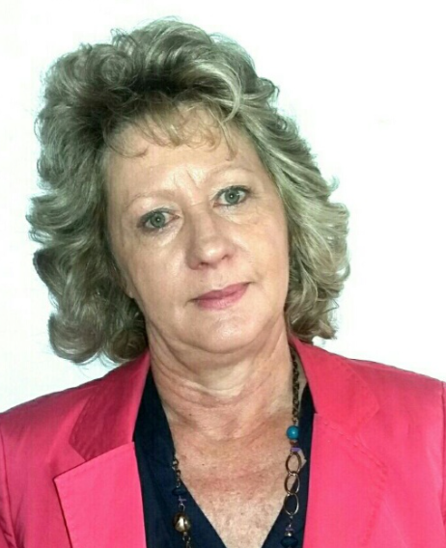
Elaine Bancken, Senior Proposals Estimator
Having worked at David Brown Santasalo for more than 27 years, Elaine has longstanding experience in engineering and proposals.
Tel: 0117480032
Email: elaine.bancken@dbsantasalo.com

Filip Houndalas, Sales Engineer
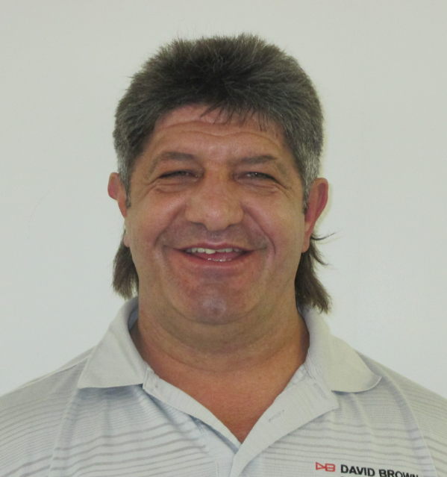
Filip joined David Brown Santasalo in 2010. Filip is responsible for the Eskom account, particularly milling plants and conveyor systems.
T: 083 625 1435
Email: filip.houndalas@dbsantasalo.com

Iain Headland, Proposals Lead
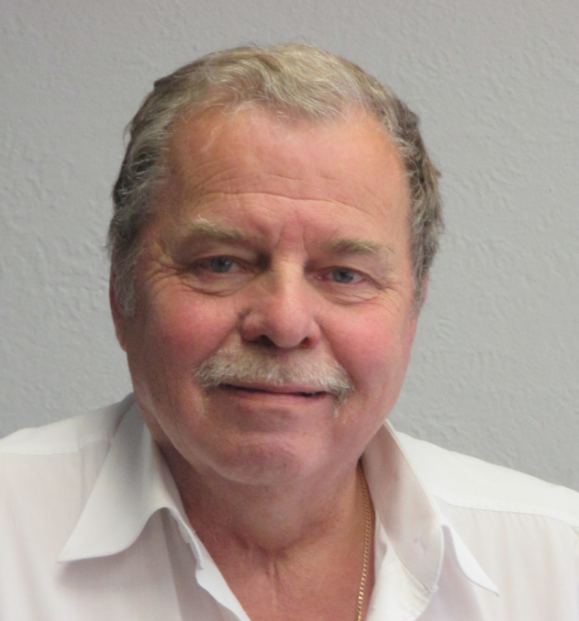
Iain has been at David Brown Santasalo for 21 years and has more than 30 years’ experience in the mining industry.
Tel: 011 748 0000
Cell: 083 626 2459
Email: ian.headland@dbsantasalo.com

Josua Louwrens, Sales Representative
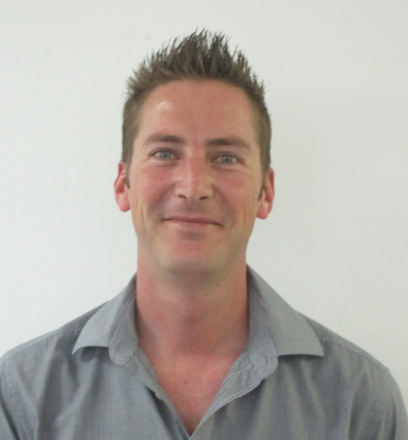
Josua recently joined David Brown Santasalo from Hansen Sumitomo. He has experience in gearbox selection, proposals and preparing project tenders.
Tel: 078 803 6036
Email: josua.louwrens@dbsantasalo.com

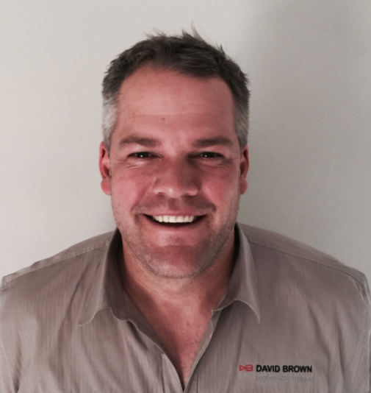
PC de Bruin, Area & Service Centre Manager - Northern Cape
PC has been at David Brown Santasalo for 3 years and has more than 8 years’ experience in the gear industry, specifically in Quality and Sales.
Tel: 0795236228
Email: pc.debruin@dbsantasalo.com
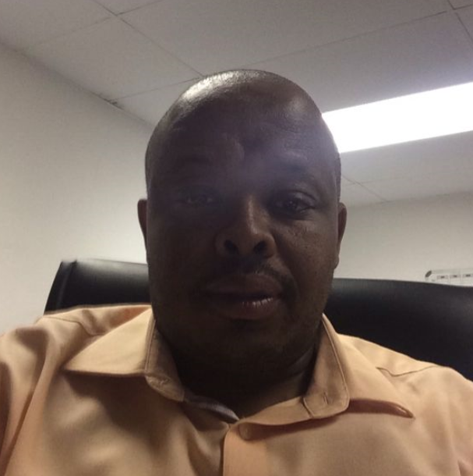
Petros Mahlangu, Sales Engineer
Petros started his career in gear engineering as an apprentice. After 15 years with David Brown Santasalo, Petros has gained long standing experience in the proposals and sales functions.
Tel: 078 451 1911
Email: petros.mahlangu@dbsantasalo.com

Siyabonga Nkosi, Proposal Engineer
Siyabonga joined David Brown Santasalo in 2012 from Bauer Geared Motors. Having held positions at Flender Siemens previously, Siyabonga has a wealth of gear engineering knowledge.
Tel: 011 748 0000
Email: siyabonga.nkosi@dbsantasalo.com
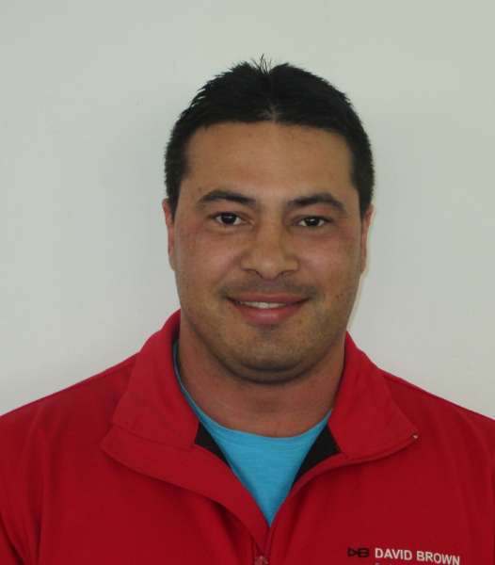
Theo Kleinhans, Area Manager Limpopo & North West
Theo started his career in gearing as a fitter before studying Mechanical Engineering. Theo held a position at Arcelor Mittal steel for 12 years, as a mechanical specialist before joining SEW Eurodrive, and then David Brown Santasalo 3 years ago.
Tel :076 741 0337
Email: theo.kleinhans@dbsantasalo.com

